UNITED STATES
SECURITIES AND EXCHANGE COMMISSION
Washington, D.C. 20549
___________________________________
FORM 8-K
___________________________________
CURRENT REPORT
Pursuant to Section 13 or 15(d) of the Securities Exchange Act of 1934

Date of Report (date of earliest event reported): August 4, 2026

___________________________________

GXO LOGISTICS, INC.
(Exact name of registrant as specified in its charter)
_____________________________________________________________________________________________

Delaware  (State or other jurisdiction of  incorporation) |  |  | 001-40470  (Commission File Number) |  |  | 86-2098312  (IRS Employer Identification No.)
Two American Lane  Greenwich, Connecticut |  |  |  |  |  | 06831
(Address of principal executive offices) |  |  |  |  |  | (Zip Code)
Registrant's telephone number, including area code: (203) 489-1287
Not Applicable
(Former name or former address, if changed since last report)
___________________________________
Check the appropriate box below if the Form 8-K filing is intended to simultaneously satisfy the filing obligation of the registrant under any of the following provisions:

☐ |  |  | Written communications pursuant to Rule 425 under the Securities Act (17 CFR 230.425)
☐ |  |  | Soliciting material pursuant to Rule 14a-12 under the Exchange Act (17 CFR 240.14a-12)
☐ |  |  | Pre-commencement communications pursuant to Rule 14d-2(b) under the Exchange Act (17 CFR 240.14d-2(b))
☐ |  |  | Pre-commencement communications pursuant to Rule 13e-4(c) under the Exchange Act (17 CFR 240.13e-4(c))
Securities registered pursuant to Section 12(b) of the Act:
Title of each class |  |  | Trading Symbol |  |  | Name of each exchange on which registered
Common stock, par value $0.01 per share |  |  | GXO |  |  | New York Stock Exchange
3.750% Notes due 2030 |  |  | GXO/30 |  |  | New York Stock Exchange

Indicate by check mark whether the registrant is an emerging growth company as defined in Rule 405 of the Securities Act of 1933 (§230.405 of this chapter) or Rule 12b-2 of the Securities Exchange Act of 1934 (§240.12b-2 of this chapter).
Emerging growth company ☐

If an emerging growth company, indicate by check mark if the registrant has elected not to use the extended transition period for complying with any new or revised financial accounting standards provided pursuant to Section 13(a) of the Exchange Act. ☐

Item 7.01. Regulation FD Disclosure.

On August 4, 2026, GXO Logistics, Inc. (the “Company”) released a slide presentation expected to be used by the Company in connection with certain future investor presentations. A copy of the slide presentation is attached as Exhibit 99.1 to this Current Report on Form 8-K.

The slide presentation should be read together with the Company's filings with the Securities and Exchange Commission, including the Quarterly Report on Form 10-Q for the fiscal quarter ended June 30, 2026.

The information furnished pursuant to this Item 7.01, including Exhibit 99.1, shall not be deemed “filed” for purposes of Section 18 of the Securities Exchange Act of 1934 (the “Exchange Act”) or otherwise subject to the liabilities under that Section and shall not be deemed to be incorporated by reference into any filing of the Company under the Securities Act of 1933 or the Exchange Act, except as shall be expressly set forth by specific reference in such filing.

Item 9.01. Financial Statements and Exhibits.
(d) The following exhibits are being filed herewith:

Exhibit  Number |  |  |  |  |  | Description
99.1 |  |  |  |  |  | Investor Presentation, dated August 4, 2026.
104 |  |  |  |  |  | Cover Page Interactive Data File (embedded within the Inline XBRL document).

SIGNATURE

Pursuant to the requirements of the Securities Exchange Act of 1934, the registrant has duly caused this report to be signed on its behalf by the undersigned hereunto duly authorized.

Dated: August 4, 2026 |  |  |  |  |  | GXO LOGISTICS, INC.
 |  |  |  |  |  | By: |  |  | /s/ Mark Suchinski
 |  |  |  |  |  | Name: |  |  | Mark Suchinski
 |  |  |  |  |  | Title: |  |  | Chief Financial Officer
 |  |  |  |  |  |  |  |  | (Principal Financial Officer)

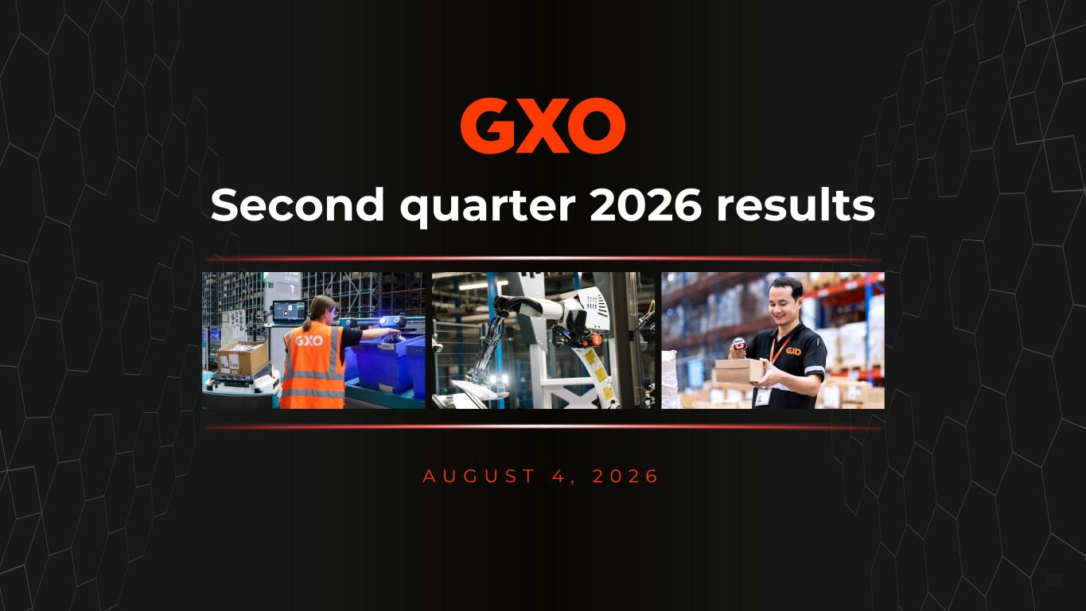

© GXO Logistics, Inc.© GXO Logistics, Inc. 1 Second quarter 2026 results A U G U S T 4 , 2 0 2 6

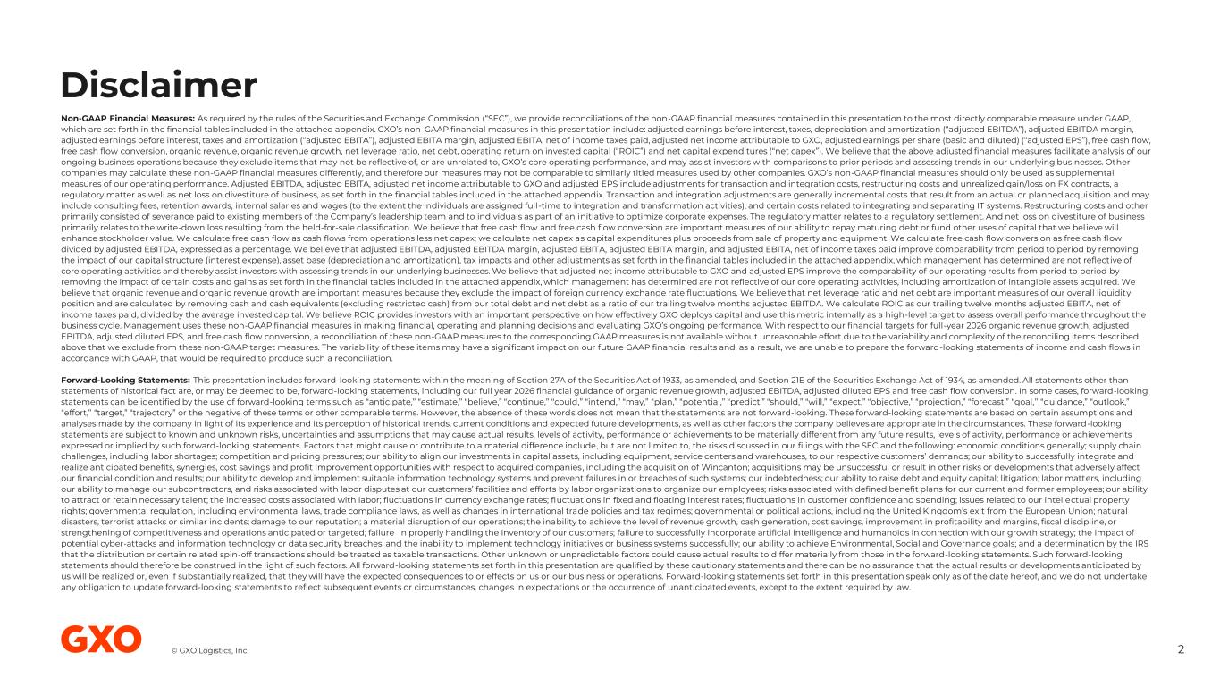
© GXO Logistics, Inc. Disclaimer 2 Non-GAAP Financial Measures: As required by the rules of the Securities and Exchange Commission (“SEC”), we provide reconciliations of the non-GAAP financial measures contained in this presentation to the most directly comparable measure under GAAP, which are set forth in the financial tables included in the attached appendix. GXO’s non-GAAP financial measures in this presentation include: adjusted earnings before interest, taxes, depreciation and amortization (“adjusted EBITDA”), adjusted EBITDA margin, adjusted earnings before interest, taxes and amortization (“adjusted EBITA”), adjusted EBITA margin, adjusted EBITA, net of income taxes paid, adjusted net income attributable to GXO, adjusted earnings per share (basic and diluted) (“adjusted EPS”), free cash flow, free cash flow conversion, organic revenue, organic revenue growth, net leverage ratio, net debt, operating return on invested capital (“ROIC”) and net capital expenditures (“net capex”). We believe that the above adjusted financial measures facilitate analysis of our ongoing business operations because they exclude items that may not be reflective of, or are unrelated to, GXO’s core operating performance, and may assist investors with comparisons to prior periods and assessing trends in our underlying businesses. Other companies may calculate these non-GAAP financial measures differently, and therefore our measures may not be comparable to similarly titled measures used by other companies. GXO’s non-GAAP financial measures should only be used as supplemental measures of our operating performance. Adjusted EBITDA, adjusted EBITA, adjusted net income attributable to GXO and adjusted EPS include adjustments for transaction and integration costs, restructuring costs and unrealized gain/loss on FX contracts, a regulatory matter as well as net loss on divestiture of business, as set forth in the financial tables included in the attached appendix. Transaction and integration adjustments are generally incremental costs that result from an actual or planned acquisition and may include consulting fees, retention awards, internal salaries and wages (to the extent the individuals are assigned full-time to integration and transformation activities), and certain costs related to integrating and separating IT systems. Restructuring costs and other primarily consisted of severance paid to existing members of the Company’s leadership team and to individuals as part of an initiative to optimize corporate expenses. The regulatory matter relates to a regulatory settlement. And net loss on divestiture of business primarily relates to the write-down loss resulting from the held-for-sale classification. We believe that free cash flow and free cash flow conversion are important measures of our ability to repay maturing debt or fund other uses of capital that we believe will enhance stockholder value. We calculate free cash flow as cash flows from operations less net capex; we calculate net capex as capital expenditures plus proceeds from sale of property and equipment. We calculate free cash flow conversion as free cash flow divided by adjusted EBITDA, expressed as a percentage. We believe that adjusted EBITDA, adjusted EBITDA margin, adjusted EBITA, adjusted EBITA margin, and adjusted EBITA, net of income taxes paid improve comparability from period to period by removing the impact of our capital structure (interest expense), asset base (depreciation and amortization), tax impacts and other adjustments as set forth in the financial tables included in the attached appendix, which management has determined are not reflective of core operating activities and thereby assist investors with assessing trends in our underlying businesses. We believe that adjusted net income attributable to GXO and adjusted EPS improve the comparability of our operating results from period to period by removing the impact of certain costs and gains as set forth in the financial tables included in the attached appendix, which management has determined are not reflective of our core operating activities, including amortization of intangible assets acquired. We believe that organic revenue and organic revenue growth are important measures because they exclude the impact of foreign currency exchange rate fluctuations. We believe that net leverage ratio and net debt are important measures of our overall liquidity position and are calculated by removing cash and cash equivalents (excluding restricted cash) from our total debt and net debt as a ratio of our trailing twelve months adjusted EBITDA. We calculate ROIC as our trailing twelve months adjusted EBITA, net of income taxes paid, divided by the average invested capital. We believe ROIC provides investors with an important perspective on how effectively GXO deploys capital and use this metric internally as a high-level target to assess overall performance throughout the business cycle. Management uses these non-GAAP financial measures in making financial, operating and planning decisions and evaluating GXO’s ongoing performance. With respect to our financial targets for full-year 2026 organic revenue growth, adjusted EBITDA, adjusted diluted EPS, and free cash flow conversion, a reconciliation of these non-GAAP measures to the corresponding GAAP measures is not available without unreasonable effort due to the variability and complexity of the reconciling items described above that we exclude from these non-GAAP target measures. The variability of these items may have a significant impact on our future GAAP financial results and, as a result, we are unable to prepare the forward-looking statements of income and cash flows in accordance with GAAP, that would be required to produce such a reconciliation. Forward-Looking Statements: This presentation includes forward-looking statements within the meaning of Section 27A of the Securities Act of 1933, as amended, and Section 21E of the Securities Exchange Act of 1934, as amended. All statements other than statements of historical fact are, or may be deemed to be, forward-looking statements, including our full year 2026 financial guidance of organic revenue growth, adjusted EBITDA, adjusted diluted EPS and free cash flow conversion. In some cases, forward-looking statements can be identified by the use of forward-looking terms such as “anticipate,” “estimate,” “believe,” “continue,” “could,” “intend,” “may,” “plan,” “potential,” “predict,” “should,” “will,” “expect,” “objective,” “projection,” “forecast,” “goal,” “guidance,” “outlook,” “effort,” “target,” “trajectory” or the negative of these terms or other comparable terms. However, the absence of these words does not mean that the statements are not forward-looking. These forward-looking statements are based on certain assumptions and analyses made by the company in light of its experience and its perception of historical trends, current conditions and expected future developments, as well as other factors the company believes are appropriate in the circumstances. These forward-looking statements are subject to known and unknown risks, uncertainties and assumptions that may cause actual results, levels of activity, performance or achievements to be materially different from any future results, levels of activity, performance or achievements expressed or implied by such forward-looking statements. Factors that might cause or contribute to a material difference include, but are not limited to, the risks discussed in our filings with the SEC and the following: economic conditions generally; supply chain challenges, including labor shortages; competition and pricing pressures; our ability to align our investments in capital assets, including equipment, service centers and warehouses, to our respective customers’ demands; our ability to successfully integrate and realize anticipated benefits, synergies, cost savings and profit improvement opportunities with respect to acquired companies, including the acquisition of Wincanton; acquisitions may be unsuccessful or result in other risks or developments that adversely affect our financial condition and results; our ability to develop and implement suitable information technology systems and prevent failures in or breaches of such systems; our indebtedness; our ability to raise debt and equity capital; litigation; labor matters, including our ability to manage our subcontractors, and risks associated with labor disputes at our customers’ facilities and efforts by labor organizations to organize our employees; risks associated with defined benefit plans for our current and former employees; our ability to attract or retain necessary talent; the increased costs associated with labor; fluctuations in currency exchange rates; fluctuations in fixed and floating interest rates; fluctuations in customer confidence and spending; issues related to our intellectual property rights; governmental regulation, including environmental laws, trade compliance laws, as well as changes in international trade policies and tax regimes; governmental or political actions, including the United Kingdom’s exit from the European Union; natural disasters, terrorist attacks or similar incidents; damage to our reputation; a material disruption of our operations; the inability to achieve the level of revenue growth, cash generation, cost savings, improvement in profitability and margins, fiscal discipline, or strengthening of competitiveness and operations anticipated or targeted; failure in properly handling the inventory of our customers; failure to successfully incorporate artificial intelligence and humanoids in connection with our growth strategy; the impact of potential cyber-attacks and information technology or data security breaches; and the inability to implement technology initiatives or business systems successfully; our ability to achieve Environmental, Social and Governance goals; and a determination by the IRS that the distribution or certain related spin-off transactions should be treated as taxable transactions. Other unknown or unpredictable factors could cause actual results to differ materially from those in the forward-looking statements. Such forward-looking statements should therefore be construed in the light of such factors. All forward-looking statements set forth in this presentation are qualified by these cautionary statements and there can be no assurance that the actual results or developments anticipated by us will be realized or, even if substantially realized, that they will have the expected consequences to or effects on us or our business or operations. Forward-looking statements set forth in this presentation speak only as of the date hereof, and we do not undertake any obligation to update forward-looking statements to reflect subsequent events or circumstances, changes in expectations or the occurrence of unanticipated events, except to the extent required by law.

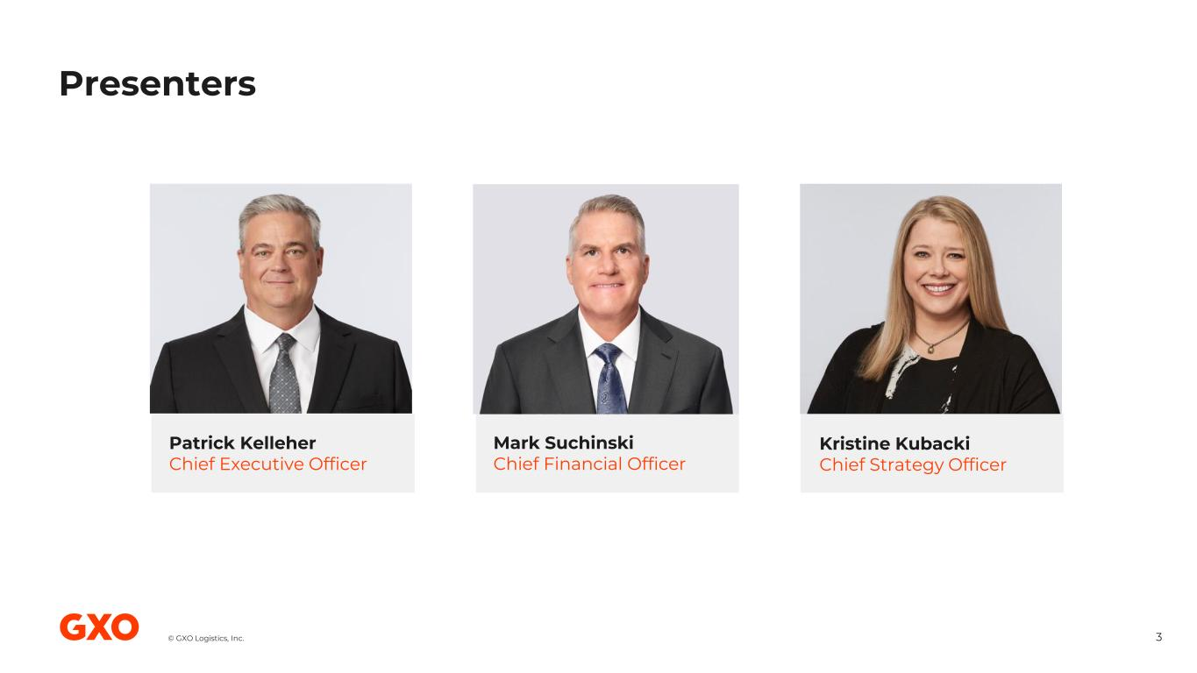
© GXO Logistics, Inc. Patrick Kelleher Chief Executive Officer Mark Suchinski Chief Financial Officer Kristine Kubacki Chief Strategy Officer Presenters 3

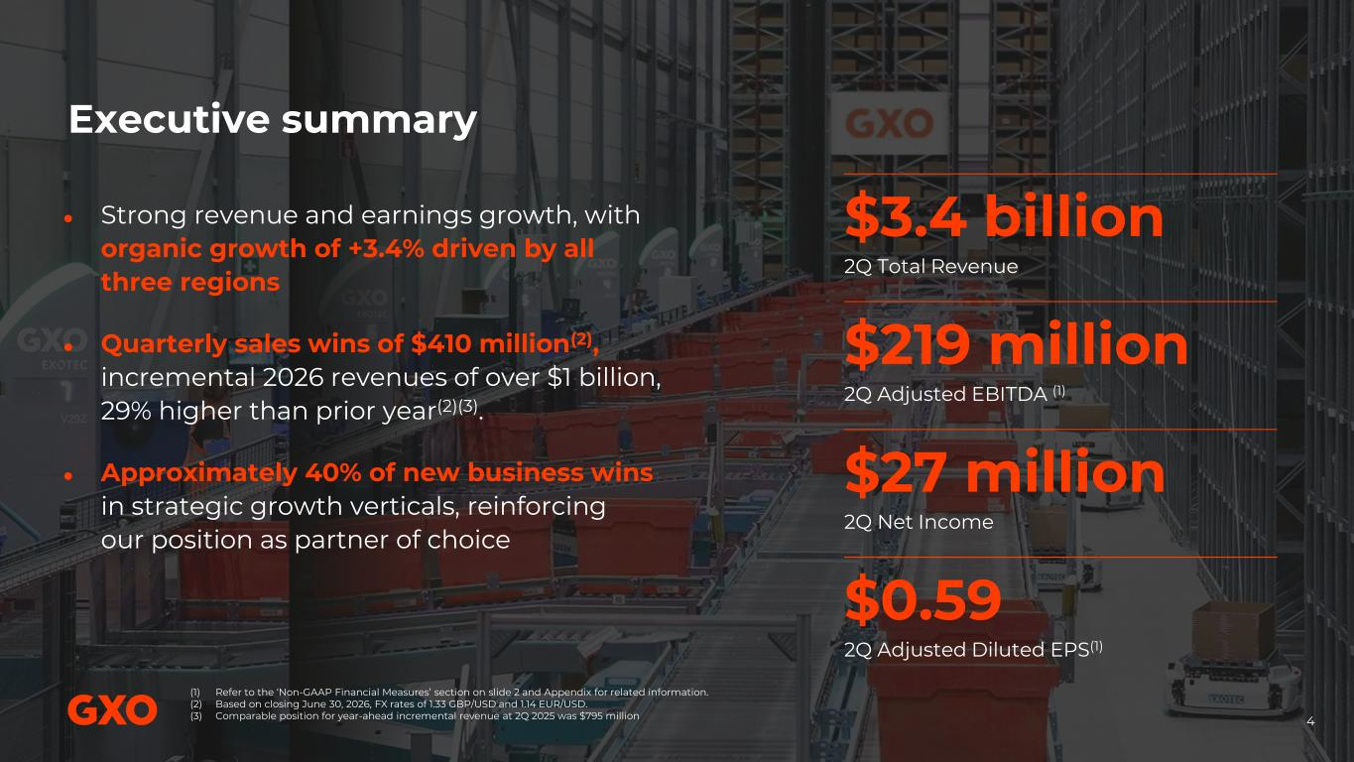
© GXO Logistics, Inc. Executive summary ● Strong revenue and earnings growth, with organic growth of +3.4% driven by all three regions ● Quarterly sales wins of $410 million(2), incremental 2026 revenues of over $1 billion, 29% higher than prior year(2)(3). ● Approximately 40% of new business wins in strategic growth verticals, reinforcing our position as partner of choice $3.4 billion 2Q Total Revenue $219 million 2Q Adjusted EBITDA (1) $27 million 2Q Net Income $0.59 2Q Adjusted Diluted EPS(1) (1) Refer to the ‘Non-GAAP Financial Measures’ section on slide 2 and Appendix for related information. (2) Based on closing June 30, 2026, FX rates of 1.33 GBP/USD and 1.14 EUR/USD. (3) Comparable position for year-ahead incremental revenue at 2Q 2025 was $795 million. 4

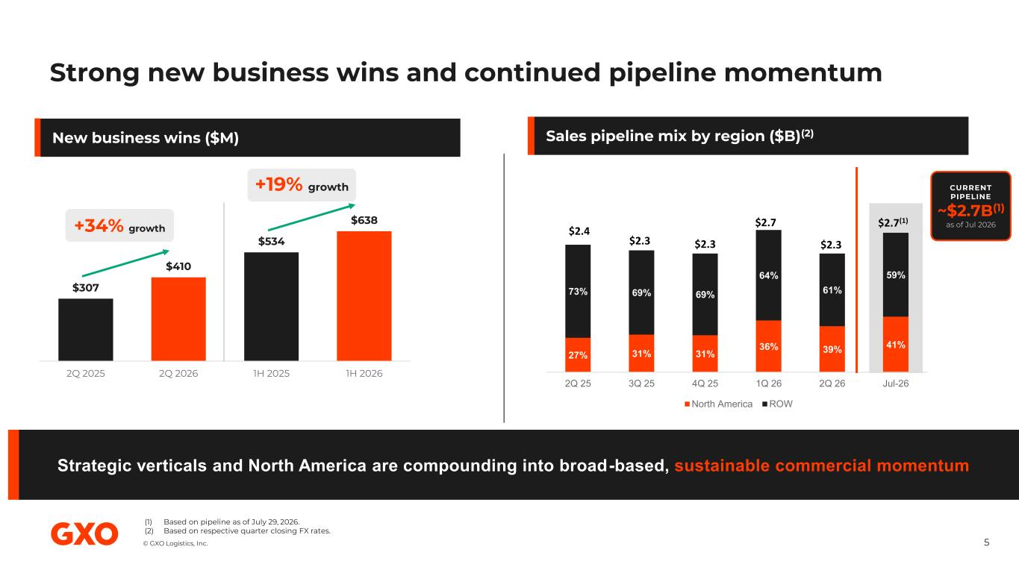
© GXO Logistics, Inc. 27% 31% 31% 36% 39% 41% 73% 69% 69% 64% 61% 59% 2Q 25 3Q 25 4Q 25 1Q 26 2Q 26 Jul-26 North America ROW $307 $410 $534 $638 2Q 2025 2Q 2026 1H 2025 1H 2026 Strong new business wins and continued pipeline momentum 5 Sales pipeline mix by region ($B)(2)New business wins ($M) Strategic verticals and North America are compounding into broad-based, sustainable commercial momentum $2.4 $2.3 $2.3 $2.7 $2.3 +34% growth +19% growth CURRENT PIPELINE ~$2.7B(1) $2.7(1) (1) Based on pipeline as of July 29, 2026. (2) Based on respective quarter closing FX rates.

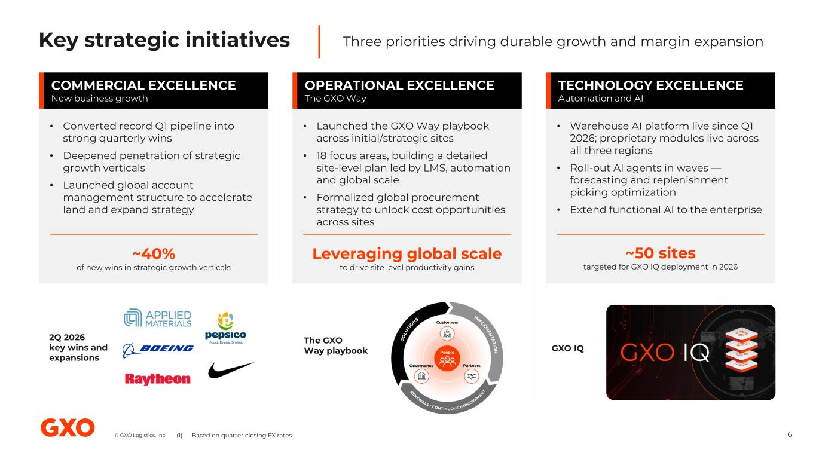
© GXO Logistics, Inc. Key strategic initiatives Three priorities driving durable growth and margin expansion COMMERCIAL EXCELLENCE New business growth OPERATIONAL EXCELLENCE The GXO Way TECHNOLOGY EXCELLENCE Automation and AI • Converted record Q1 pipeline into strong quarterly wins • Deepened penetration of strategic growth verticals • Launched global account management structure to accelerate land and expand strategy • Launched the GXO Way playbook across initial/strategic sites • 18 focus areas, building a detailed site-level plan led by LMS, automation and global scale • Formalized global procurement strategy to unlock cost opportunities across sites • Warehouse AI platform live since Q1 2026; proprietary modules live across all three regions • Roll-out AI agents in waves — forecasting and replenishment picking optimization • Extend functional AI to the enterprise ~40% of new wins in strategic growth verticals Leveraging global scale to drive site level productivity gains ~50 sites targeted for GXO IQ deployment in 2026 6 2Q 2026 key wins and expansions The GXO Way playbook GXO IQ (1) Based on quarter closing FX rates

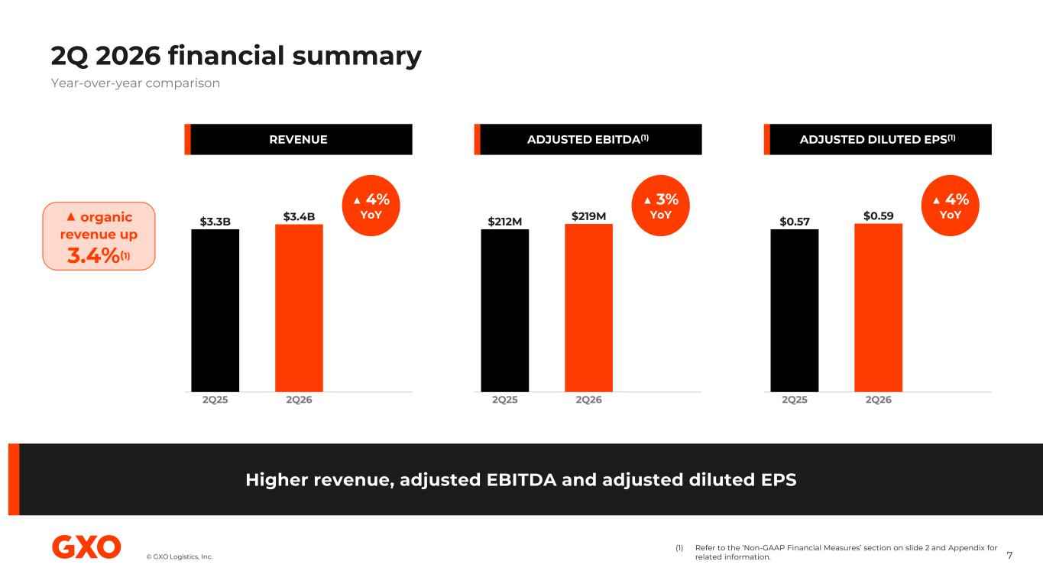
© GXO Logistics, Inc. 2Q 2026 financial summary 7 (1) Refer to the ‘Non-GAAP Financial Measures’ section on slide 2 and Appendix for related information. Higher revenue, adjusted EBITDA and adjusted diluted EPS Year-over-year comparison REVENUE $3.3B 2Q25 $3.4B 2Q26 ▲ 4% YoY▲ organic revenue up 3.4%(1) ADJUSTED EBITDA(1) $212M 2Q25 $219M 2Q26 ▲ 3% YoY ADJUSTED DILUTED EPS(1) $0.57 2Q25 $0.59 2Q26 ▲ 4% YoY

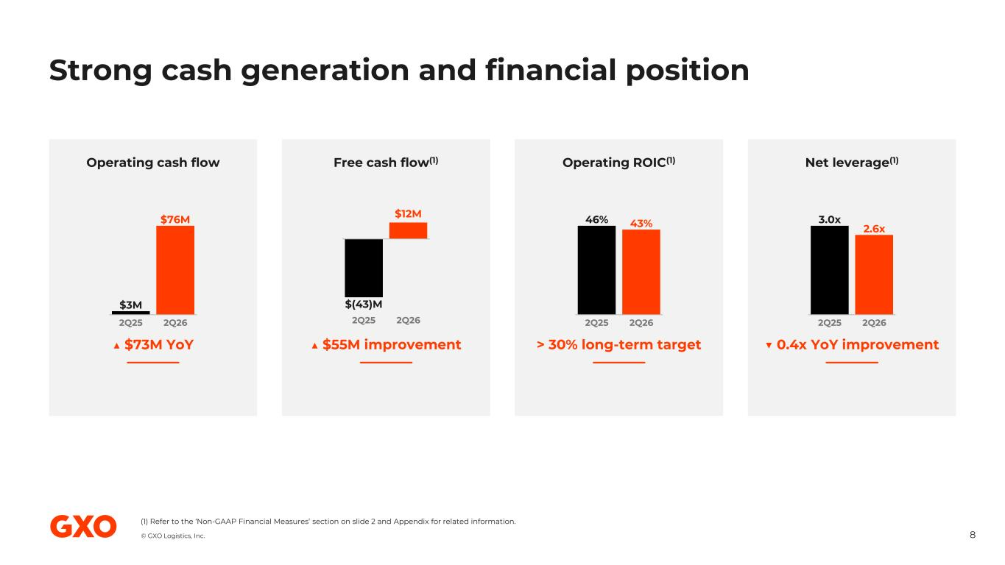
© GXO Logistics, Inc. Strong cash generation and financial position 8 (1) Refer to the ‘Non-GAAP Financial Measures’ section on slide 2 and Appendix for related information. Operating cash flow $3M $76M 2Q25 2Q26 ▲ $73M YoY Free cash flow(1) $(43)M $12M 2Q25 2Q26 ▲ $55M improvement Operating ROIC(1) 46% 43% 2Q25 2Q26 > 30% long-term target Net leverage(1) 3.0x 2.6x 2Q25 2Q26 ▼ 0.4x YoY improvement Solid financial position

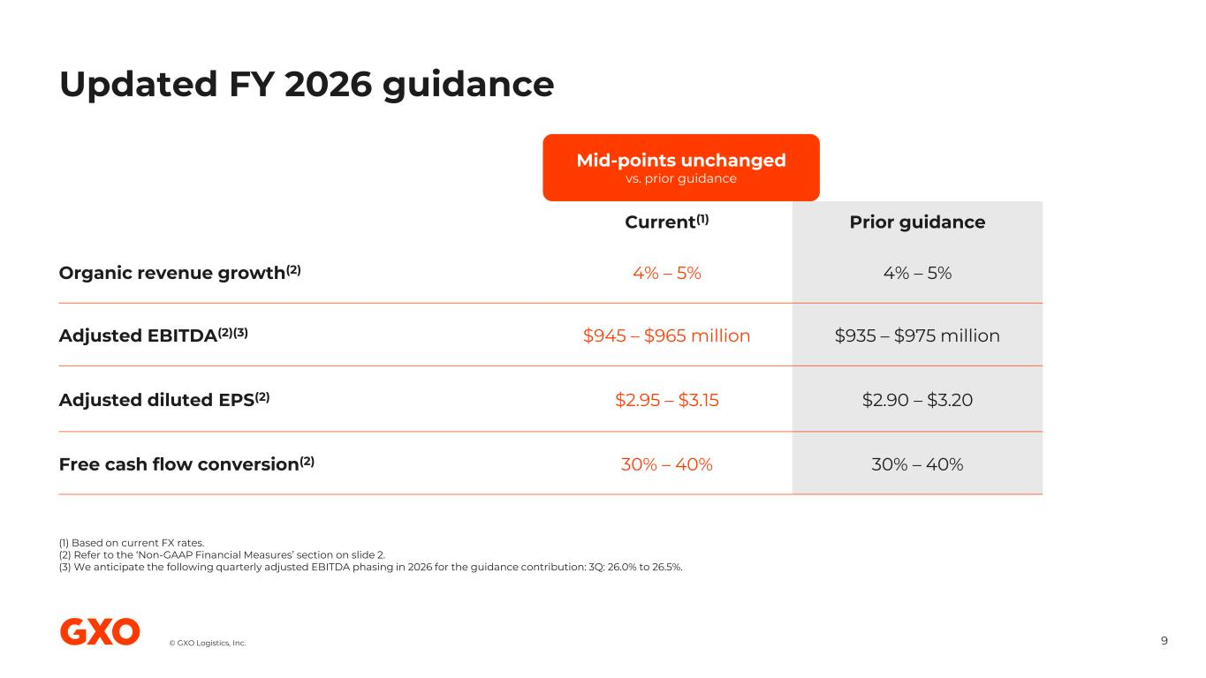
© GXO Logistics, Inc. Updated FY 2026 guidance 9 Prior guidanceCurrent(1) 4% – 5%4% – 5%Organic revenue growth(2) $935 – $975 million$945 – $965 millionAdjusted EBITDA(2)(3) $2.90 – $3.20$2.95 – $3.15Adjusted diluted EPS(2) 30% – 40%30% – 40% Free cash flow conversion(2) (1) Based on current FX rates. (2) Refer to the ‘Non-GAAP Financial Measures’ section on slide 2. (3) We anticipate the following quarterly adjusted EBITDA phasing in 2026 for the guidance contribution: 3Q: 26.0% to 26.5%. Mid-points unchanged vs. prior guidance

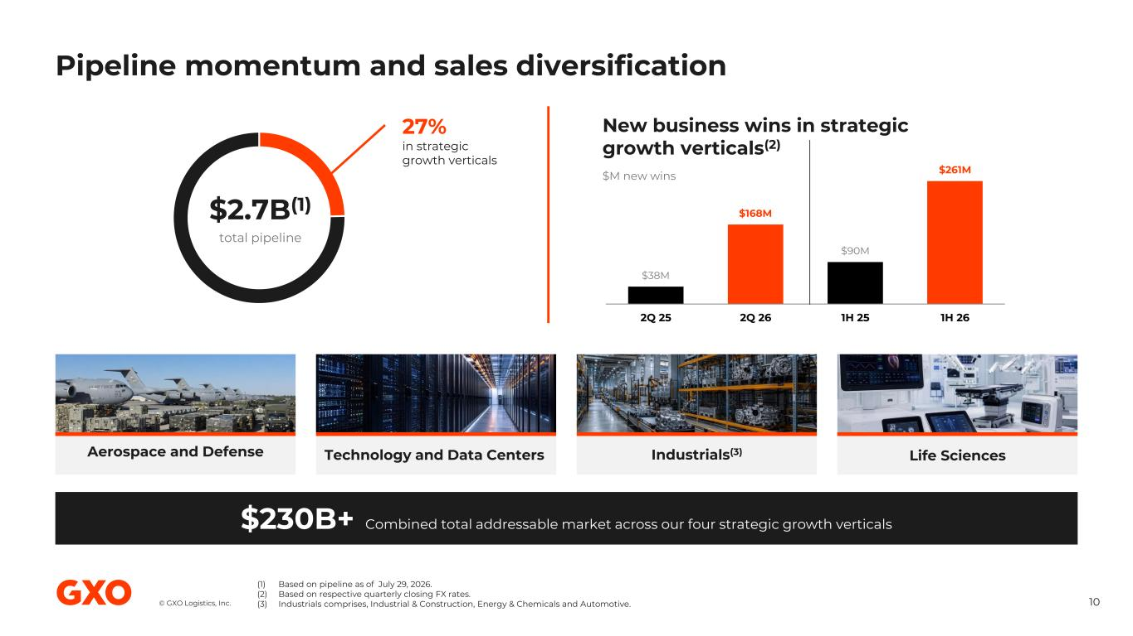
© GXO Logistics, Inc. Pipeline momentum and sales diversification 10 (1) Based on pipeline as of July 29, 2026. (2) Based on respective quarterly closing FX rates. (3) Industrials comprises, Industrial & Construction, Energy & Chemicals and Automotive. $2.7B(1) total pipeline 27% in strategic growth verticals $38M $168M $90M $261M 2Q 25 2Q 26 1H 25 1H 26 New business wins in strategic growth verticals(2) $M new wins Aerospace and Defense Technology and Data Centers Industrials(3) Life Sciences $230B+ Combined total addressable market across our four strategic growth verticals

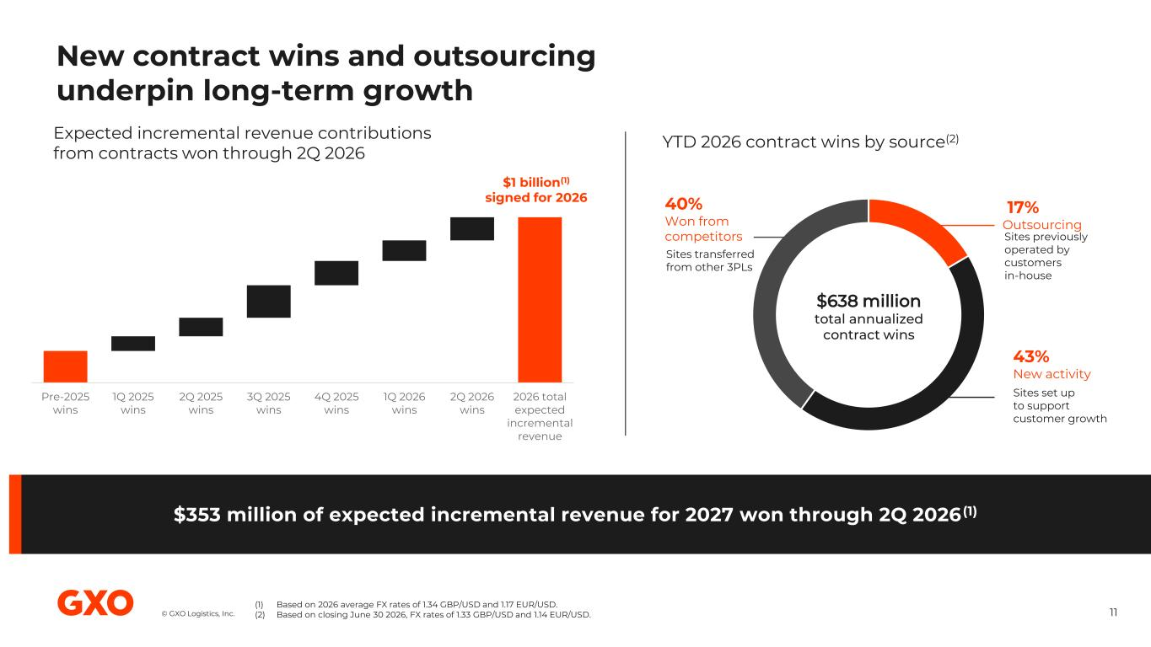
© GXO Logistics, Inc. New contract wins and outsourcing underpin long-term growth 11 Expected incremental revenue contributions from contracts won through 2Q 2026 YTD 2026 contract wins by source(2) Sites set up to support customer growth Sites previously operated by customers in-house 43% New activity 17% Outsourcing $1 billion(1) signed for 2026 (1) Based on 2026 average FX rates of 1.34 GBP/USD and 1.17 EUR/USD. (2) Based on closing June 30 2026, FX rates of 1.33 GBP/USD and 1.14 EUR/USD. $353 million of expected incremental revenue for 2027 won through 2Q 2026 (1) Sites transferred from other 3PLs 40% Won from competitors $638 million total annualized contract wins Pre-2025 wins 1Q 2025 wins 2Q 2025 wins 3Q 2025 wins 4Q 2025 wins 1Q 2026 wins 2Q 2026 wins 2026 total expected incremental revenue


Q&A © GXO Logistics, Inc.

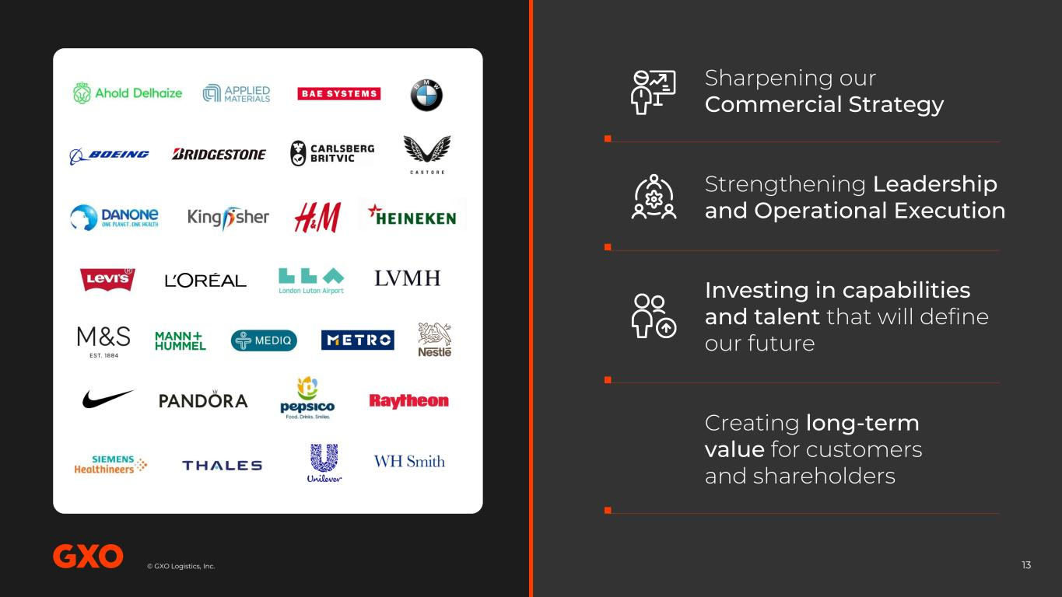
© GXO Logistics, Inc.© GXO Logistics, Inc. 13 Sharpening our Commercial Strategy Strengthening Leadership and Operational Execution Investing in capabilities and talent that will define our future Creating long-term value for customers and shareholders

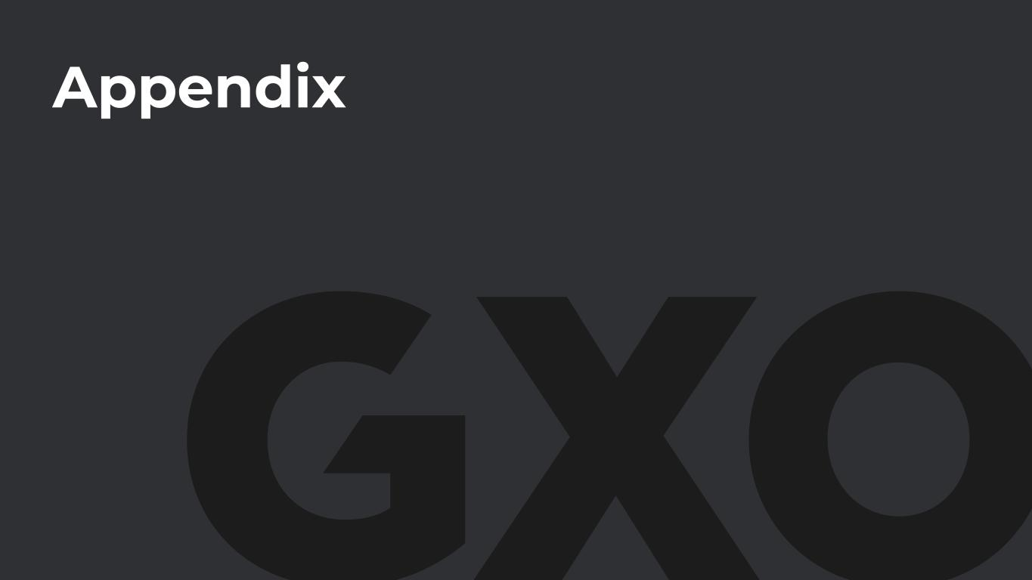
Appendix

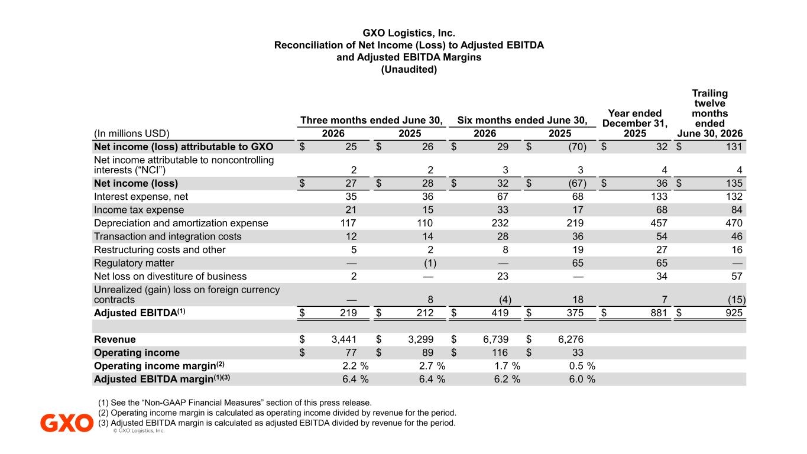
© GXO Logistics, Inc. Trailing twelve months ended June 30, 2026 Year ended December 31, 2025 Six months ended June 30, Three months ended June 30, 2025202620252026(In millions USD) $ 131$ 32$ (70)$ 29$ 26$ 25Net income (loss) attributable to GXO 443322 Net income attributable to noncontrolling interests (“NCI”) $ 135$ 36$ (67)$ 32$ 28$ 27Net income (loss) 13213368673635Interest expense, net 846817331521Income tax expense 470457219232110117Depreciation and amortization expense 465436281412Transaction and integration costs 162719825Restructuring costs and other —6565—(1)—Regulatory matter 5734—23—2Net loss on divestiture of business (15)718(4)8— Unrealized (gain) loss on foreign currency contracts $ 925$ 881$ 375$ 419$ 212$ 219Adjusted EBITDA(1) $ 6,276$ 6,739$ 3,299$ 3,441Revenue $ 33$ 116$ 89$ 77Operating income 0.5 %1.7 %2.7 %2.2 %Operating income margin(2) 6.0 %6.2 %6.4 %6.4 %Adjusted EBITDA margin(1)(3) GXO Logistics, Inc. Reconciliation of Net Income (Loss) to Adjusted EBITDA and Adjusted EBITDA Margins (Unaudited) (1) See the “Non-GAAP Financial Measures” section of this press release. (2) Operating income margin is calculated as operating income divided by revenue for the period. (3) Adjusted EBITDA margin is calculated as adjusted EBITDA divided by revenue for the period.

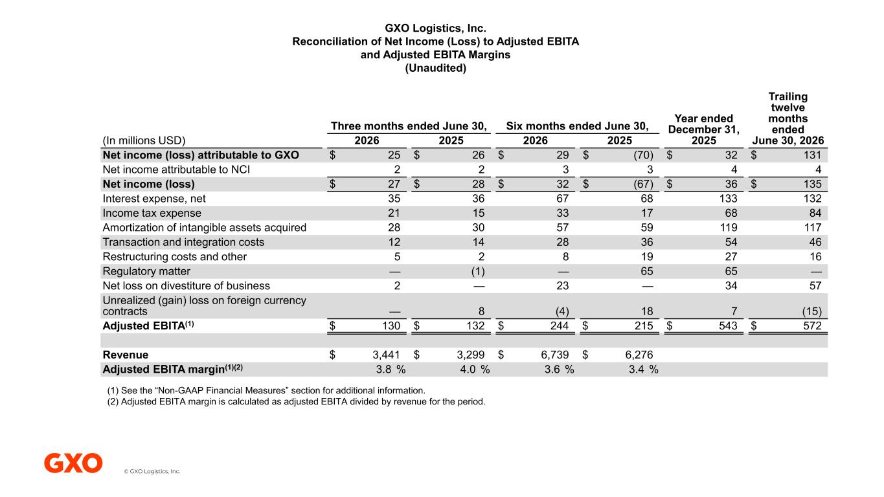
© GXO Logistics, Inc. GXO Logistics, Inc. Reconciliation of Net Income (Loss) to Adjusted EBITA and Adjusted EBITA Margins (Unaudited) Trailing twelve months ended June 30, 2026 Year ended December 31, 2025 Six months ended June 30, Three months ended June 30, 2025202620252026(In millions USD) $ 131$ 32$ (70)$ 29$ 26$ 25Net income (loss) attributable to GXO 443322Net income attributable to NCI $ 135$ 36$ (67)$ 32$ 28$ 27Net income (loss) 13213368673635Interest expense, net 846817331521Income tax expense 11711959573028Amortization of intangible assets acquired 465436281412Transaction and integration costs 162719825Restructuring costs and other —6565—(1)—Regulatory matter 5734—23—2Net loss on divestiture of business (15)718(4)8— Unrealized (gain) loss on foreign currency contracts $ 572$ 543$ 215$ 244$ 132$ 130Adjusted EBITA(1) $ 6,276$ 6,739$ 3,299$ 3,441Revenue 3.4 %3.6 %4.0 %3.8 %Adjusted EBITA margin(1)(2) (1) See the “Non-GAAP Financial Measures” section for additional information. (2) Adjusted EBITA margin is calculated as adjusted EBITA divided by revenue for the period.

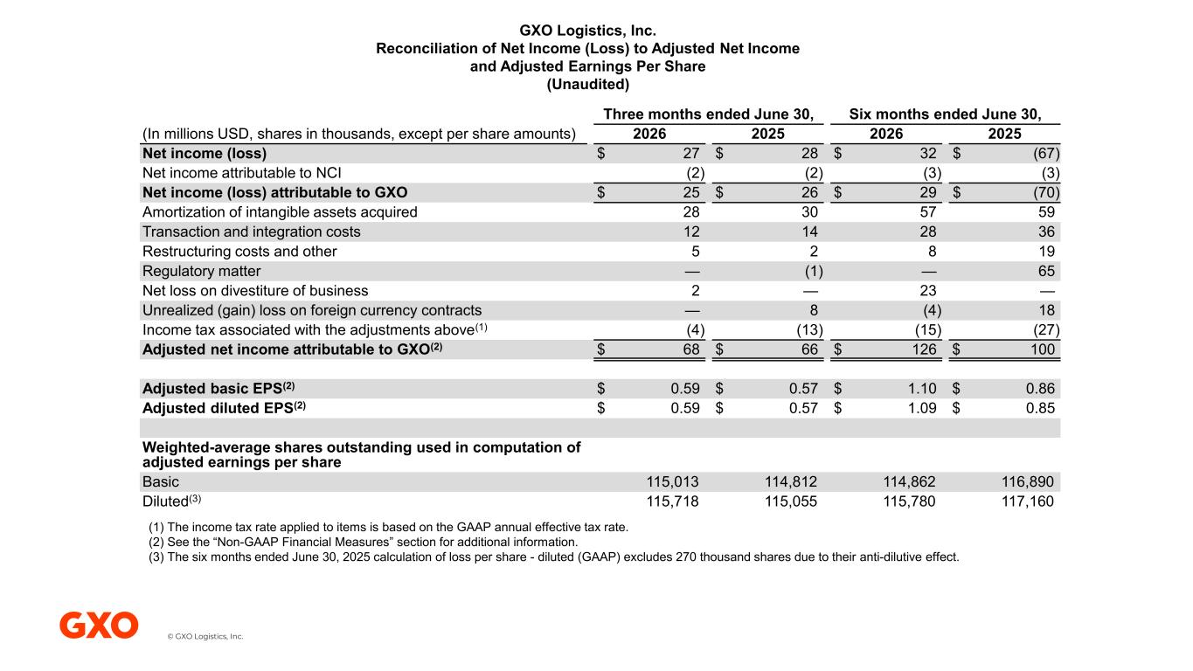
© GXO Logistics, Inc. GXO Logistics, Inc. Reconciliation of Net Income (Loss) to Adjusted Net Income and Adjusted Earnings Per Share (Unaudited) Six months ended June 30, Three months ended June 30, 2025202620252026(In millions USD, shares in thousands, except per share amounts) $ (67)$ 32$ 28$ 27Net income (loss) (3)(3)(2)(2)Net income attributable to NCI $ (70)$ 29$ 26$ 25Net income (loss) attributable to GXO 59573028Amortization of intangible assets acquired 36281412Transaction and integration costs 19825Restructuring costs and other 65—(1)—Regulatory matter —23—2Net loss on divestiture of business 18(4)8—Unrealized (gain) loss on foreign currency contracts (27)(15)(13)(4)Income tax associated with the adjustments above(1) $ 100$ 126$ 66$ 68Adjusted net income attributable to GXO(2) $ 0.86$ 1.10$ 0.57$ 0.59Adjusted basic EPS(2) $ 0.85$ 1.09$ 0.57$ 0.59Adjusted diluted EPS(2) Weighted-average shares outstanding used in computation of adjusted earnings per share 116,890114,862114,812115,013Basic 117,160115,780115,055115,718Diluted(3) (1) The income tax rate applied to items is based on the GAAP annual effective tax rate. (2) See the “Non-GAAP Financial Measures” section for additional information. (3) The six months ended June 30, 2025 calculation of loss per share - diluted (GAAP) excludes 270 thousand shares due to their anti-dilutive effect.

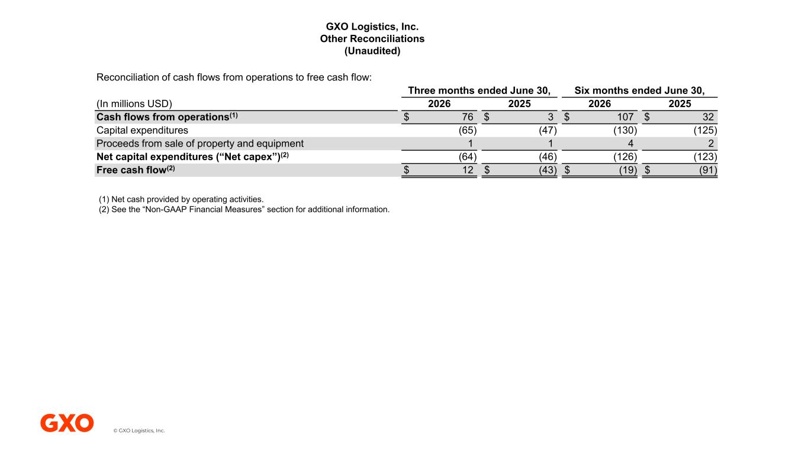
© GXO Logistics, Inc. GXO Logistics, Inc. Other Reconciliations (Unaudited) Reconciliation of cash flows from operations to free cash flow: Six months ended June 30, Three months ended June 30, 2025202620252026(In millions USD) $ 32$ 107$ 3$ 76Cash flows from operations(1) (125)(130)(47)(65)Capital expenditures 2411Proceeds from sale of property and equipment (123)(126)(46)(64)Net capital expenditures (“Net capex”)(2) $ (91)$ (19)$ (43)$ 12Free cash flow(2) (1) Net cash provided by operating activities. (2) See the “Non-GAAP Financial Measures” section for additional information.

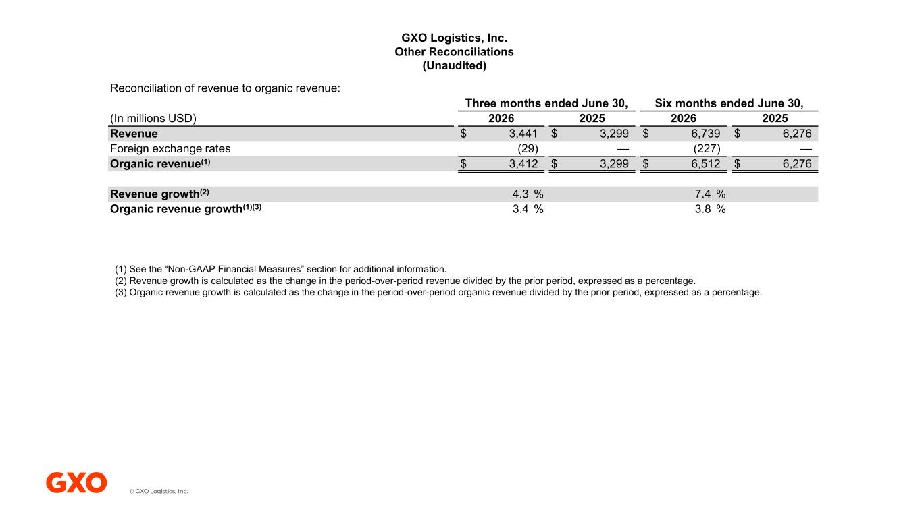
© GXO Logistics, Inc. GXO Logistics, Inc. Other Reconciliations (Unaudited) Reconciliation of revenue to organic revenue: Six months ended June 30, Three months ended June 30, 2025202620252026(In millions USD) $ 6,276$ 6,739$ 3,299$ 3,441Revenue —(227)—(29)Foreign exchange rates $ 6,276$ 6,512$ 3,299$ 3,412Organic revenue(1) 7.4 %4.3 %Revenue growth(2) 3.8 %3.4 %Organic revenue growth(1)(3) (1) See the “Non-GAAP Financial Measures” section for additional information. (2) Revenue growth is calculated as the change in the period-over-period revenue divided by the prior period, expressed as a percentage. (3) Organic revenue growth is calculated as the change in the period-over-period organic revenue divided by the prior period, expressed as a percentage.

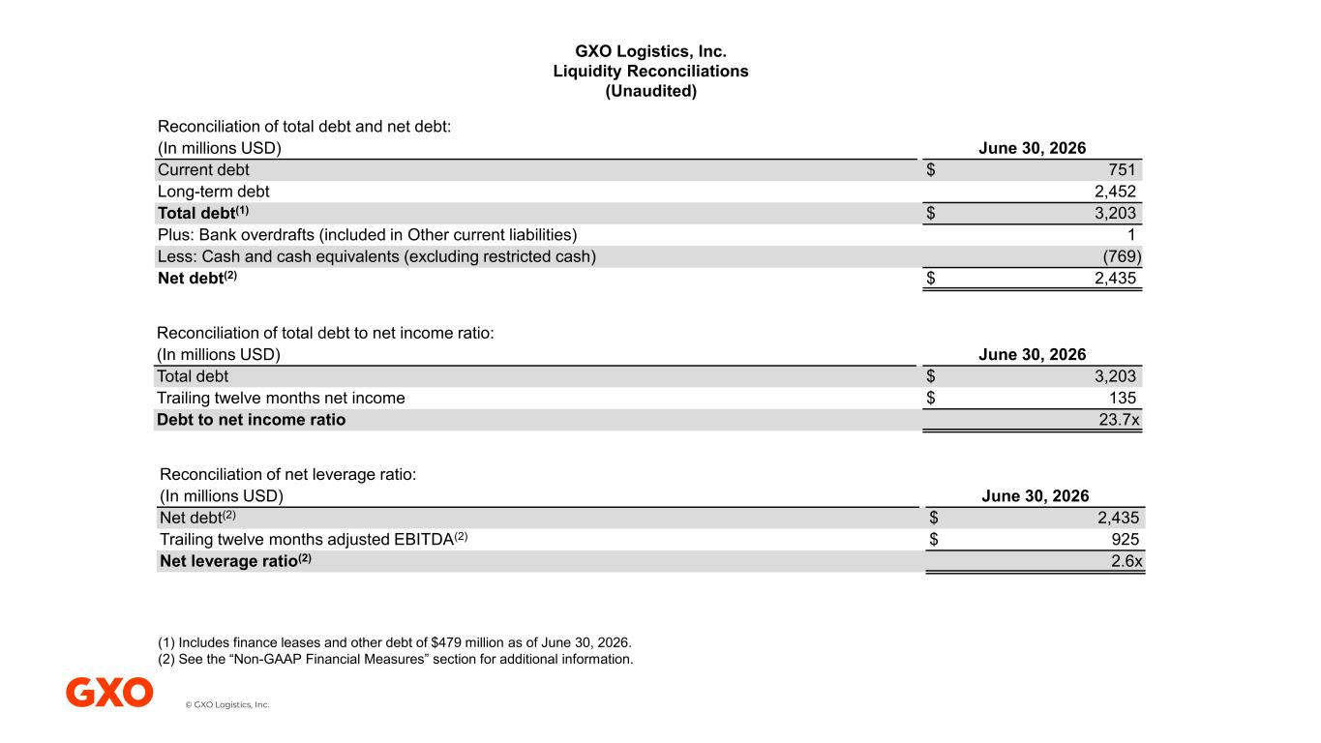
© GXO Logistics, Inc. GXO Logistics, Inc. Liquidity Reconciliations (Unaudited) Reconciliation of total debt and net debt: June 30, 2026(In millions USD) $ 751Current debt 2,452Long-term debt $ 3,203Total debt(1) 1Plus: Bank overdrafts (included in Other current liabilities) (769)Less: Cash and cash equivalents (excluding restricted cash) $ 2,435Net debt(2) Reconciliation of total debt to net income ratio: June 30, 2026(In millions USD) $ 3,203Total debt $ 135Trailing twelve months net income 23.7xDebt to net income ratio Reconciliation of net leverage ratio: June 30, 2026(In millions USD) $ 2,435Net debt(2) $ 925Trailing twelve months adjusted EBITDA(2) 2.6xNet leverage ratio(2) (1) Includes finance leases and other debt of $479 million as of June 30, 2026. (2) See the “Non-GAAP Financial Measures” section for additional information.

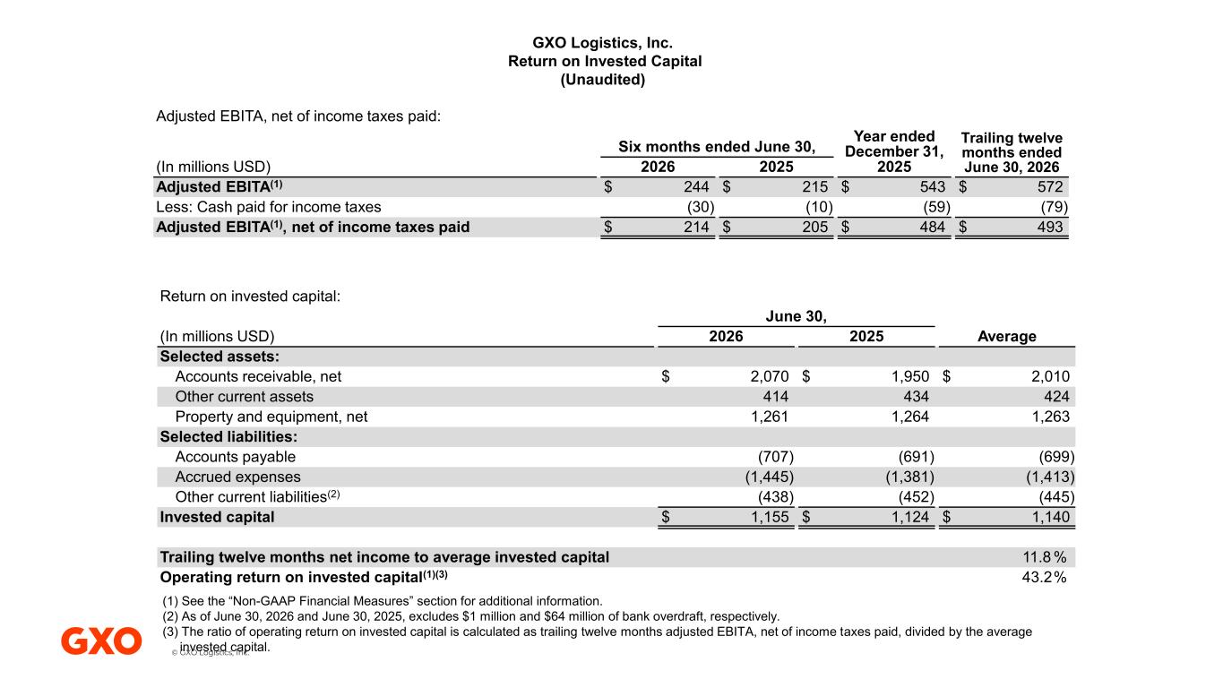
© GXO Logistics, Inc. Adjusted EBITA, net of income taxes paid: Trailing twelve months ended June 30, 2026 Year ended December 31, 2025 Six months ended June 30, 20252026(In millions USD) $ 572$ 543$ 215$ 244Adjusted EBITA(1) (79)(59)(10)(30)Less: Cash paid for income taxes $ 493$ 484$ 205$ 214Adjusted EBITA(1), net of income taxes paid Return on invested capital: June 30, Average20252026(In millions USD) Selected assets: $ 2,010$ 1,950$ 2,070Accounts receivable, net 424434414Other current assets 1,2631,2641,261Property and equipment, net Selected liabilities: (699)(691)(707)Accounts payable (1,413)(1,381)(1,445)Accrued expenses (445)(452)(438)Other current liabilities(2) $ 1,140$ 1,124$ 1,155Invested capital 11.8 %Trailing twelve months net income to average invested capital 43.2%Operating return on invested capital(1)(3) GXO Logistics, Inc. Return on Invested Capital (Unaudited) (1) See the “Non-GAAP Financial Measures” section for additional information. (2) As of June 30, 2026 and June 30, 2025, excludes $1 million and $64 million of bank overdraft, respectively. (3) The ratio of operating return on invested capital is calculated as trailing twelve months adjusted EBITA, net of income taxes paid, divided by the average invested capital.

