SEC Form 3
FORM 3 | UNITED STATES SECURITIES AND EXCHANGE COMMISSION  Washington, D.C. 20549  INITIAL STATEMENT OF BENEFICIAL OWNERSHIP OF SECURITIES  Filed pursuant to Section 16(a) of the Securities Exchange Act of 1934  or Section 30(h) of the Investment Company Act of 1940
  OMB APPROVAL
  OMB Number: | 3235-0104
  Estimated average burden
  hours per response: | 0.5
1. Name and Address of Reporting Person*  (Street) | 2. Date of Event Requiring Statement (Month/Day/Year)  09/14/2026 | 3. Issuer Name and Ticker or Trading Symbol  GXO Logistics, Inc. [ GXO ]  Foreign Trading Symbol
  Carvalho Christina
  (Last) | (First) | (Middle)
  C/O GXO LOGISTICS, INC.
  TWO AMERICAN LANE
  GREENWICH | CT | 06831
  (City) | (State) | (Zip)
 |  | 4. Relationship of Reporting Person(s) to Issuer  (Check all applicable) | 5. If Amendment, Date of Original Filed (Month/Day/Year)
   | Director |  | 10% Owner
   | Officer (give title below) |  | Other (specify below)
  Chief Accounting Officer
6. Individual or Joint/Group Filing (Check Applicable Line)
Form filed by One Reporting Person
Form filed by More than One Reporting Person

Table I - Non-Derivative Securities Beneficially Owned
1. Title of Security (Instr. 4) | 2. Amount of Securities Beneficially Owned (Instr. 4) | 3. Ownership Form: Direct (D) or Indirect (I) (Instr. 5) | 4. Nature of Indirect Beneficial Ownership (Instr. 5)
Table II - Derivative Securities Beneficially Owned
(e.g., puts, calls, warrants, options, convertible securities)
1. Title of Derivative Security (Instr. 4) | 2. Date Exercisable and Expiration Date (Month/Day/Year) |  | 3. Title and Amount of Securities Underlying Derivative Security (Instr. 4) |  | 4. Conversion or Exercise Price of Derivative Security | 5. Ownership Form: Direct (D) or Indirect (I) (Instr. 5) | 6. Nature of Indirect Beneficial Ownership (Instr. 5)
1. Title of Derivative Security (Instr. 4) | Date Exercisable | Expiration Date | Title | Amount or Number of Shares | 4. Conversion or Exercise Price of Derivative Security | 5. Ownership Form: Direct (D) or Indirect (I) (Instr. 5) | 6. Nature of Indirect Beneficial Ownership (Instr. 5)
Explanation of Responses:
Remarks:
At the time of becoming an officer of GXO Logistics, Inc. ("GXO"), the Reporting Person did not beneficially own, directly or indirectly, any securities of GXO. See Exhibit 24, Power of Attorney attached.
No securities are beneficially owned.
 | /s/ Karlis P. Kirsis, Attorney-in-Fact | 09/16/2026
 | ** Signature of Reporting Person | Date
Reminder: Report on a separate line for each class of securities beneficially owned directly or indirectly.
* If the form is filed by more than one reporting person, see Instruction 5 (b)(v).
** Intentional misstatements or omissions of facts constitute Federal Criminal Violations See 18 U.S.C. 1001 and 15 U.S.C. 78ff(a).
Note: File three copies of this Form, one of which must be manually signed. If space is insufficient, see Instruction 6 for procedure.
Persons who respond to the collection of information contained in this form are not required to respond unless the form displays a currently valid OMB Number.
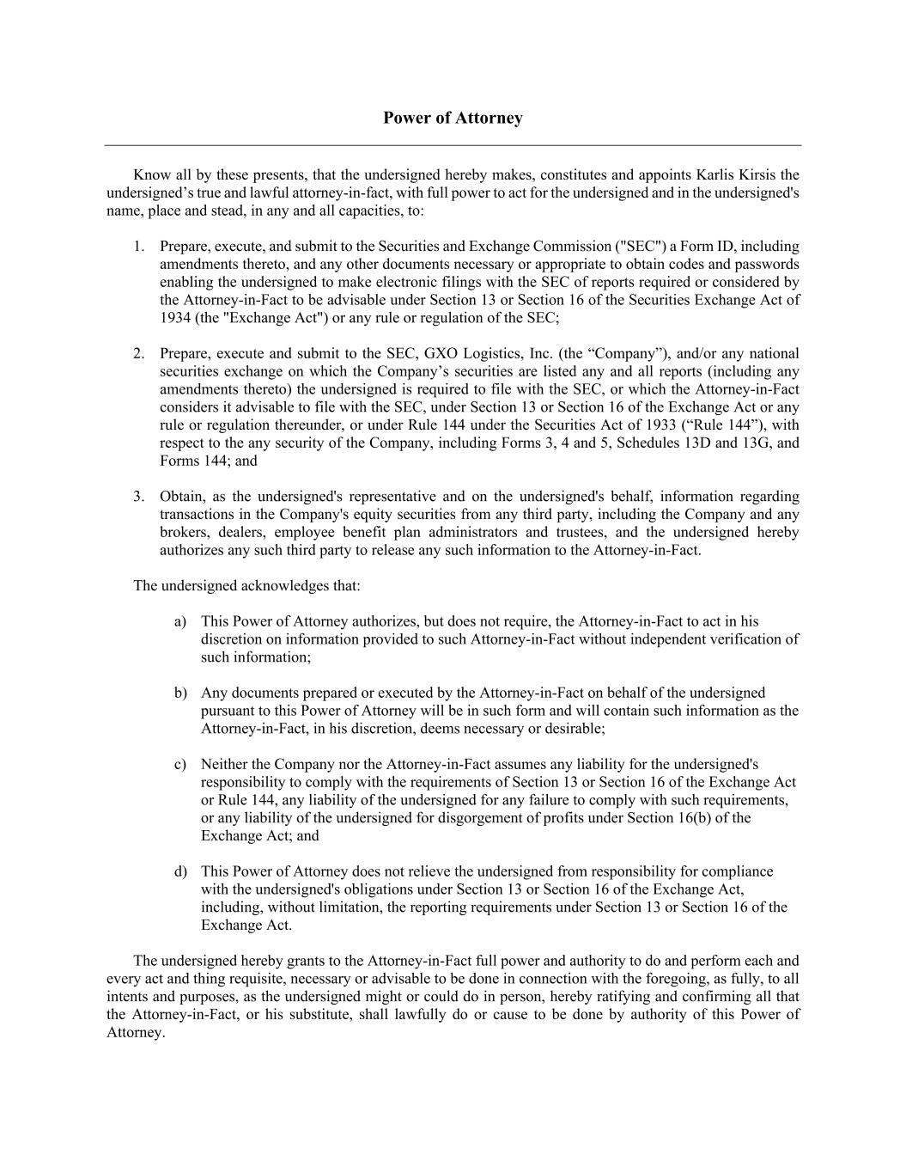
Power of Attorney Know all by these presents, that the undersigned hereby makes, constitutes and appoints Karlis Kirsis the undersigned’s true and lawful attorney-in-fact, with full power to act for the undersigned and in the undersigned's name, place and stead, in any and all capacities, to: 1. Prepare, execute, and submit to the Securities and Exchange Commission ("SEC") a Form ID, including amendments thereto, and any other documents necessary or appropriate to obtain codes and passwords enabling the undersigned to make electronic filings with the SEC of reports required or considered by the Attorney-in-Fact to be advisable under Section 13 or Section 16 of the Securities Exchange Act of 1934 (the "Exchange Act") or any rule or regulation of the SEC; 2. Prepare, execute and submit to the SEC, GXO Logistics, Inc. (the “Company”), and/or any national securities exchange on which the Company’s securities are listed any and all reports (including any amendments thereto) the undersigned is required to file with the SEC, or which the Attorney-in-Fact considers it advisable to file with the SEC, under Section 13 or Section 16 of the Exchange Act or any rule or regulation thereunder, or under Rule 144 under the Securities Act of 1933 (“Rule 144”), with respect to the any security of the Company, including Forms 3, 4 and 5, Schedules 13D and 13G, and Forms 144; and 3. Obtain, as the undersigned's representative and on the undersigned's behalf, information regarding transactions in the Company's equity securities from any third party, including the Company and any brokers, dealers, employee benefit plan administrators and trustees, and the undersigned hereby authorizes any such third party to release any such information to the Attorney-in-Fact. The undersigned acknowledges that: a) This Power of Attorney authorizes, but does not require, the Attorney-in-Fact to act in his discretion on information provided to such Attorney-in-Fact without independent verification of such information; b) Any documents prepared or executed by the Attorney-in-Fact on behalf of the undersigned pursuant to this Power of Attorney will be in such form and will contain such information as the Attorney-in-Fact, in his discretion, deems necessary or desirable; c) Neither the Company nor the Attorney-in-Fact assumes any liability for the undersigned's responsibility to comply with the requirements of Section 13 or Section 16 of the Exchange Act or Rule 144, any liability of the undersigned for any failure to comply with such requirements, or any liability of the undersigned for disgorgement of profits under Section 16(b) of the Exchange Act; and d) This Power of Attorney does not relieve the undersigned from responsibility for compliance with the undersigned's obligations under Section 13 or Section 16 of the Exchange Act, including, without limitation, the reporting requirements under Section 13 or Section 16 of the Exchange Act. The undersigned hereby grants to the Attorney-in-Fact full power and authority to do and perform each and every act and thing requisite, necessary or advisable to be done in connection with the foregoing, as fully, to all intents and purposes, as the undersigned might or could do in person, hereby ratifying and confirming all that the Attorney-in-Fact, or his substitute, shall lawfully do or cause to be done by authority of this Power of Attorney.

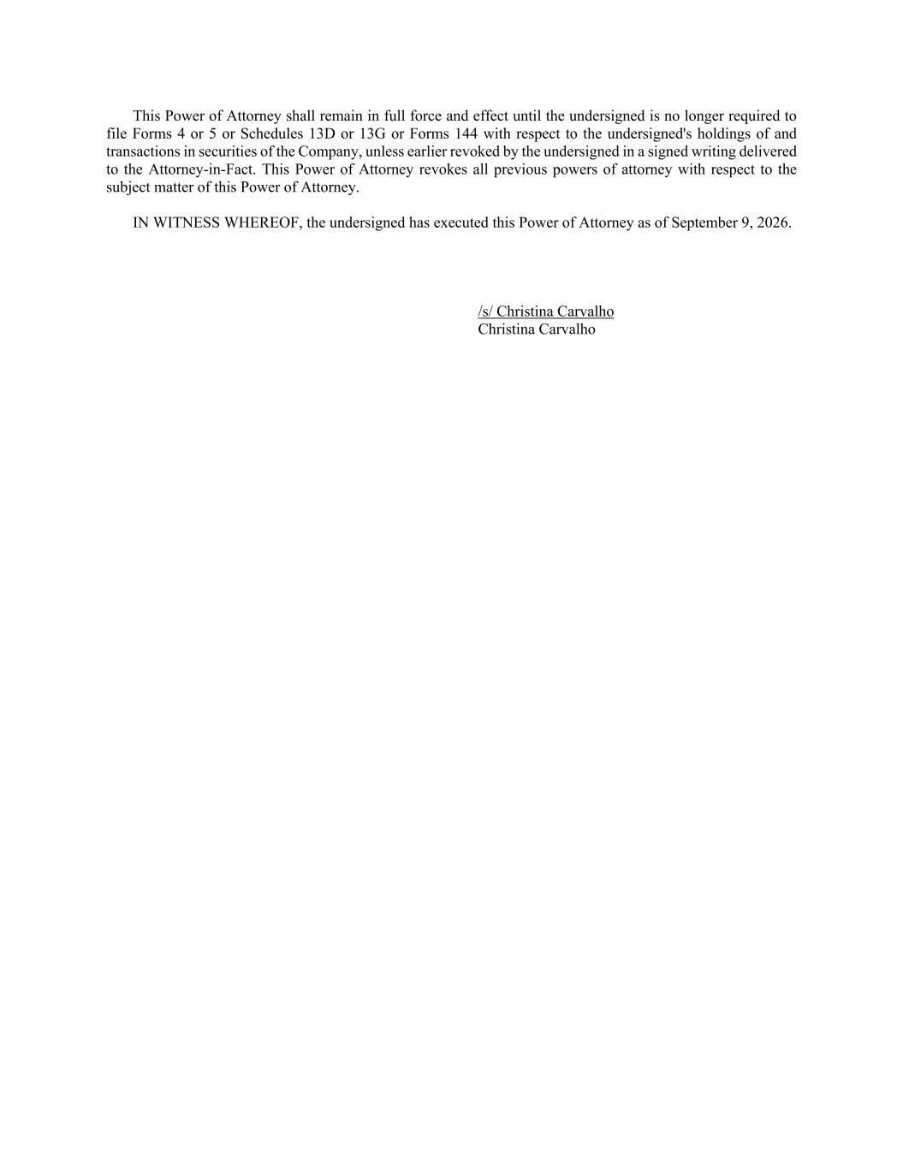
This Power of Attorney shall remain in full force and effect until the undersigned is no longer required to file Forms 4 or 5 or Schedules 13D or 13G or Forms 144 with respect to the undersigned's holdings of and transactions in securities of the Company, unless earlier revoked by the undersigned in a signed writing delivered to the Attorney-in-Fact. This Power of Attorney revokes all previous powers of attorney with respect to the subject matter of this Power of Attorney. IN WITNESS WHEREOF, the undersigned has executed this Power of Attorney as of September 9, 2026. /s/ Christina Carvalho Christina Carvalho

