UNITED STATES

SECURITIES AND EXCHANGE COMMISSION

Washington, D.C. 20549

___________________________________

FORM 10-K

___________________________________

(Mark One)

- ANNUAL REPORT PURSUANT TO SECTION 13 OR 15(d) OF THE SECURITIES EXCHANGE ACT OF 1934 For the fiscal year ended December 31, 2024

OR
- TRANSITION REPORT PURSUANT TO SECTION 13 OR 15(d) OF THE SECURITIES EXCHANGE ACT OF 1934

For the transition period from to

Commission file number 001-40470

___________________________________


GXO Logistics, Inc.

(Exact name of registrant as specified in its charter)

___________________________________

 | Delaware |  |  |  |  |  | 86-2098312
 | (State or other jurisdiction of incorporation or organization) |  |  |  |  |  | (I.R.S. Employer Identification No.)
 | Two American Lane |  |  |  |  |  | 06831
 | Greenwich, Connecticut |  |  |  |  |  | 06831
 | (Address of Principal Executive Offices) |  |  |  |  |  | (Zip Code)
 |  | (203) 489-1287
 |  | Registrant’s telephone number, including area code
 |  | ___________________________________
Securities registered pursuant to Section 12(b) of the Act:
 | Title of each class |  |  | Trading Symbol(s) |  |  | Name of each exchange on which registered
 | Common stock, par value $0.01 per share |  |  | GXO |  |  | New York Stock Exchange

Securities registered pursuant to section 12(g) of the Act: None

Indicate by check mark if the registrant is a well-known seasoned issuer, as defined in Rule 405 of the Securities Act. Yes x No o

Indicate by check mark if the registrant is not required to file reports pursuant to Section 13 or Section 15(d) of the Act. Yes o No x

Indicate by check mark whether the registrant: (1) has filed all reports required to be filed by Section 13 or 15(d) of the Securities Exchange Act of 1934 during the preceding 12 months (or for such shorter period that the registrant was required to file such reports), and (2) has been subject to such filing requirements for the past 90 days. Yes x No o

Indicate by check mark whether the registrant has submitted electronically every Interactive Data File required to be submitted pursuant to Rule 405 of Regulation S-T (§232.405 of this chapter) during the preceding 12 months (or for such shorter period that the registrant was required to submit such files). Yes x No o

Indicate by check mark whether the registrant is a large accelerated filer, an accelerated filer, a non-accelerated filer, a smaller reporting company, or an emerging growth company. See the definitions of “large accelerated filer,” “accelerated filer,” “smaller reporting company,” and “emerging growth company” in Rule 12b-2 of the Exchange Act.

Large accelerated filer | Accelerated filer
x | o
Non-accelerated filer | Smaller reporting company
o | o
 | Emerging growth company
 | o

If an emerging growth company, indicate by check mark if the registrant has elected not to use the extended transition period for complying with any new or revised financial accounting standards provided pursuant to Section 13(a) of the Exchange Act. o

Indicate by check mark whether the registrant has filed a report on and attestation to its management’s assessment of the effectiveness of its internal control over financial reporting under Section 404(b) of the Sarbanes-Oxley Act (15 U.S.C. 7262(b)) by the registered public accounting firm that prepared or issued its audit report. x

If securities are registered pursuant to Section 12(b) of the Act, indicate by check mark whether the financial statements of the registrant included in the filing reflect the correction of an error to previously issued financial statements. o

Indicate by check mark whether any of those error corrections are restatements that required a recovery analysis of incentive-based compensation received by any of the registrant’s executive officers during the relevant recovery period pursuant to §240.10D-1(b). o

Indicate by check mark whether the registrant is a shell company (as defined in Rule 12b-2 of the Act). Yes ☐ No x

The aggregate market value of the registrant’s common stock held by non-affiliates of the registrant was $5.9 billion as of June 28, 2024 (the last business day of the registrant’s most recently completed second fiscal quarter), based upon the closing price of the common stock on that date.

As of February 13, 2025, there were 119,518,035 shares of the registrant’s common stock, par value $0.01 per share, outstanding.

DOCUMENTS INCORPORATED BY REFERENCE

Specified portions of the registrant’s proxy statement, which will be filed with the Securities and Exchange Commission pursuant to Regulation 14A in connection with the registrant’s 2025 Annual Meeting of Stockholders (the “Proxy Statement”), are incorporated by reference into Part III of this Annual Report on Form 10-K. Except with respect to information specifically incorporated by reference in this Annual Report, the Proxy Statement is not deemed to be filed as part hereof.

 |  |  |  |  |  |  |  |  |  |  |  |  |  |  |  |  |  |  |  | GXO Logistics, Inc.
 |  |  |  |  |  |  |  |  |  |  |  |  |  |  |  |  |  |  |  |  | Form 10-K
 |  |  |  |  |  |  |  |  |  |  |  |  |  |  |  |  |  | For the Fiscal Year Ended December 31, 2024
 |  |  |  |  |  |  |  |  |  |  |  |  |  |  |  |  |  |  |  | Table of Contents |  |  |  |  | Page
 | Part I
 |  |  |  | Item 1. Business |  |  |  |  |  |  |  |  |  |  |  |  |  |  |  |  |  |  |  |  | 1
 |  |  |  | Item 1A. Risk Factors |  |  |  |  |  |  |  |  |  |  |  |  |  |  |  |  |  |  |  |  | 6
 |  |  |  | Item 1B. Unresolved Staff Comments |  |  |  |  |  |  |  |  |  |  |  |  |  |  |  |  |  |  |  |  | 16
 |  |  |  | Item 1C. Cybersecurity |  |  |  |  |  |  |  |  |  |  |  |  |  |  |  |  |  |  |  |  | 16
 |  |  |  | Item 2. Properties |  |  |  |  |  |  |  |  |  |  |  |  |  |  |  |  |  |  |  |  | 18
 |  |  |  | Item 3. Legal Proceedings |  |  |  |  |  |  |  |  |  |  |  |  |  |  |  |  |  |  |  |  | 18
 |  |  |  | Item 4. Mine Safety Disclosures |  |  |  |  |  |  |  |  |  |  |  |  |  |  |  |  |  |  |  |  | 18
 | Part II
 |  |  |  | Item 5. Market for Registrant’s Common Equity, Related Stockholder Matters and Issuer Purchases of Equity Securities |  |  |  |  |  |  |  |  |  |  |  |  |  |  |  |  |  |  |  |  | 19
 |  |  |  | Item 6. [Reserved] |  |  |  |  |  |  |  |  |  |  |  |  |  |  |  |  |  |  |  |  | 20
 |  |  |  | Item 7. Management’s Discussion and Analysis of Financial Condition and Results of Operations |  |  |  |  |  |  |  |  |  |  |  |  |  |  |  |  |  |  |  |  | 20
 |  |  |  | Item 7A. Quantitative and Qualitative Disclosures about Market Risk |  |  |  |  |  |  |  |  |  |  |  |  |  |  |  |  |  |  |  |  | 27
 |  |  |  | Item 8. Financial Statements and Supplementary Data |  |  |  |  |  |  |  |  |  |  |  |  |  |  |  |  |  |  |  |  | 28
 |  |  |  | Item 9. Changes in and Disagreements with Accountants on Accounting and Financial Disclosure |  |  |  |  |  |  |  |  |  |  |  |  |  |  |  |  |  |  |  |  | 68
 |  |  |  | Item 9A. Controls and Procedures |  |  |  |  |  |  |  |  |  |  |  |  |  |  |  |  |  |  |  |  | 68
 |  |  |  | Item 9B. Other Information |  |  |  |  |  |  |  |  |  |  |  |  |  |  |  |  |  |  |  |  | 69
 |  |  |  | Item 9C. Disclosure Regarding Foreign Jurisdictions that Prevent Inspections |  |  |  |  |  |  |  |  |  |  |  |  |  |  |  |  |  |  |  |  | 69
 | Part III
 |  |  |  | Item 10. Directors, Executive Officers and Corporate Governance |  |  |  |  |  |  |  |  |  |  |  |  |  |  |  |  |  |  |  |  | 70
 |  |  |  | Item 11. Executive Compensation |  |  |  |  |  |  |  |  |  |  |  |  |  |  |  |  |  |  |  |  | 70
 |  |  |  | Item 12. Security Ownership of Certain Beneficial Owners and Management and Related Stockholder Matters |  |  |  |  |  |  |  |  |  |  |  |  |  |  |  |  |  |  |  |  | 70
 |  |  |  | Item 13. Certain Relationships and Related Transactions, and Director Independence |  |  |  |  |  |  |  |  |  |  |  |  |  |  |  |  |  |  |  |  | 70
 |  |  |  | Item 14. Principal Accountant Fees and Services |  |  |  |  |  |  |  |  |  |  |  |  |  |  |  |  |  |  |  |  | 70
 | Part IV
 |  |  |  | Item 15. Exhibits and Financial Statement Schedules |  |  |  |  |  |  |  |  |  |  |  |  |  |  |  |  |  |  |  |  | 71
 |  |  |  | Item 16. Form 10-K Summary |  |  |  |  |  |  |  |  |  |  |  |  |  |  |  |  |  |  |  |  | 74
 |  |  |  | Signatures |  |  |  |  |  |  |  |  |  |  |  |  |  |  |  |  |  |  |  |  | 75

Cautionary Statement Regarding Forward-Looking Statements

This Annual Report on Form 10-K (“Annual Report”) and other written reports and oral statements we make from time to time contain forward-looking statements within the meaning of Section 27A of the Securities Act of 1933, as amended (the “Securities Act”), and Section 21E of the Securities Exchange Act of 1934, as amended (the “Exchange Act”). All statements other than statements of historical fact are, or may be deemed to be, forward-looking statements. In some cases, forward-looking statements can be identified by the use of forward-looking terms such as “anticipate,” “estimate,” “believe,” “continue,” “could,” “intend,” “may,” “plan,” “potential,” “predict,” “should,” “will,” “expect,” “objective,” “projection,” “forecast,” “goal,” “guidance,” “outlook,” “effort,” “target,” “trajectory” or the negative of these terms or other comparable terms. However, the absence of these words does not mean that the statements are not forward-looking. These forward-looking statements are based on certain assumptions and analyses made by the Company in light of its experience and its perception of historical trends, current conditions and expected future developments, as well as other factors it believes are appropriate in the circumstances. These forward-looking statements are subject to known and unknown risks, uncertainties and assumptions that may cause actual results, levels of activity, performance or achievements to be materially different from any future results, levels of activity, performance or achievements expressed or implied by such forward-looking statements. Factors that might cause or contribute to a material difference include those discussed below and the risks discussed in the Company’s other filings with the Securities and Exchange Commission (the “SEC”). All forward-looking statements set forth in this Annual Report are qualified by these cautionary statements, and there can be no assurance that the results or developments anticipated by the Company will be realized or, even if substantially realized, that they will have the expected consequence to or effects on the Company or its business or operations.

The following discussion should be read in conjunction with the Company’s audited Consolidated Financial Statements and corresponding notes thereto included elsewhere in this Annual Report. Forward-looking statements set forth in this Annual Report speak only as of the date hereof, and we do not undertake any obligation to update forward-looking statements to reflect subsequent events or circumstances, changes in expectations or the occurrence of unanticipated events, except as required by law.

Part I

Item 1. Business.

Company Overview

GXO Logistics, Inc., together with its subsidiaries (“GXO,” the “Company,” “our” or “we”), is the largest pure-play contract logistics provider in the world and a foremost innovator in the industry. We provide our customers with high-value-added warehousing and distribution, order fulfillment, e-commerce, reverse logistics and other supply chain services differentiated by our ability to deliver technology-enabled, customized solutions at scale.

As of December 31, 2024, our approximately 152,000 team members operated in 1,030 facilities worldwide totaling approximately 218 million square feet of space, primarily on behalf of large corporations that have outsourced their warehousing, distribution and other related activities to us.

Our revenue is diversified among over one thousand customers, including many multinational corporations, across numerous verticals. Our customers rely on us to move their goods, with high efficiency, through their supply chains — from the moment goods arrive at our warehouses through fulfillment and distribution, and the management of returned products. Our customer base includes many blue-chip leaders in sectors that demonstrate high growth and/or durable demand, with significant growth potential through customer outsourcing of logistics services.

GXO’s common stock, par value of $0.01 per share, began trading on the New York Stock Exchange under the ticker symbol “GXO” on August 2, 2021. GXO was incorporated as a Delaware corporation in February 2021.

On April 29, 2024, we completed the acquisition of Wincanton plc (“Wincanton”), a logistics company based in Chippenham, United Kingdom (the “Wincanton Acquisition”). Wincanton is a logistics provider specializing in warehousing and transportation solutions in the U.K. and Ireland. Wincanton services industries in grocery, retail and manufacturing, consumer goods, e-commerce, healthcare, defense, industrial, and energy. The Wincanton Acquisition is subject to a review by the Competition and Markets Authority (the “CMA”) in the U.K. On November 14, 2024, the CMA referred the completed acquisition by GXO Logistics, Inc. of Wincanton plc for an in-depth investigation (“Phase 2”) with a statutory deadline of April 30, 2025. See Item 8 of Part II, “Financial Statements and Supplementary Data — Note — 4 Acquisitions” to the Consolidated Financial Statements for additional information.

Our Strategy

We design and operate the most advanced warehouse solutions in the world. Our strategy is to help our customers manage their warehouse needs for optimal efficiency, using our network of people, technology and other physical assets. We deliver value to customers in the form of technological innovations, process efficiencies, cost efficiencies and reliable outcomes. Our services are highly responsive to customer goals, such as increasing visibility in the supply chain, decreasing fulfillment times and mitigating environmental impacts, while being proactive in identifying potential improvements.

GXO creates short- and long-term value for customers and shareholders through our unique combination of technology, scale and expertise. Our strategy addresses growth and optimization by focusing on core verticals that demonstrate enduring demand over time and where we already have a deep presence. We expect to attract new customers and expand the services we provide to existing customers through new projects, thus earning more of their logistics spend. We integrate best practices to drive productivity, with a focus on automation and other levers of profitable growth.

To aid in executing our strategy, we have instilled a culture that focuses on delivering mutually beneficial results for our customers and our company with the highest legal and ethical standards and clear policies and practices to support compliance throughout our organization.

1

Technology and Intellectual Property

Contract logistics is becoming more and more complex, as changing consumer expectations and preferences continue to drive a need for faster delivery times, higher levels of returned inventory and better visibility throughout the supply chain. Traditional warehousing solutions are no longer sufficient to fill these needs. The industry needs scaled technology players, like GXO, to deliver these complex solutions.

Technology is a core competitive advantage for GXO and fundamental to how we win and retain business. Technology enables us to add value to our customers’ end-to-end operations in terms of cost, efficiency, accuracy and environmental impact. Investments in cutting-edge technology are a major growth driver for our business.

Our highly scalable warehouse management platform is built on the cloud to speed the deployment of new ways to increase efficiency and leverage our footprint. In a relatively short time, we can implement innovations across multiple geographies or take an innovation developed for one vertical and apply it to other verticals to enhance the value we offer our customers.

To date, the most significant impacts of our proprietary technology are in three areas: labor and inventory management productivity, intelligent warehouse automation and predictive analytics, all of which are integrated through our proprietary warehouse management platform.

Labor and Inventory Management

Our productivity is driven by our comprehensive suite of intelligent tools and analytics designed to optimize labor and inventory management. This technology incorporates dynamic data science, predictive analytics and machine learning to aid decision-making. Our site managers use these tools to improve productivity in site-specific ways in a safe, disciplined and cost-effective manner.

Intelligent Warehouse Automation

Our intelligent warehouse automation includes deployments of autonomous robots and collaborative robots (“cobots”), automated sortation systems, automated guided vehicles, goods-to-person systems and wearable devices — these are all effective ways to deliver critical improvements in speed, accuracy and productivity. Importantly, automation also enhances safety and the overall quality of employment. Our warehouse management system creates a synchronized environment across automation platforms to control these technologies holistically, providing an integrated solution.

We have found that autonomous goods-to-person systems and cobots, which assist workers with the inventory picking process, can improve labor productivity. Stationary robot arms can repeat demanding tasks with greater precision than is possible manually. Robots are particularly valuable in markets with labor shortages and where wage inflation can erode customer margins.

Other technologies that differentiate our logistics environments are our proprietary warehouse module for order management, which gives customers deep visibility into fulfillment flows, and our analytics dashboard, which gives customers valuable business intelligence to manage their supply chains. Our connection management software module facilitates integration with SAP, Oracle and other external systems, enabling our customers to get the maximum benefit from our technology.

Predictive Analytics

Our predictive analytics add significant value for customers, particularly in e-commerce and omnichannel retail, where seasonality drives high volumes through outbound and inbound logistics processes. For example, up to 30% of consumer goods bought online are returned, and this creates increased volumes at certain times of the year. We have developed analytics that predict surges in demand using a combination of historical data and customer forecasting.

2

As an industry leader that invests in technology, we have access to an immense amount of data, as well as the analytical processing capabilities to capitalize on that data by incorporating our learnings into customer solutions. We believe our ability to process and act upon data is a key competitive advantage and differentiator.

Customers and Markets

We provide our customers with high-value-added warehousing and distribution, order fulfillment, e-commerce, reverse logistics and other supply chain services. We provide services to customers globally, including Fortune 100 companies in the U.S., Fortune Global 500 companies in the world, European multinational market leaders and other renowned global brands. The customers we serve are primarily in North America and Europe and operate in every major industry. The diversification of our customer base reduces concentration risk. In 2024, our top five customers combined accounted for no more than 20% of our total revenue, and no customer represented more than 6%.

Our revenue is highly diversified due to our expertise across multiple verticals, reflecting our customers’ principal industry sectors. In 2024, 46% of our revenue was from Omnichannel retail, 13% from Technology and consumer electronics, 11% from Industrial and manufacturing, 11% from Food and beverage, 11% from Consumer packaged goods, and 8% from other industries, with the vast majority of our revenue generated in the United Kingdom, the United States, the Netherlands, France, Spain and Italy.

Seasonality

During the fourth quarter, our business benefits from strong positioning in the e-commerce sector, where demand is characterized by surges in activity associated with the holiday season. Our revenue and profitability are typically lower in the first quarter of the calendar year relative to other quarters. This is due in part to seasonality, namely the post-holiday reduction in demand experienced by many of our customers, which leads to less use of the logistics services we provide.

Competition

We operate in a highly competitive global industry with a highly fragmented marketplace where thousands of companies compete domestically and internationally. We compete based on our ability to deliver quality service, reliability, scope and scale of operations, technological capabilities, expertise and pricing.

Our competitors include local, regional, national and international companies that offer services similar to those we provide. Our competitors include CEVA Logistics, DHL Group, DSV, GEODIS, ID Logistics Group, Kuehne + Nagel and Ryder Systems. Due to the competitive nature of our marketplace, we strive daily to strengthen and expand existing business relationships and forge new relationships.

Government Regulations

Our operations are regulated and licensed by various governmental agencies in the U.S. at the local, state, and federal levels and in other countries where we conduct business. These regulations impact us directly and indirectly when they regulate third parties with which we arrange or contract services. In addition, we are subject to a variety of other U.S. and foreign laws and regulations, including, but not limited to, the Foreign Corrupt Practices Act and other anti-bribery and anti-corruption statutes.

Environmental Sustainability

Environmental sustainability is a key pillar of our Environmental, Social, and Governance (“ESG”) strategy. We are partnering with customers around the globe to help them achieve their environmental goals while we innovate to reduce our impact. For many of our customers, the logistics component of their supply chain accounts for a sizeable portion of their greenhouse gas (“GHG”) emissions and waste footprint. We collaborate with customers to create action plans that reduce emissions related to their supply chains through technology-enabled solutions.

3

Our environmental sustainability strategy is designed to be applicable globally while also compliant with local environmental regulations. Throughout our business, GXO has identified GHG emissions and waste associated with operations as our greatest opportunities to reduce our environmental impact. In 2021, we established environmental targets to track and prioritize our reduction of Scopes 1 and 2 GHG emissions and increase waste diversion rates globally. Part of our environmental strategy focuses on improving the energy efficiency of our buildings. We have a global initiative to replace our warehouse lighting with LED and are developing our strategy to increase the amount of renewable electricity used in our buildings.

Human Capital

Our success relies in large part on our robust governance structure and Code of Business Ethics, our corporate citizenship and engaged employees who embrace our values. As a customer-centric company with a strong service culture, we constantly work to maintain and improve our position as an employer of choice. This requires an unwavering commitment to workplace inclusion and safety as well as competitive total compensation that meets the needs of our employees and their families.

Employee Profile

As of December 31, 2024, we operated in 27 countries with approximately 152,000 team members (comprising approximately 105,000 full-time and part-time employees and 47,000 temporary workers engaged through third-party agencies). Our workforce is located: 50% in the United Kingdom, 28% in Europe (excluding the United Kingdom), 20% in North America and 2% in Latin America and Asia combined. The majority of our employees in Europe and the United Kingdom were covered by collective bargaining agreements, while none of our employees in North America were covered by collective bargaining agreements. As of December 31, 2024, approximately 32% of our global workforce were women, and 68% of our full-time workforce in the U.S. were ethnic minorities.

We have made and continue to make significant investments in the safety, well-being and satisfaction of our employees in numerous areas, including diversity, inclusion and belonging; health and safety; talent development and engagement; and expansive total rewards.

Diversity, Inclusion and Belonging

We take pride in having an inclusive workplace that encourages a diversity of backgrounds and perspectives and mandates fair treatment for all individuals. These attributes of our culture make us a stronger organization and a better partner to all GXO stakeholders. We welcome employees of every gender identity, sexual orientation, race, ethnicity, national origin, religion, life experience, veteran status and disability.

Health and Safety

Our employees’ safety is always our foremost priority, and we have numerous protocols in place to ensure a safe workplace environment. We aim to maintain an Occupational Safety and Health Administration recordable incident rate that is less than half the published rate for the General Warehousing and Storage sector, based on the “Industry Injury and Illness Data” of the U.S. Bureau of Labor Statistics.

Talent Development and Engagement

Our employees are critically important to our ability to provide best-in-class service. We ask our employees for feedback through engagement surveys, roundtables and town halls. We use periodic engagement surveys to gauge our progress and assess satisfaction. In this way, our employees help drive the continuous improvement of our business. We seek to identify top talent in all aspects of the recruitment process and we emphasize training and development supported by our own online GXO University.

We tailor our recruitment efforts by geography and job function, using an array of channels to ensure a diverse candidate pool. Our talent development infrastructure provides resources to employees who aspire to grow

4

throughout their careers, such as tailored skills development, training and mentoring. In addition, we maintain a robust pipeline of future operations leaders by using structured sponsorships and additional learning techniques to develop internal candidates who demonstrate high potential to advance from supervisory roles into site leader positions. Our programs also retain top talent by defining personalized development paths and attract new talent by differentiating GXO as an employer of choice.

Expansive Total Rewards

We offer a competitive compensation package to help attract and retain outstanding talent. We offer competitive wages and a comprehensive suite of benefits to all employees to maintain our position as an employer of choice in the talent marketplace. A number of the benefits we offer were introduced in response to employee feedback — in the U.S., examples include our pregnancy care policy, family bonding policy, tuition reimbursement program for continuing education, and benefits such as diabetes management, supplemental insurance and short-term loans. In Europe, the benefits offered vary by country and are tailored to the needs of the local markets. Examples include comprehensive healthcare and risk insurance, employee assistance programs covering mental, physical and financial well-being, pension plans, profit sharing and local and global bonuses structured to offer competitive pay in each country.

Information About Our Executive Officers
The following information relates to our current executive officers:
Name |  |  | Age |  | Position
Malcolm Wilson |  |  | 66 |  | Chief Executive Officer
Baris Oran |  |  | 51 |  | Chief Financial Officer
Karlis Kirsis |  |  | 45 |  | Chief Legal Officer
Elizabeth Fogarty |  |  | 55 |  | Chief Communications Officer
Richard Cawston |  |  | 51 |  | Chief Revenue Officer
Corinna Refsgaard |  |  | 57 |  | Chief Human Resources Officer

Malcolm Wilson has served as Chief Executive Officer and a director since August 2021, after serving as Chief Executive Officer of XPO Logistics Europe since September 2017. He joined XPO in 2015 through XPO’s acquisition of Norbert Dentressangle, where he led the logistics division and served on the executive board. In December 2024, Mr. Wilson announced his retirement as Chief Executive Officer (“CEO”) and director of the Company in 2025.

Baris Oran has served as Chief Financial Officer since August 2021. Mr. Oran joined XPO in May 2021 as Chief Financial Officer of XPO’s Logistics segment after having previously served as Chief Financial Officer of the Sabanci Group, one of Turkey’s largest publicly traded companies. Mr. Oran served as Chief Financial Officer of Sabanci from 2016 to 2021, prior to which he held other senior finance roles at the company.

Karlis Kirsis has served as Chief Legal Officer since August 2021, after serving as Senior Vice President, European Chief Legal Officer, Corporate Secretary for XPO, a role he had held since February 2020. Mr. Kirsis previously served in various roles at XPO, including Senior Vice President, Corporate Counsel from July 2017 to February 2020 and Vice President, Corporate and Securities Counsel from September 2016 to July 2017.

Elizabeth Fogarty has served as Chief Communications Officer since September 2021. Prior to her time with GXO, Ms. Fogarty was employed by Citi as the Managing Director and Head of Global Consumer Banking Public Affairs from October 2013 to September 2021 and before that as the Director of Corporate Communications and Vice President of Global Public Affairs.

5

Richard Cawston has served as Chief Revenue Officer and President of Europe since December 2023, after serving as President of Europe for GXO since August 2021 and President of XPO Logistics Europe – Supply Chain since September 2017. He joined XPO in 2015 through XPO’s acquisition of Norbert Dentressangle, where he was Managing Director of the logistics division in the United Kingdom and Ireland.

Corinna Refsgaard has served as Chief Human Resource Officer since April 2024. Prior to her time with GXO, Ms. Refsgaard served as Group Chief People and Culture Officer at ISS, one of the world’s leading workplace experience and facility management companies, from November 2018 to March 2024. Over the course of three decades, she has held global, regional and business unit HR roles at firms, including Kontron, Fujitsu Technology Solutions, EADS and Mercedes-Benz.

Available Information

We are required to file annual, quarterly and current reports, proxy statements and other information with the SEC. Reports filed with the SEC can be viewed at http://www.sec.gov and on our corporate website at www.gxo.com. Materials are available online as soon as reasonably practicable after we electronically submit them to the SEC. Further materials regarding our corporate governance policies and practices, including our Corporate Governance Guidelines, Code of Business Ethics and the charters relating to the committees of our Board of Directors, are also available on the investors section of our website.

Item 1A. Risk Factors.

The following are important factors that could affect our financial performance and could cause actual results for future periods to differ materially from our anticipated results or other expectations, including those expressed in any forward-looking statements made in this Annual Report or our other filings with the SEC or in oral presentations such as telephone conferences and webcasts open to the public. You should carefully consider the following factors in conjunction with “Management’s Discussion and Analysis of Financial Condition and Results of Operations” in Item 7 and our Consolidated Financial Statements and related Notes in Item 8.

Risks Related to Our Business

Risks Related to Our Strategy and Operations

We operate in a highly competitive industry, and failure to compete or respond to customer requirements could negatively affect our business and our results of operations.

The logistics industry is intensely competitive and is expected to remain so for the foreseeable future. We compete against multinational firms, regional players and emerging technology companies. We also must contend with our customers’ ability to in-source their logistics operations. The competitive factors that are most important to our customers are price and quality of service. Many larger customers utilize the services of multiple logistics providers. Customers regularly solicit bids from competitors to improve service and to secure favorable pricing and contractual terms such as longer payment terms, fixed-price arrangements, higher or unlimited liability and performance penalties. Increased competition and competitors’ acceptance of more onerous contractual terms could result in reduced revenues, reduced margins, higher operating costs or loss of market share, any of which could have a material adverse effect on our results of operations, cash flows and financial condition.

Increases in our labor costs to attract, develop and retain employees may have a material adverse effect on our business.

Our workforce is comprised primarily of employees who work on an hourly basis. To grow our operations and meet the needs and expectations of our customers, we must attract, develop and retain a large number of hourly employees while controlling labor costs. Many of our long-term customer contracts are fixed-price arrangements that limit our ability to pass on to our customers increases in labor costs due to low unemployment, increases in government unemployment benefits, competitive pressures, union activity or changes in federal or state minimum

6

wage or overtime laws and any such increases in labor costs could adversely affect our business, results of operations, cash flows and financial condition.

Additionally, our operations are subject to various employment-related laws and regulations, which govern matters such as minimum wages, union organizing rights, the classification of employees and independent contractors, family and medical leave, overtime pay, compensable time, recordkeeping and other working conditions and a variety of similar laws that govern these and other employment-related matters. Any changes to employment-related laws and regulations, including increased minimum wages or the expansion of union organization rights, could result in increased labor costs that could adversely affect our business, results of operations, cash flows and financial condition.

Labor represents a significant portion of our operating expenses, thus, compliance with these evolving laws and regulations could substantially increase our cost of doing business, while failure to do so could subject us to significant fines and lawsuits and could adversely affect our business, results of operations, cash flows and financial condition. We are currently subject to employment-related claims in connection with our operations. These claims, lawsuits and proceedings are in various stages of adjudication or investigation and involve a wide variety of claims and potential outcomes.

We depend on our ability to attract and retain qualified employees and temporary workers.

We depend on our ability to attract and retain qualified employees, including our executive officers and managers. If we are unable to attract and retain such individuals, we may be unable to maintain our current competitive position within the industry, meet our customers’ expectations or successfully expand and grow our business.

Our ability to meet customer demands and expectations, especially during periods of peak volume, is substantially dependent on our ability to recruit and retain qualified temporary part-time and full-time workers. Increased demand for temporary workers, low unemployment or changes in federal or state minimum wage laws may increase the costs of temporary labor, and any such increases in labor costs could adversely affect our business, results of operations, cash flows and financial condition. In addition, macro-economic headwinds such as inflation and supply change disruptions may increase the potential for labor shortages and heightened levels of employee turnover. Therefore, our inability to recruit a qualified temporary workforce may result in our inability to meet our customers’ performance targets.

Our past acquisitions, as well as any acquisitions that we may complete in the future, may be unsuccessful or result in other risks or developments that adversely affect our financial condition and results.

While we intend for our acquisitions to improve our competitiveness and profitability, we cannot be certain that our past or future acquisitions will be accretive to earnings or otherwise meet our operational or strategic expectations. Special risks, including accounting, regulatory, compliance, information technology or human resources issues may arise in connection with, or as a result of, the acquisition of an existing company, including the assumption of unanticipated liabilities and contingencies, difficulties in integrating acquired businesses, possible management distractions or the inability of the acquired business to achieve the levels of revenue, income, productivity or synergies we anticipate or otherwise perform as we expect on the timeline contemplated. We are unable to predict all the risks that could arise as a result of our acquisitions.

If the performance of an acquired business varies from our projections or assumptions or if estimates about the future profitability of an acquired business change, our revenues, earnings or other aspects of our financial condition could be adversely affected. We may also experience difficulties in connection with integrating any acquired companies into our existing businesses and operations, including our existing infrastructure and information technology systems. The infrastructure and information technology systems of acquired companies could present issues that we were unable to identify prior to the acquisition and could adversely affect our financial condition and results. We have experienced challenges of this nature relating to the infrastructure and systems of certain companies that we have acquired. Also, we may not realize all of the synergies we anticipate from past and potential future acquisitions. Among the synergies that we currently expect to realize are cross-selling opportunities to our existing

7

customers, as well as network and operational efficiencies. Variances from these or other assumptions or expectations could adversely affect our financial condition and results of operations.

We may not successfully manage our growth.

We have grown rapidly and substantially over prior years, including by expanding our internal resources, making acquisitions and entering new markets and we intend to continue to focus on rapid growth, including organic growth and additional acquisitions. We may experience difficulties and higher than expected expenses in executing this strategy as a result of unfamiliarity with new markets, changes in revenue and business models, entry into new geographic areas or increased pressure on our existing infrastructure and information technology systems.

Our growth will place a significant strain on our management, operational, financial and information technology resources. We will need to continually improve existing procedures and controls, as well as implement new transaction processing, operational and financial systems and procedures and controls to expand, train and manage our employee base. Our working capital needs will continue to increase as our operations grow. Failure to manage our growth effectively or obtain necessary working capital could have a material adverse effect on our business, results of operations, cash flows and financial condition.

Our overseas operations are subject to various operational and financial risks that could adversely affect our business.

The services we provide outside the U.S. are subject to risks resulting from changes in tariffs, trade restrictions, trade agreements, tax rules and policies, difficulties in managing or overseeing foreign operations and agents, different liability standards, issues related to compliance with anti-corruption laws, such as the Foreign Corrupt Practices Act and the U.K. Bribery Act, data protection, trade compliance and intellectual property laws of countries that do not protect our rights relating to our intellectual property, including our proprietary information systems, to the same extent as U.S. laws. The occurrence or consequences of any of these factors may restrict our ability to operate in the affected region or decrease the profitability of our operations in that region. In addition, as we expand our business in foreign countries, we will be exposed to increased risk of loss from foreign currency fluctuations and exchange controls.

We are exposed to currency exchange rate fluctuations because a significant proportion of our assets, liabilities and earnings are denominated in foreign currencies.

We present our financial statements in U.S. dollars (“USD”), but we hold a significant proportion of our net assets and generate income in non-USD currencies, primarily the Euro and British pound sterling. Consequently, a depreciation of non-USD currencies relative to the USD could have an adverse impact on our financial results as further discussed in Item 7A, “Quantitative and Qualitative Disclosures about Market Risk.”

National and regional differences in monetary policy may cause the value of the non-USD currencies to fluctuate against the USD. Currency volatility contributes to variations in our revenue and expenses in foreign currency jurisdictions. Accordingly, fluctuations in currency exchange rates could adversely affect our business and financial condition.

Our inability to successfully manage the costs and operational difficulties of adding new customers and business may negatively affect our financial condition and operations.

Establishing new customer relationships or adding operational sites for existing customers requires a significant amount of time, operational focus and capital. Although we typically partner with our new customers to ensure that onboarding is smooth, our inability to integrate new customers or operational sites into our technology systems or recruit additional employees to manage new customer relationships or the incurrence of higher than anticipated costs to onboard new customers may negatively affect our financial condition or operations.

8

In addition, our operations can require a significant commitment of capital in the form of shelving, racking and other warehousing systems that may be necessary to implement warehouse solutions for our customers. These costs are often billed to the customer over the expected length of the customer relationship. To the extent that a customer defaults on its obligations under its agreement with us, we could be forced to take a significant loss on the unrecovered portion of the upfront capital costs.

The contractual terms between us and our customers could expose us to penalties and other costs in the event we do not meet the contractually prescribed performance levels.

We maintain long-term contracts with the majority of our customers, many of which include performance-based minimum levels of service. Although we manage our business to exceed prescribed performance levels, our inability to meet these service levels, whether due to labor shortages, volume peaks, our inability to procure temporary labor, technological malfunctions or other events that may or may not be within our control, may expose us to penalties or incremental costs or lead to the termination of customer contracts, any of which could negatively affect our business and financial condition.

Our operations are subject to seasonal fluctuations, and our inability to manage these fluctuations could negatively affect our business and our results of operations.

Many of our customers typically realize a significant portion of their sales during the holiday season in the fourth quarter of each calendar year. Although not all of our customers experience the same seasonal variation, and some customers may have seasonal peaks that occur in periods other than the fourth quarter, the seasonality of our customers’ businesses places higher demands on our services during peak periods, requiring us to take measures, including temporarily expanding our workforce, to meet our customers’ demands. Our failure to meet our customers’ expectations during these seasonal peaks may negatively affect our customer relationships, could expose us to penalties under our contractual arrangements with customers and ultimately could negatively affect our business and our results of operations.

Damage to our reputation through unfavorable publicity or the actions of our employees or temporary workers could adversely affect our financial condition.

Our success depends on our ability to consistently deliver operational excellence and strong customer service. Our inability to deliver our services and solutions as promised on a consistent basis, or our customers having a negative experience or otherwise becoming dissatisfied, can negatively impact our relationships with new or existing customers and adversely affect our brand and reputation, which could, in turn, adversely affect revenue and earnings growth. Adverse publicity (whether or not justified) relating to activities by our employees, contractors, agents or others with whom we do business, such as customer service issues, could tarnish our reputation and reduce the value of our brand. With the increase in the use of social media outlets such as LinkedIn, X (formerly Twitter), Facebook, Instagram and YouTube, adverse publicity can be disseminated quickly and broadly, making it increasingly difficult for us to effectively respond. This unfavorable publicity could also require us to allocate significant resources to rebuild our reputation.

We face risks associated with the handling of customer inventory.

Under some of our agreements, we maintain the inventory of our customers, some of which may be significant in value. Our failure to properly handle and safeguard such inventory exposes us to potential claims and expenses as well as harm to our business and reputation.

The Competition and Markets Authority in the United Kingdom (the “CMA”) has referred the Wincanton Acquisition for an in-depth Phase 2 investigation.

On February 29, 2024, the Company and the board of directors of Wincanton plc (“Wincanton”) reached an agreement on the terms of a cash offer by the Company for Wincanton. On April 10, 2024, the Wincanton shareholders approved the Wincanton Acquisition and, on April 29, 2024, the Company completed the Wincanton

9

Acquisition. The Wincanton Acquisition was notified to the CMA which initiated its formal review of the transaction on September 9, 2024. Since completion of the transaction, Wincanton has been held separate from the Company pursuant to the terms of a customary initial enforcement order imposed by the CMA while it carries out its review. On November 1, 2024, the CMA announced that it intends to refer the Wincanton Acquisition for an in-depth Phase 2 investigation with a statutory deadline of April 30, 2025. The Company is reviewing the decision and will continue to engage constructively and collaboratively with the CMA. As a result, the possible timing and likelihood of the CMA’s investigation is uncertain, and the CMA may require, in connection with granting its approval of the transaction, divestitures or ongoing restrictions on the operation of the combined business, each of which could have a material impact on the anticipated strategic benefits and synergies from the combination. Any delay in the receipt of regulatory approval from the CMA for the Wincanton Acquisition will result in greater transaction costs and professional fees. The success of the Wincanton Acquisition will depend, in significant part, on our ability to successfully integrate Wincanton and its subsidiaries, grow the revenue of the combined company and realize the anticipated strategic benefits and synergies from the combination. If we are not able to achieve these objectives and realize the anticipated benefits and synergies expected from the Wincanton Acquisition within a reasonable time, our business, financial condition and operating results may be adversely affected.

Risks Related to Our Use of Technology

Our business will be seriously harmed if we fail to develop, implement, maintain, upgrade, enhance, protect and integrate our information technology systems, including the systems of any businesses that we acquire.

We rely heavily on our information technology systems in managing our business; they are a key component of our customer-facing services and internal growth strategy. In general, we expect our customers to continue to demand more sophisticated, fully integrated technology. To keep pace with changing technologies and customer demands, we must correctly address market trends and enhance the features and functionality of our proprietary technology platform in response to these trends. This process of continuous enhancement may lead to significant ongoing software development costs, which will continue to increase if we pursue new acquisitions of companies and their current systems. In addition, we may fail to accurately determine the needs of our customers or trends in the logistics industry, or we may fail to respond appropriately by implementing functionality for our technology platform in a timely or cost-effective manner. Any such failures could result in decreased demand for our services and a corresponding decrease in our revenues.

If our information technology systems are unable to manage high volumes with reliability, accuracy and speed as we grow, or if such systems are not suited to manage the various services we offer, our service levels and operating efficiency could decline. In addition, if we fail to hire and retain qualified personnel to implement, protect and maintain our information technology systems, or if we fail to enhance our systems to meet our customers’ needs, our results of operations could be negatively impacted.

Our technology may not be successful or may not achieve the desired results, and we may require additional training or different personnel to successfully implement this technology. Our technology development process may be subject to cost overruns or delays in obtaining the expected results, which may result in disruptions to our operations. Technology and new market entrants may also disrupt the way we and our competitors operate.

If we fail to successfully implement critical technology, if our technology does not provide the anticipated benefits or it does not meet market demands, we may be placed at a competitive disadvantage and could lose customers, materially adversely impacting our financial condition and results of operations.

A failure of our information technology infrastructure or a breach of our information systems, networks or processes may have a material adverse effect on our business.

The efficient operation of our business depends on our information technology systems, including internet and cloud-based services, for many activities important to our business. We also rely on third parties and virtualized infrastructure to operate our information technology systems. Despite significant testing for risk management, external and internal risks, such as malware, insecure coding, “Acts of God,” data leakage and human error pose a

10

direct threat to the stability or effectiveness of our information technology systems and operations. The failure of our information technology systems to perform as we anticipate could adversely affect our business through transaction errors, billing and invoicing errors, internal recordkeeping and reporting errors, processing inefficiencies and loss of sales, receivables collection or customers. Any such failure could result in harm to our reputation and have an ongoing adverse impact on our business, results of operations and financial condition, including after the underlying failures have been remedied.

We may also be subject to cyberattacks and other intentional hacking. Any failure to identify and address such defects or errors or prevent a cyberattack could result in service interruptions, operational difficulties, loss of revenues or market share, liabilities to our customers or others, the diversion of corporate resources, injury to our reputation or increased service and maintenance costs. Addressing such issues could prove to be impossible or very costly and responding to the resulting claims or liability could similarly involve substantial cost. In addition, recently, regulatory and enforcement focus on data protection has heightened in the U.S. and abroad, particularly in the European Union (“EU”), and failure to comply with applicable U.S. or foreign data protection regulations or other data protection standards may expose us to litigation, fines, sanctions or other penalties, which could harm our business, its reputation, results of operations and financial condition.

Issues related to the intellectual property rights on which our business depends, whether related to our failure to enforce our own rights or infringement claims brought by others, could have a material adverse effect on our business, financial condition and results of operations.

We use both internally developed and purchased technologies in conducting our business. It is possible that users of these technologies, whether internally developed or purchased, could be claimed to infringe upon or violate the intellectual property rights of third parties. In the event that a claim is made against us by a third party for the infringement of intellectual property rights, a settlement or adverse judgment against us could result in increased costs to license the technology or a legal prohibition against continued use of the technology. Thus, our failure to obtain, maintain or enforce our intellectual property rights could have a material adverse effect on our business, financial condition and results of operations.

We rely on a combination of intellectual property rights, including patents, copyrights, trademarks, domain names, trade secrets, intellectual property licenses and other contractual rights, to protect our intellectual property and technology. Any of our owned or licensed intellectual property rights could be challenged, invalidated, circumvented, infringed or misappropriated; our trade secrets and other confidential information could be disclosed in an unauthorized manner to third parties; or we may fail to secure the rights to intellectual property developed by our employees, contractors and others. Efforts to enforce our intellectual property rights may be time-consuming and costly, distract management’s attention, divert our resources in other ways and ultimately be unsuccessful. Moreover, should we fail to develop and properly manage future intellectual property, this could adversely affect our market positions and business opportunities.

Risks Related to Our Credit and Liquidity

Challenges in the commercial and credit environment may adversely affect our future access to capital on favorable terms.

Volatility in the world financial markets could increase borrowing costs or affect our ability to access the capital markets. Our ability to issue debt or enter into other financing arrangements on acceptable terms could be adversely affected if there is a material decline in the demand for our services or in the solvency of our customers or suppliers or if there are other significantly unfavorable changes in economic conditions.

We have incurred debt obligations that could adversely affect our business and profitability and our ability to meet other obligations.

Our inability to generate sufficient cash flows to satisfy our debt obligations, or to refinance our indebtedness on commercially reasonable terms or at all, could materially and adversely affect our financial position and results of

11

operations. Further, failure to comply with the covenants under our indebtedness may have a material adverse impact on our operations. If we fail to comply with any of the covenants under our debt obligations and are unable to obtain a waiver or amendment, such failure may result in an event of default under our indebtedness. We may not have sufficient liquidity to repay or refinance our indebtedness if such indebtedness were accelerated upon an event of default. We may also incur additional indebtedness in the future.

Our borrowing costs and access to capital and credit markets may be adversely affected by a downgrade or potential downgrade of our credit ratings.

Rating agencies routinely evaluate us, and their ratings of our long-term and short-term debt are based upon a number of factors, including our cash generating capability, levels of indebtedness, policies with respect to shareholder distributions and financial strength generally, as well as factors beyond our control, such as the then-current state of the economy and our industry generally. Our objective is to maintain credit ratings that provide us with ready access to global capital and credit markets. Any downgrade or announcement that we are under review for a potential downgrade of our current credit ratings by a credit rating agency, especially any downgrade to below investment grade, could increase our future borrowing costs, impair our ability to access capital and credit markets on terms commercially acceptable to us or at all, and result in a reduction in our liquidity, all of which could adversely affect our financial condition, results of operations and cash flows.

Risks Related to Third-Party Relationships

Our business may be materially adversely affected by labor disputes or organizing efforts.

Labor disputes involving our customers could affect our operations. If our customers experience plant slowdowns or closures because they are unable to negotiate labor contracts, our revenue and profitability could be negatively impacted. In particular, we derive a substantial portion of our revenue from the operation and management of facilities that are often located close to a customer’s manufacturing plant and are integrated into the customer’s production line process. If any of our customers are affected by labor disputes and consequently cease or significantly modify their operations at a plant served by us, we may experience significant revenue loss and shutdown costs, including costs related to early termination of leases.

In Europe, our business activities rely on a large amount of labor, including a number of workers who are affiliated with trade unions and other staff representative institutions. A deteriorating economic environment may result in tensions in industrial relations, which may lead to industrial action within our European operations which could have a direct impact on our business operations. Generally, any deterioration in industrial relations in our European operations, such as general strike activities or other material labor disputes, could have an adverse effect on our revenues, earnings and financial position.

Although our workforce in the U.S. is not unionized, labor unions have, from time to time, attempted to organize our employees. Successful unionization of our employees or organizing efforts could lead to business interruptions, work stoppages and the reduction of service levels due to work rules and could have an adverse effect on our customer relationships and our revenues, earnings and financial position.

Any failure to properly manage our temporary workers could have a material adverse impact on our revenues, earnings and financial position.

Our business uses a large number of temporary workers in our operations. We cannot guarantee that temporary workers are as well-trained as our other employees. Specifically, we may be exposed to the risk that temporary workers may not perform their assignments in a satisfactory manner or may not comply with our safety rules in an appropriate manner, whether as a result of their lack of experience or otherwise. If such risks materialize, they could have a material adverse effect on our business and financial condition.

12

Risks Related to Litigation and Regulations

We may be involved in lawsuits and are subject to various claims that could result in significant expenditures and impact our operations.

The nature of our business exposes us to the potential for various types of claims and litigation. We are subject to claims and litigation related to our customer contracts and relationships, labor and employment, personal injury, vehicular accidents, cargo and other property damage, business practices, environmental liability and other matters, including claims asserted under various other theories of agency or employer liability, such as the investigation by Italian authorities into the deductibility of value-added tax payments by the Company to certain third-party cooperative labor providers. Claims against us may exceed the amount of insurance coverage that we have or may not be covered by insurance at all. Businesses that we acquire also increase our exposure to litigation. Material increases in liability claims or workers’ compensation claims, the unfavorable resolution of claims or our failure to recover, in full or in part, under indemnity provisions could materially and adversely affect our operating results. In addition, significant increases in insurance costs or the inability to purchase insurance as a result of these claims could affect our earnings.

We are subject to risks associated with defined benefit plans for our current and former employees, which could have a material adverse effect on our earnings and financial position.

We maintain defined benefit pension plans in the U.K. A decline in interest rates or lower returns on funded plan assets may cause increases in the expense and funding requirements for the plans. Despite past amendments that froze our defined benefit pension plan to new participants and curtailed benefits, the pension plans remain subject to volatility associated with interest rates, inflation, returns on plan assets, other actuarial assumptions and statutory funding requirements. Any of these factors could lead to a significant increase in the expense of the plans and a deterioration in the solvency of the plans, which could significantly increase our contribution requirements. As a result, we are unable to predict the effect on our financial statements associated with our defined benefit pension plan.

Changes in tax laws and regulations for U.S. and multinational companies may increase our tax liability.

The U.S. Congress, the Organisation for Economic Co-operation and Development (“OECD”), the EU and other government agencies in jurisdictions in which we and our affiliates do business have maintained a focus on the taxation of multinational companies. During 2023, the OECD issued administrative guidance for the Pillar Two Global Anti-Base Erosion rules (“Pillar Two”), which generally imposes a 15% global minimum tax on multinational companies. Many Pillar Two rules are effective for fiscal years beginning on January 1, 2024, with other aspects to be effective from 2025. The Company regularly monitors developments in its jurisdictions and considers the impact of the tax-related proposals as they arise.

We are subject to regulations, which could negatively impact our business.

Our operations are regulated and licensed by various governmental agencies at the local, state and federal levels in the U.S. and in the foreign countries where we operate. These regulatory agencies have authority and oversight of domestic and international activities. Our subsidiaries must also comply with applicable regulations and requirements of various agencies.

The regulatory landscape in which we operate is constantly evolving and subject to significant change, including as a result of evolving political and social pressures. Future laws, regulations and regulatory reforms may be more stringent and may require changes to our operating practices that influence the demand for our services or require us to incur significant additional costs. We are unable to predict the impact that recently enacted and future regulations may have on our business. If higher costs are incurred by us as a result of future changes in regulations, this could adversely affect our results of operations to the extent we are unable to obtain a corresponding increase in price from our customers.

13

Proposed or pending legislative or regulatory changes, or future legislative or regulatory changes, at the federal, state or local level may decrease demand for our services, increase our costs, including our labor costs, and negatively affect our business and our results of operations.

Our business is subject to possible regulatory and legislative changes that may impact our operations, including but not limited to changes that would encourage workers to unionize, make it easier for workers to collectively bargain, increase operational requirements on our business or mandate certain restrictions on the terms of employment for individual workers, including how often they can work or how long they can work in any individual shift. Any and all of these changes or other similar changes could have significant implications for our business model, including increasing our labor costs, reducing our operational flexibility and restricting our ability to meet our customers’ expectations and demands, any of which could negatively affect our business and our results of operations. If such regulations are adopted, they could increase our cost of operations or hinder our ability to meet our customers’ expectations and demands, either of which would negatively affect our business and our results of operations.

Additionally, significant regulatory changes at the federal, state or local level may negatively affect economic output, cause growth to slow, reduce consumer spending and sentiment and result in decreased demand for our services, negatively affecting our business and our results of operations.

Economic recessions and other factors, such as heightened geopolitical tensions or conflict, that reduce consumer spending, both in North America and Europe, could have a material adverse impact on our business.

Our performance is affected by recessionary economic cycles, downturns in customers’ business cycles and changes in customers’ business practices. Our customers experience cyclical fluctuations in demand for their products due to economic recessions, which reduces the demand for our services and could adversely affect our business, results of operations, cash flows and financial condition. The ramifications of any period of heightened geopolitical tensions or conflicts, including increased international trade sanctions or tariffs, may negatively impact regional and global economic markets, including where we operate, may cause supply chain disruptions, may reduce consumer demand and may cause inflation with increased costs for labor, transportation and energy. Any period of heightened geopolitical tensions or conflict can increase financial market volatility and could negatively affect our ability to raise additional capital when required. While we do not conduct business in Russia, the conflict and its effects could adversely affect our business, results of operations, cash flows and financial condition.

Risks Related to Environmental, Social and Governance

Compliance with ESG laws and regulations could result in significant costs that adversely affect our consolidated results of operations.

Our operating locations are subject to environmental laws and regulations relating to the protection of the environment and health and safety matters, including those governing discharges of pollutants into the air and water, the management and disposal of hazardous substances and wastes and the clean-up of contaminated sites. The operation of our businesses entails risks under environmental laws and regulations. We could incur significant costs, including clean-up costs, fines and sanctions and claims by third parties for property damage and personal injury, as a result of violations of or liabilities under these laws and regulations. In addition, potentially significant expenditures could be required to comply with environmental laws and regulations, including requirements that may be adopted or imposed in the future.

Additionally, various jurisdictions, such as the State of California, the United Kingdom, and the European Union, have enacted legislation requiring certain companies disclose climate-related financial risk as well as GHG emissions, and other non-financial information. The requirements differ across regulations, increasing the cost of compliance. We may incur additional expenses both in the management of disclosure as well as potential changes in company operations to comply with the regulations. Certain jurisdictions have enacted legislation requiring certain companies to look in their supply chain and more actively manage risk and disclose non-financial metrics such as GHG emissions and health and safety. Managing bespoke customer requests related to ESG regulation may also increase our expenses. As the nature, scope and complexity of ESG reporting, diligence and disclosure requirements

14

expand, we may have to undertake additional costs to control, assess and report on ESG metrics. Any failure or perceived failure to satisfy various ESG reporting standards within the timelines we announce, or at all, could increase the risk of litigation.

Our ability to achieve our ESG goals is subject to risks, many of which are outside our control, and our reputation could be harmed if we fail to meet such goals.

Our ability to achieve our ESG goals, including our goal to achieve 30% reduction in Greenhouse Gas (“GHG”) emissions by 2030, and to accurately and transparently report our progress presents numerous operational, financial, legal and other risks and may be dependent on the actions of suppliers and other third parties, all of which are outside our control. Additionally, as we focus on growth the cost to meet our ESG goals, specifically decarbonization, may increase. If we are unable to meet our ESG goals or evolving stakeholder expectations and industry standards, our reputation could be negatively impacted. If, as a result of their assessment of our ESG practices, certain investors are unsatisfied with our actions or progress, they may reconsider their investment in our Company.

Risks Related to Our Common Stock

Any stockholder’s percentage of ownership in GXO may be diluted in the future at any given time.

In the future, existing holders of our common stock may be diluted because of equity issuances for acquisitions, capital market transactions or otherwise, including any equity awards that we will grant to our directors, officers and employees. Our employees have stock-based awards that correspond to shares of our common stock and the compensation committee of our board of directors has granted and is likely to continue to grant additional stock-based awards to our employees under our employee benefits plans. Such awards will have a dilutive effect on the number of GXO shares outstanding and therefore on our earnings per share, which could adversely affect the market price of our common stock.

Certain provisions in GXO’s amended and restated certificate of incorporation and amended and restated bylaws, and of Delaware law, may prevent or delay an acquisition of GXO, which could decrease the trading price of GXO’s common stock.

Our amended and restated certificate of incorporation and amended and restated bylaws contain, and Delaware law contains, provisions that are intended to deter coercive takeover practices and inadequate takeover bids by making such practices or bids unacceptably expensive to the bidder and to encourage prospective acquirers to negotiate with our board of directors rather than to attempt a hostile takeover. These provisions include:

- the ability of our remaining directors to fill vacancies on our board of directors;

- limitations on stockholders’ ability to call a special stockholder meeting or act by written consent;

- rules regarding how stockholders may present proposals or nominate directors for election at stockholder meetings; and

- the right of our board of directors to issue preferred stock without stockholder approval.

In addition, we are subject to Section 203 of the Delaware General Corporate Law (the “DGCL”), which could have the effect of delaying or preventing a change of control. Section 203 provides that, subject to limited exceptions, persons that acquire, or are affiliated with persons that acquire, more than 15% of the outstanding voting stock of a Delaware corporation may not engage in a business combination with that corporation, including by merger, consolidation or acquisitions of additional shares, for a three-year period following the date on which that person or any of its affiliates become the holder of more than 15% of the corporation’s outstanding voting stock.

We believe these provisions will protect our stockholders from coercive or otherwise unfair takeover tactics by requiring potential acquirers to negotiate with our board of directors and by providing our board of directors with more time to assess any acquisition proposal. These provisions are not intended to make GXO immune from takeovers; however, these provisions will apply even if the offer may be considered beneficial by some stockholders

15

and could delay or prevent an acquisition that our board of directors determines is not in the best interests of GXO and our stockholders. These provisions may also prevent or discourage attempts to remove and replace incumbent directors.

GXO’s amended and restated certificate of incorporation contains an exclusive forum provision that may discourage lawsuits against GXO and GXO’s directors and officers.

Our amended and restated certificate of incorporation provides that unless the board of directors otherwise determines, the state courts within the State of Delaware (or, if no state court located within the State of Delaware has jurisdiction, the federal district court for the District of Delaware) will be the sole and exclusive forum for any derivative action or proceeding brought on behalf of GXO, any action asserting a claim for or based on a breach of a fiduciary duty owed by any current or former director or officer of GXO to GXO or to GXO stockholders, including a claim alleging the aiding and abetting of such a breach of fiduciary duty, any action asserting a claim against GXO or any current or former director or officer of GXO arising pursuant to any provision of the DGCL or our amended and restated certificate of incorporation or amended and restated bylaws, any action asserting a claim relating to or involving GXO governed by the internal affairs doctrine or any action asserting an “internal corporate claim” as that term is defined in Section 115 of the DGCL.

To the fullest extent permitted by law, this exclusive forum provision will apply to state and federal law claims, including claims under the federal securities laws, including the Securities Act and the Exchange Act, although GXO stockholders will not be deemed to have waived GXO’s compliance with the federal securities laws and the rules and regulations thereunder.

This exclusive forum provision may limit the ability of our stockholders to bring a claim in a judicial forum that such stockholders find favorable for disputes with GXO or our directors or officers, which may discourage such lawsuits against GXO or our directors or officers. Alternatively, if a court were to find this exclusive forum provision inapplicable to, or unenforceable in respect of, one or more of the specified types of actions or proceedings described above, we may incur additional costs associated with resolving such matters in other jurisdictions, which could negatively affect our business, results of operations and financial condition.

We cannot guarantee that our share repurchase program will be fully implemented or that it will enhance long-term shareholder value.

In February 2025, our board of directors authorized the repurchase by the Company of up to $500 million of our common stock. The share repurchase plan permits repurchases of our common stock to be made from time to time in management’s discretion, through a variety of methods, including a 10b5-1 trading plan, open market purchases, privately negotiated transactions or otherwise. The timing and number of shares of common stock repurchased will depend on a variety of factors, including price, general business and market conditions, alternative investment opportunities and funding considerations. As a result, there can be no guarantee regarding the timing or volume of our share repurchases. The share repurchase program could affect the price of our common stock, increase volatility and diminish our cash reserves. The repurchase program may be suspended or discontinued at any time and, even if fully implemented, may not enhance long-term shareholder value.

Item 1B. Unresolved Staff Comments.

None.

Item 1C. Cybersecurity.

We believe that cybersecurity is fundamental to how we operate and as such we place significant focus on defining and managing our cybersecurity risk. With the ever-changing cybersecurity landscape and continual emergence of new threats, our Board of Directors, Audit Committee and senior management team ensure that significant resources are devoted to cybersecurity risk management and the technologies, processes and people that support it. We have an Enterprise Risk Management Committee, comprising senior leaders from key functions, and a Cybersecurity Risk

16

Committee which utilize the National Institute of Standards and Technology (“NIST”) framework to ensure that these risks are clearly and effectively categorized and treated.

We utilize comprehensive and widespread information sources and services (including third-party threat intelligence) to understand the threat landscape faced by the Company and design our protective controls accordingly using a defense-in-depth approach. The layers of these defenses are aligned to the NIST framework; Govern, Identify, Protect, Detect, Respond and Recover. The Enterprise Risk Management Committee and Cybersecurity Risk Management Committee meet regularly to consider any change to risk levels and ensure that the Company’s cybersecurity controls remain commensurate to those risk levels. These controls and their performance are constantly evaluated and evolved to ensure that the Company remains well protected against any new threats.

The Company’s Chief Information Security Officer (“CISO”) is responsible for developing and implementing our cybersecurity program and reporting on related matters to our Board of Directors. The CISO has over two decades of cyber security experience in a variety of industries including banking, aerospace, manufacturing and defense. A decade of this experience has been in senior leadership roles. The CISO leads a global team of highly trained experts covering all major cybersecurity functions including Technical Engineering and Architecture, Governance Risk and Compliance, Security Operations and Incident Response, Threat and Vulnerability Management and Security Awareness. The technologies, policies and processes associated with these functions are tested by third parties at least annually to ensure continued effectiveness and identify any opportunities for improvement. These tests and assessments are useful tools for maintaining a robust cybersecurity program to protect our investors, customers, employees, vendors and intellectual property.

A full suite of cybersecurity policies exists and is applicable to all employees globally. These policies are reviewed annually and approved by relevant senior leaders. All Company employees are required to complete cybersecurity training annually, with quarterly “refreshers” throughout the year. An advanced phishing simulation program exists at the Company and all employees are tested at least monthly on their ability to identify phishing emails.

We invest in our cybersecurity defenses and have implemented multiple layers of protection against all known critical threats. We have high levels of compliance to protective controls on our technical estate, robust perimeter defenses, industry-leading filtering and analysis of web and email traffic, widespread multi-factor authentication, continuous training of our employees through educational material or simulation (e.g., phishing) and 24/7 monitoring of the IT estate. We have a robust and up-to-date Cyber Incident Response Plan (“CIRP”) that is performed as a table-top exercise at least annually. A range of dashboards has been designed for use by the cybersecurity management team to monitor the day-to-day performance of the cybersecurity defenses and immediately remediate any sign of concern.

All third-party vendors utilized by GXO undergo a cybersecurity assessment at the time of engagement. This assessment scrutinizes the third party’s cybersecurity maturity to ascertain the level of risk the third party may present to the systems and data of GXO and its customers. Additionally, these vendors’ security maturity is constantly monitored via a third-party service.

Our Audit Committee and our Board of Directors actively participate in discussions with management and among themselves regarding cybersecurity risks. In addition, our Board receives regular cybersecurity reports, which include a review of key performance and risk indicators, test results and related remediation and recent threats and how the Company is managing those threats.

Despite the continuous risk faced by the Company, we have suffered no incidents that have materially affected or are reasonably likely to materially affect the Company, including our business strategy, results of operations, or financial condition, nor have we had any widespread intrusion or incident. Notwithstanding the exhaustive approach we take to cybersecurity, we may not be successful in preventing or mitigating a cybersecurity incident that could have a material adverse effect on our business, results of operations and financial condition. While GXO maintains cybersecurity insurance, the costs related to cybersecurity threats or disruptions may not be fully insured. See Item 1A. “Risk Factors” for a discussion of cybersecurity risks.

17

Item 2. Properties.

As of December 31, 2024, we operated in 1,030 facilities, including our corporate and administrative offices, of which 420 facilities are owned or leased by our customers. We lease our global headquarters in Greenwich, Connecticut and our executive office in London, England. In the aggregate, we occupied approximately 218 million square feet in our locations.

 |  |  |  | Facilities |  |  |  |  |  |  |  | Square Footage
Locations |  | Leased Facilities |  | Owned Facilities |  | Customer Facilities |  | Total |  | Leased Facilities |  | Owned Facilities |  | Customer Facilities |  |  | Total
 |  |  |  |  |  | (1) |  |  |  |  |  |  |  |  | (1) |  | Total
 |  |  |  |  |  |  |  |  |  |  |  | (in millions)
United States |  | 176 |  | — |  | 120 |  | 296 |  | 49 |  | — |  |  | 35 |  | 84
United Kingdom |  | 209 |  | 4 |  | 186 |  | 399 |  | 21 |  | 1 |  |  | 36 |  | 58
Europe |  | 184 |  | — |  | 97 |  | 281 |  | 41 |  | — |  |  | 30 |  | 71
Other ⁽²⁾ |  | 37 |  | — |  | 17 |  | 54 |  | 4 |  | — |  |  | 1 |  | 5
Total |  | 606 |  | 4 |  | 420 |  | 1,030 |  | 115 |  | 1 |  |  | 102 |  | 218

- Locations owned or leased by our customers.

- Locations are in Asia, Latin America and Canada.

Item 3. Legal Proceedings.

See Item 8 of Part II, “Financial Statements and Supplementary Data — Note 18. “Commitments and Contingencies” to the Consolidated Financial Statements.

Item 4. Mine Safety Disclosures.

Not applicable.

18

Part II

Item 5. Market for Registrant’s Common Equity, Related Stockholder Matters and Issuer Purchases of Equity Securities.

Market Information and Dividends

Our common stock is traded on the New York Stock Exchange under the symbol “GXO.” On February 13, 2025, there were approximately 74 record holders of our common stock.

We have never declared or paid cash dividends on our common stock. Any determination to pay dividends on our common stock will be at the discretion of our board of directors, subject to applicable laws, and will depend on our financial condition, results of operations, capital requirements, general business conditions and other factors that our board of directors considers relevant.

Stock Performance Graph

GXO became a standalone publicly traded company on August 2, 2021. The following graph sets forth the cumulative total stockholder return to GXO’s stockholders for the period beginning August 2, 2021, through December 31, 2024, as well as the corresponding returns on the S&P 400 MidCap Index, the S&P 500 Technology Index and the S&P 500 Transportation Index.

The stock performance assumes $100 was invested on August 2, 2021, in our common stock, the S&P 400 MidCap Index, the S&P 500 Technology Index and the S&P 500 Transportation Index, including reinvestment of dividends through December 31, 2024.
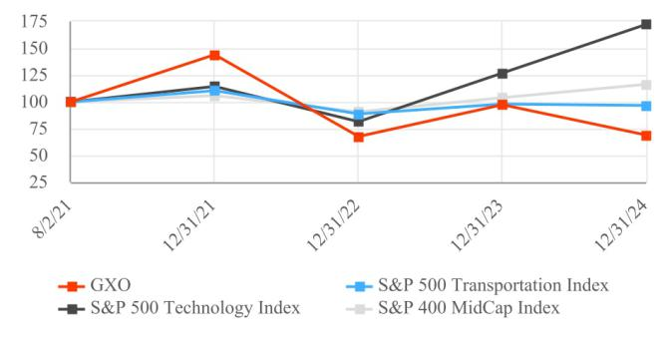

 | 8/2/21 |  |  |  |  | 12/31/21 |  |  | 12/31/22 |  |  | 12/31/23 |  |  | 12/31/24
GXO |  | $ | 100.00 |  | $ | 144.01 |  | $ | 67.69 |  | $ | 96.97 |  | $ | 68.97
S&P 400 | MidCap Index |  | 100.00 |  |  | 105.57 |  |  | 90.28 |  |  | 103.33 |  |  | 115.93
S&P 500 | Technology Index |  | 100.00 |  |  | 113.85 |  |  | 80.94 |  |  | 126.59 |  |  | 171.76
S&P 500 | Transportation Index |  | 100.00 |  |  | 110.27 |  |  | 88.61 |  |  | 97.57 |  |  | 96.16

19

Item 6. [Reserved]

Item 7. Management’s Discussion and Analysis of Financial Condition and Results of Operations.

The following discussion and analysis of our financial condition and results of operations should be read in conjunction with our Consolidated Financial Statements and related notes included elsewhere in this Annual Report. This Form 10-K contains certain forward-looking statements that are intended to be covered by the safe harbors created by The Private Securities Litigation Reform Act of 1995. Please see “Cautionary Statement Regarding Forward-Looking Statements” and “Risk Factors” for a discussion of the uncertainties, risks and assumptions associated with these statements.

Also, the following discussion and analysis of our financial condition and results of operations generally discusses 2024 and 2023 items and year-to-year comparisons between 2024 and 2023. Discussions of 2022 financial condition and year-to-year comparisons between 2023 and 2022 are not included in this Annual Report and can be found in Part II, Item 7, “Management’s Discussion and Analysis of Financial Condition and Results of Operations” in our Annual Report on Form 10-K for the year ended December 31, 2023.

Business Overview

GXO Logistics, Inc., together with its subsidiaries (“GXO,” the “Company,” “our” or “we”), is the largest pure-play contract logistics provider in the world and a foremost innovator in the industry. We provide our customers with high-value-added warehousing and distribution, order fulfillment, e-commerce, reverse logistics and other supply chain services differentiated by our ability to deliver technology-enabled, customized solutions at scale. Our customers rely on us to move their goods with high efficiency through their supply chains — from the moment goods arrive at our warehouses through fulfillment and distribution, and the management of returned products. Our customer base includes many blue-chip leaders in sectors that demonstrate high growth and/or durable demand, with significant growth potential through customer outsourcing of logistics services.

We strive to provide all customers with consistent quality service and cutting-edge automation. We also collaborate with our largest customers on planning and forecasting and assist with network optimization, working with these customers to design or redesign their supply chains to meet specific goals, such as environmental, social and governance. Our multidisciplinary, consultative approach has led to many of our key customer relationships extending for years and expanding in scope.

The most dramatic growth in demand in recent years has been in e-commerce and related sectors, including omnichannel retail and other direct-to-consumer channels. We expect to attract new customers and expand the services we provide to existing customers through new projects, thus earning more of their logistics spending. We use technology to manage advanced automation, labor productivity, sustainability, safety and the complex flow of goods within sophisticated warehouse environments.

Our business model is asset-light and historically resilient in cycles, with high returns, strong free cash flow and visibility into revenue and earnings. The vast majority of our contracts with customers are long-term in nature, and our warehouse lease arrangements generally align with contract length. The Company has both fixed-price contracts (closed book or hybrid contracts) and cost-plus contracts (open book contracts). Most of our customer contracts contain both fixed and variable components. The fixed component is typically designed to cover warehouse, technology and equipment costs, while the variable component is determined based on expected volumes and associated labor costs. Under fixed-price contracts, the Company agrees to perform the specified work for a pre-determined price. To the extent the Company’s actual costs vary from the estimates upon which the price was negotiated, the Company will generate more or less profit. Cost-plus contracts provide for the payment of allowable costs incurred during the performance of the contract plus a specified margin.

20

On April 29, 2024, the Company completed the acquisition of Wincanton plc (“Wincanton”), a U.K. logistics provider specializing in both warehousing and transportation solutions (“the Wincanton Acquisition”). On October 23, 2023, the Company completed the acquisition of PFSweb, Inc. (“PFS”), an e-commerce order fulfillment company based in Irving, Texas (the “PFS Acquisition”). Due to the acquisitions of Wincanton in 2024 and PFS in 2023, comparisons in our results of operations between 2024 and 2023 are less meaningful. For additional information regarding our acquisitions, see Note 4. “Acquisitions” to the Consolidated Financial Statements.

Results of Operations

(In millions, except percentages) |  |  |  |  |  | Year Ended December 31,
 |  |  | 2024 |  |  | 2023 |  |  | $ Change |  | % Change
Revenue |  | $ | 11,709 |  | $ | 9,778 |  | $ | 1,931 |  | 20 %
Direct operating expense |  |  | 9,853 |  |  | 8,035 |  |  | 1,818 |  | 23 %
Selling, general and administrative expense |  |  | 1,061 |  |  | 998 |  |  | 63 |  | 6 %
Depreciation and amortization expense |  |  | 415 |  |  | 361 |  |  | 54 |  | 15 %
Transaction and integration costs |  |  | 76 |  |  | 34 |  |  | 42 |  | n/m
Restructuring costs and other |  |  | 27 |  |  | 32 |  |  | (5) |  | (16)%
Litigation expense |  |  | 59 |  |  | — |  |  | 59 |  | n/m
Operating income |  |  | 218 |  |  | 318 |  |  | (100) |  | (31)%
Other income, net |  |  | 31 |  |  | 1 |  |  | 30 |  | n/m
Interest expense, net |  |  | (103) |  |  | (53) |  |  | (50) |  | 94 %
Income before income taxes |  |  | 146 |  |  | 266 |  |  | (120) |  | (45)%
Income tax expense |  |  | (8) |  |  | (33) |  |  | 25 |  | (76)%
Net income |  | $ | 138 |  | $ | 233 |  | $ | (95) |  | (41)%

n/m - not meaningful

Revenue for 2024 increased by 20%, or $1.9 billion, to $11.7 billion compared with $9.8 billion for 2023. The increase primarily reflects $1.6 billion from the acquisitions of Wincanton and PFS.

Also, revenue increased in our Continental Europe and U.K. and Ireland businesses, mainly driven by higher pricing. Foreign currency movements increased revenue by $109 million in 2024.

Direct operating expenses comprise both fixed and variable expenses and consist of operating costs related to our warehouse operations, including personnel costs, rent expenses, utility costs, equipment maintenance and repair costs, transportation costs, costs of materials and supplies and information technology expenses. Direct operating expense for 2024 increased by 23%, or $1.8 billion, to $9.9 billion compared with $8.0 billion for 2023. The increase primarily reflects $1.4 billion from the acquisitions of Wincanton and PFS, and higher personnel and temporary labor expenses in the U.K. and Ireland business from growth in the business. Direct operating expense also increased due to foreign currency movement in our U.K. and Ireland and Continental Europe businesses. As a percentage of revenue, direct operating expense was 84.1% and 82.2% in 2024 and 2023, respectively. The increase in Direct operating expense as a percentage of revenue was primarily related to the Wincanton Acquisition.

Selling, general and administrative expense (“SG&A”) primarily consists of salary and benefit costs for executive and certain administration functions, professional fees, bad debt expense and legal costs. SG&A for 2024 increased by 6%, or $63 million, to $1.1 billion, compared with $998 million in 2023. The increase was primarily driven by the acquisitions of Wincanton and PFS.

Depreciation and amortization expense for 2024 increased by $54 million to $415 million compared with $361 million for 2023. Depreciation and amortization expense increased primarily due to the acquisitions of Wincanton and PFS. Depreciation and amortization expense included amortization of intangible assets acquired of $108 million and $71 million in 2024 and 2023, respectively.

21

Transaction and integration costs were $76 million in 2024, compared with $34 million for 2023. Transaction and integration costs in 2024 primarily included $61 million related to the Wincanton Acquisition and $8 million related to the integration of PFS. Transaction and integration costs in 2023 primarily included $20 million related to the integration of Clipper Logistics plc and $12 million related to the PFS Acquisition.

We engage in restructuring actions as part of our ongoing efforts to best use our resources and infrastructure. These costs are primarily related to severance, including projects to optimize human resources, finance and information technology activities, and are not associated with customer attrition. Restructuring costs and other were $27 million for 2024, compared with $32 million for 2023. Restructuring costs and other in 2024 related to a restructuring plan designed to centralize certain finance, human resource and IT functions. Restructuring costs and other for 2023 included $16 million related to severance, $11 million for impairment charges, and $5 million associated with the exit of a non-core businesses in Asia.

Litigation expense in 2024 related to a settlement agreement dated June 14, 2024. We recognized $59 million for the settlement, associated legal fees, and other related expenses. For additional information regarding our legal matters see Note 18. “Commitments and Contingencies” to the Consolidated Financial Statements.

Other income, net increased due to higher pension income and foreign currency movements. In 2024, pension income primarily increased due to a defined benefit plan assumed in connection with the Wincanton Acquisition.

In 2024, the Company recorded a gain of $8 million in connection with a real estate transaction.

Other income, net was as follows:
 | (In millions, except percentages) |  |  |  |  |  | Year Ended December 31,
 |  |  |  | 2024 |  |  | 2023 |  |  | $ Change |  | % Change
 | Net periodic pension income |  | $ | 21 |  | $ | 8 |  | $ | 13 |  | n/m
 | Foreign currency gain (loss):
 | Realized foreign currency option and forward contracts loss |  |  | (5) |  |  | (13) |  |  | 8 |  | (62)%
 | Unrealized foreign currency option and forward contracts gain |  |  | 11 |  |  | 4 |  |  | 7 |  | n/m
 | Foreign currency transaction and remeasurement loss |  |  | (3) |  |  | — |  |  | (3) |  | n/m
 | Total foreign currency gain (loss) |  |  | 3 |  |  | (9) |  |  | 12 |  | n/m
 | Other |  |  | 7 |  |  | 2 |  |  | 5 |  | n/m
 | Other income, net |  | $ | 31 |  | $ | 1 |  | $ | 30 |  | n/m

n/m - not meaningful

Interest expense, net increased due to the debt incurred for the Wincanton Acquisition. Interest expense, net was as follows:

 |  |  |  |  |  | Year Ended December 31,
(In millions, except percentages) |  |  | 2024 |  |  | 2023 |  |  | $ Change |  | % Change
Debt and capital leases |  | $ | 148 |  | $ | 96 |  | $ | 52 |  | 54 %
Cross-currency swaps |  |  | (39) |  |  | (33) |  |  | (6) |  | 18 %
Interest income |  |  | (6) |  |  | (10) |  |  | 4 |  | (40)%
Interest expense, net |  | $ | 103 |  | $ | 53 |  | $ | 50 |  | 94 %

Income before income taxes for 2024 decreased by $120 million, to $146 million, compared with $266 million for 2023. The decrease was mainly driven by higher transaction and integration costs, litigation expense, and interest expense, partially offset by higher other income, net. Income before income taxes for our domestic operations was a pre-tax loss of $88 million for 2024, compared with $97 million of pre-tax income in 2023. The decrease from income to a loss in 2024 was primarily driven by higher transaction and integration costs, litigation expense and

22

interest expense for debt incurred for the Wincanton Acquisition. Income before income taxes for our foreign operations was $234 million for 2024 compared with $169 million in 2023. The increase in 2024 was primarily driven by growth in the business and other income, net.

Income tax expense was $8 million in 2024, compared with $33 million in 2023. Our effective tax rate was 5.6% in 2024 and 12.4% in 2023. The decrease in our effective income tax rate was driven by income tax benefits from the release of valuation allowances in 2024.

Liquidity and Capital Resources

Overview

Our ability to fund our operations and anticipated capital needs is reliant upon the generation of cash from operations, supplemented as necessary by periodic utilization of our revolving credit facility and factoring programs. Our principal uses of cash in the future will be primarily to fund our operations, working capital needs, capital expenditures, repayment of borrowings and strategic business development transactions. The timing and magnitude of our new contract start-ups can vary and may positively or negatively impact our cash flows. We continually evaluate our liquidity requirements and capital structure in light of our operating needs, growth initiatives and capital resources.

As of December 31, 2024, we held cash and cash equivalents of $413 million, restricted cash of $72 million recorded in Other long-term assets, and we had $999 million of borrowing capacity available, net of letters of credit under our revolving credit facilities. During 2024, we deposited €68 million ($70 million as of December 31, 2024) of restricted cash in relation to a contingency, and in January 2025, the Company deposited an additional amount of €16 million ($17 million).

We believe that our cash and cash equivalents on hand, our cash flows from operations, the borrowing capacity under our revolving credit facilities, and the use of our factoring programs will provide sufficient liquidity to operate our business and fund our current and assumed obligations for at least the next 12 months.

For additional information regarding our cash requirements from contractual obligations, indebtedness and lease obligations, and legal matters, see Note 18. “Commitments and Contingencies,” Note 10. “Debt and Financing Arrangements” and Note 9. “Leases” to the Consolidated Financial Statements.

Capital Expenditures

Our future capital spending includes fulfillment costs and investments in technology and automation to improve the speed and accuracy of order fulfillment and the resiliency of our supply chains. The level and the timing of the Company’s capital expenditures within these categories can vary as a result of a variety of factors outside our control, such as the timing of new contracts, availability of labor and materials and foreign currency fluctuations. We believe that we have significant discretion over the amount and timing of our capital expenditures as we are not subject to any agreement that would require significant capital expenditures on a designated schedule or upon the occurrence of designated events.

23

Financial Condition
The following table summarizes our asset and liability balances as of December 31, 2024 and 2023:
 |  |  |  |  |  |  | December 31,
 | (In millions, except percentages) |  | 2024 |  |  |  | 2023 |  |  | $ Change |  | % Change
 | Total current assets |  | $ | 2,641 |  | $ | 2,568 |  | $ | 73 |  | 3 %
 | Total long-term assets |  |  | 8,625 |  |  | 6,939 |  |  | 1,686 |  | 24 %
 | Total current liabilities |  |  | 3,189 |  |  | 2,626 |  |  | 563 |  | 21 %
 | Total long-term liabilities |  |  | 5,042 |  |  | 3,935 |  |  | 1,107 |  | 28 %

Total assets and liabilities increased from December 31, 2023 to December 31, 2024 primarily due to the Wincanton Acquisition. Total liabilities also increased due to issuance of $1.1 billion of unsecured notes to fund the Wincanton Acquisition.

Cash Flow Activity

Our cash flows from operating, investing and financing activities, as reflected on our Consolidated Statements of Cash Flows, were summarized as follows:

 |  |  |  |  |  | Year Ended December 31,
(In millions, except percentages) |  |  | 2024 |  |  | 2023 |  |  | $ Change |  | % Change
Net cash provided by operating activities |  | $ | 549 |  | $ | 558 |  | $ | (9) |  | (2)%
Net cash used in investing activities |  |  | (1,157) |  |  | (410) |  |  | (747) |  | n/m
Net cash provided by (used in) financing activities |  |  | 636 |  |  | (186) |  |  | 822 |  | n/m
Effect of exchange rates on cash and cash equivalents |  |  | (13) |  |  | 13 |  |  | (26) |  | n/m
Net increase (decrease) in cash, restricted cash and cash equivalents |  | $ | 15 |  | $ | (25) |  | $ | 40 |  | n/m

n/m - not meaningful

Operating Activities

Cash flows provided by operating activities for 2024 decreased by $9 million compared to 2023. This decline was driven by decreased net income after adjustments for non-cash items, offset by benefits from working capital activity compared to the prior year.

Investing Activities

Investing activities used $1.2 billion of cash in 2024 compared with $410 million in 2023. During 2024, we used $863 million, net of cash received, to fund the Wincanton Acquisition, used

$359 million of cash to purchase property and equipment, partially offset by $61 million of proceeds from the sales of property and equipment and $4 million in net proceeds from the settlement of cross-currency swap agreements, excluding accrued interest. During 2023, we used $274 million of cash for capital expenditures, used $149 million in connection with the PFS Acquisition and $3 million in settlement of cross-currency swap agreements, excluding accrued interest, partially offset by $18 million of proceeds from the sales of property and equipment.

Financing Activities

Financing activities generated $636 million of cash in 2024 and used $186 million in 2023. The primary source of cash from financing activities in 2024 was the issuance of long-term debt of $1.1 billion, partially offset by cash used to repay $408 million of debt, $45 million to repay finance lease obligations and $8 million in payments for employee taxes on net settlement of equity awards. The primary use of cash from financing activities in 2023 was

24

$140 million in repayment of debt, $29 million to repay finance lease obligations and $12 million in payments for employee taxes on net settlement of equity awards.

Off-Balance Sheet Arrangements

We do not engage in any off-balance sheet financial arrangements that have or are reasonably likely to have a material current or future effect on our financial condition, changes in financial condition, revenues or expenses, results of operations, liquidity, capital expenditures or capital resources.

Contractual Obligations

As of December 31, 2024, our outstanding obligations under operating and finance leases were $2.5 billion and $276 million, respectively. For additional information see Note 9. “Leases” to the Consolidated Financial Statements.

As of December 31, 2024, we had a total of $1.9 billion of Unsecured Notes outstanding, consisting of $1.1 billion Unsecured Notes with interest payable semiannually on May 6 and November 6 of each year and $800 million Unsecured Notes with interest payable semiannually on January 15 and July 15 of each year. We also have $450 million of variable-rate term loans outstanding with interest payable in arrears at our option monthly, quarterly, or semiannually. For additional information see Note 10. “Debt and Financing Arrangements” to the Consolidated Financial Statements.

In addition, we have obligations for agreements to purchase goods or services entered into in the ordinary course of business that are enforceable and legally binding.

Critical Accounting Policies and Estimates

We prepare our Consolidated Financial Statements in accordance with GAAP. We make assumptions, estimates and judgments that affect our reported amounts of assets, liabilities, revenues, expenses, gains and losses. Material changes in these assumptions, estimates and/or judgments have the potential to materially alter our results of operations. We have identified the following accounting policies to be the most critical as they are important to our financial condition and results of operations and require significant judgment and estimates on the part of management in their application.

Business Combinations

We record tangible and intangible assets acquired and liabilities assumed in business combinations under the purchase method of accounting. We allocate the fair value of purchase consideration to tangible and intangible assets acquired and liabilities assumed based on their estimated fair values. The excess of the fair value of purchase consideration over the fair values of these identifiable assets and liabilities is allocated to goodwill.

Accounting for business combinations requires us to make significant estimates and assumptions, especially at the acquisition date with respect to tangible and intangible assets acquired and liabilities assumed. We use our best estimates and assumptions to accurately assign fair value to the tangible and intangible assets acquired and liabilities assumed at the acquisition date as well as the useful lives of those acquired intangible assets. Significant assumptions utilized in the allocation of the purchase price related to intangible assets include future expected cash flows from acquired intangibles and discount rates.

Our estimates of fair value are based upon reasonable assumptions but are inherently uncertain and unpredictable, and as a result, actual results may differ from these estimates. During the measurement period, which is up to one year from the acquisition date, we may record adjustments to the assets acquired and liabilities assumed with the corresponding offset to goodwill. Upon the conclusion of the measurement period, any subsequent adjustments are recorded to earnings. For additional information see Note 4. “Acquisitions” to the Consolidated Financial Statements.

25

Evaluation of Goodwill

We allocate goodwill to reporting units based on the reporting unit expected to benefit from the business combination. Goodwill is tested at the reporting unit level, which is an operating segment or one level below, on an annual basis and between annual tests if an event occurs or circumstances change that would more likely than not reduce the fair value of a reporting unit below its carrying value. We have three reporting units: i) Americas and Asia-Pacific, ii) United Kingdom and Ireland and iii) Continental Europe.

For each reporting unit, we first assess qualitative factors that are specific to the reporting unit as well as industry and macroeconomic factors to determine whether it is necessary to perform a quantitative goodwill impairment test. The qualitative factors could include a significant change in the business climate, legal factors, operating performance indicators, competition or the sale or disposition of a significant portion of a reporting unit. If the qualitative assessment indicates that it is more likely than not that an impairment exists, then a quantitative assessment is performed.

A quantitative goodwill impairment test, when performed, includes estimating the fair value of a reporting unit using the income and/or market approach. The income approach of determining fair value is based on the present value of estimated future cash flows, which requires us to make various assumptions, including assumptions about the timing and amount of future cash flows, growth rates and discount rates. The discount rates reflect management’s judgment and are based on a risk-adjusted weighted-average cost of capital utilizing industry market data of businesses similar to the reporting units. Inherent in our preparation of cash flow projections are assumptions and estimates derived from a review of our operating results, business plans, expected growth rates, cost of capital and tax rates. Our forecasts also reflect expectations concerning future economic conditions, interest rates and other market data. The market approach of determining fair value is based on comparable market multiples for companies engaged in similar businesses, as well as recent transactions within our industry. We believe using these valuation techniques yields the most appropriate evidence of the reporting unit’s fair value.

Many of the factors used in assessing fair value are outside the control of management, and these assumptions and estimates may change in future periods. Changes in assumptions or estimates could materially affect the estimate of the fair value of a reporting unit and therefore could affect the likelihood and amount of any potential impairment.

Employee Benefit Plans

We sponsor various retirement plans, with the most significant plans held in the U.K. (the “U.K. Retirement Plans”). Assumptions used in the accounting for these employee benefit plans include the discount rate and expected return on plan assets. Assumptions are determined based on company data and appropriate market indicators and are evaluated each year at December 31. A change in any of these assumptions would have an effect on the net periodic pension cost reported in the Consolidated Financial Statements.

The discount rate is determined based on the yield on a portfolio of high-quality bonds, constructed to provide cash flows necessary to meet our pension plans’ expected future benefit payments, as determined for the accumulated benefit obligation. A 50-basis-point decrease in the discount rate of the U.K. Retirement Plans would result in an estimated increase in the accumulated benefit obligation of approximately $91 million. The expected return on plan assets assumption is derived using the current and expected asset allocation of the pension plan assets and considering historical as well as expected returns on various classes of plan assets. An increase or decrease of 50 basis points in the expected return on plan assets for the U.K. Retirement Plans would have decreased or increased our net periodic pension cost by approximately $9 million in 2025. For additional information see Note 15. “Employee Benefit Plans” to the Consolidated Financial Statements.

New Accounting Standards

Information related to new accounting standards is included in Note 2. “Basis of Presentation and Significant Accounting Policies” to the Consolidated Financial Statements.

26

Item 7A. Quantitative and Qualitative Disclosures About Market Risk.

Our market risk disclosures involve forward-looking statements. Actual results could differ materially from those projected in such forward-looking statements. We are exposed to market risk related to changes in interest rates and foreign currency exchange rates.

Interest Rate Risk

Our long-term debt portfolio, excluding finance leases and other debt, consists of $1.9 billion fixed-rate notes and $450 million variable-rate term loans based on the Secured Overnight Financing Rate (“SOFR”). For our variable-rate debt, we entered into interest rate swap agreements to convert $125 million of variable-rate U.S. dollar (“USD”) denominated debt into USD-denominated fixed-rate debt. Additionally, we entered into cross-currency swap agreements to convert $250 million of variable-rate debt from SOFR to the Euro Interbank Offered Rate (“Euribor”). As of December 31, 2024, a hypothetical 1% increase in SOFR and Euribor would have increased our interest expense by approximately $3 million.

Foreign Currency Exchange Rate Risk

A significant proportion of our net assets and income are in non-USD currencies, primarily the British pound sterling (“GBP”) and the Euro (“EUR”). We are exposed to currency risk from potential changes in functional currency values of our foreign currency denominated assets, liabilities and cash flows. Consequently, the depreciation of the EUR or the GBP relative to the USD could adversely impact on our financial results.

We entered into cross-currency swap and forward agreements to manage our foreign currency exchange risk by effectively converting a portion of the fixed-rate USD-denominated debt, including the interest payments, to fixed-rate EUR-denominated debt and a portion of the floating-rate USD-denominated loans, including the interest payments, to floating-rate EUR-denominated debt. We use foreign currency options and forward contracts to mitigate the risk of a reduction in the value of earnings from our operations that use the EUR or GBP as their functional currency.

As of December 31, 2024, a uniform 10% strengthening in the value of the USD relative to the EUR and GBP would have decreased our net assets by $70 million and $92 million, respectively, net of foreign currency hedging. These theoretical calculations assume that an instantaneous, parallel shift in exchange GBP and EUR rates occurs.

See Note 11. “Fair Value Measurements and Financial Instruments” to the Consolidated Financial Statements for additional information.

27

Item 8. Financial Statements and Supplementary Data.

Index to Financial Statements

 |  |  |  |  |  |  |  |  |  |  |  |  |  |  |  |  |  |  |  |  |  |  |  |  |  |  | Page
Report of Independent Registered Public Accounting Firm |  |  |  |  |  |  |  |  |  |  |  |  |  |  |  |  |  |  |  |  |  |  |  |  |  |  | 29
Consolidated Statements of Operations for the Years Ended December 31, 2024, 2023 and 2022 |  |  |  |  |  |  |  |  |  |  |  |  |  |  |  |  |  |  |  |  |  |  |  |  |  |  | 32
Consolidated Statements of Comprehensive Income for the Years Ended December 31, 2024, 2023 and 2022 |  |  |  |  |  |  |  |  |  |  |  |  |  |  |  |  |  |  |  |  |  |  |  |  |  |  | 33
Consolidated Balance Sheets as of December 31, 2024 and 2023 |  |  |  |  |  |  |  |  |  |  |  |  |  |  |  |  |  |  |  |  |  |  |  |  |  |  | 34
Consolidated Statements of Cash Flows for the Years Ended December 31, 2024, 2023 and 2022 |  |  |  |  |  |  |  |  |  |  |  |  |  |  |  |  |  |  |  |  |  |  |  |  |  |  | 35
Consolidated Statements of Changes in Equity for the Years Ended December 31, 2024, 2023 and 2022 |  |  |  |  |  |  |  |  |  |  |  |  |  |  |  |  |  |  |  |  |  |  |  |  |  |  | 37
Notes to Consolidated Financial Statements |  |  |  |  |  |  |  |  |  |  |  |  |  |  |  |  |  |  |  |  |  |  |  |  |  |  | 38
Note 1 - Organization |  |  |  |  |  |  |  |  |  |  |  |  |  |  |  |  |  |  |  |  |  |  |  |  |  |  | 38
Note 2 - Basis of Presentation and Significant Accounting Policies |  |  |  |  |  |  |  |  |  |  |  |  |  |  |  |  |  |  |  |  |  |  |  |  |  |  | 38
Note 3 - Revenue Recognition |  |  |  |  |  |  |  |  |  |  |  |  |  |  |  |  |  |  |  |  |  |  |  |  |  |  | 44
Note 4 - Acquisitions |  |  |  |  |  |  |  |  |  |  |  |  |  |  |  |  |  |  |  |  |  |  |  |  |  |  | 45
Note 5 - Segment Information |  |  |  |  |  |  |  |  |  |  |  |  |  |  |  |  |  |  |  |  |  |  |  |  |  |  | 47
Note 6 - Goodwill |  |  |  |  |  |  |  |  |  |  |  |  |  |  |  |  |  |  |  |  |  |  |  |  |  |  | 49
Note 7 - Intangible Assets |  |  |  |  |  |  |  |  |  |  |  |  |  |  |  |  |  |  |  |  |  |  |  |  |  |  | 49
Note 8 - Property and Equipment |  |  |  |  |  |  |  |  |  |  |  |  |  |  |  |  |  |  |  |  |  |  |  |  |  |  | 50
Note 9 - Leases |  |  |  |  |  |  |  |  |  |  |  |  |  |  |  |  |  |  |  |  |  |  |  |  |  |  | 50
Note 10 - Debt and Financing Arrangements |  |  |  |  |  |  |  |  |  |  |  |  |  |  |  |  |  |  |  |  |  |  |  |  |  |  | 52
Note 11 - Fair Value Measurements and Financial Instruments |  |  |  |  |  |  |  |  |  |  |  |  |  |  |  |  |  |  |  |  |  |  |  |  |  |  | 54
Note 12 - Accrued Expenses |  |  |  |  |  |  |  |  |  |  |  |  |  |  |  |  |  |  |  |  |  |  |  |  |  |  | 57
Note 13 - Stockholders’ Equity |  |  |  |  |  |  |  |  |  |  |  |  |  |  |  |  |  |  |  |  |  |  |  |  |  |  | 58
Note 14 - Stock-Based Compensation |  |  |  |  |  |  |  |  |  |  |  |  |  |  |  |  |  |  |  |  |  |  |  |  |  |  | 58
Note 15 - Employee Benefit Plans |  |  |  |  |  |  |  |  |  |  |  |  |  |  |  |  |  |  |  |  |  |  |  |  |  |  | 60
Note 16 - Restructuring Charges and Other |  |  |  |  |  |  |  |  |  |  |  |  |  |  |  |  |  |  |  |  |  |  |  |  |  |  | 63
Note 17 - Income Taxes |  |  |  |  |  |  |  |  |  |  |  |  |  |  |  |  |  |  |  |  |  |  |  |  |  |  | 63
Note 18 - Commitments and Contingencies |  |  |  |  |  |  |  |  |  |  |  |  |  |  |  |  |  |  |  |  |  |  |  |  |  |  | 67
Note 19 - Subsequent Events |  |  |  |  |  |  |  |  |  |  |  |  |  |  |  |  |  |  |  |  |  |  |  |  |  |  | 68

28

Report of Independent Registered Public Accounting Firm

To the Stockholders and the Board of Directors

GXO Logistics, Inc.:

Opinions on the Consolidated Financial Statements and Internal Control Over Financial Reporting

We have audited the accompanying consolidated balance sheets of GXO Logistics, Inc. and subsidiaries (the Company) as of December 31, 2024 and 2023, the related consolidated statements of operations, comprehensive income, changes in equity, and cash flows for each of the years in the three-year period ended December 31, 2024, and the related notes (collectively, the consolidated financial statements). We also have audited the Company’s internal control over financial reporting as of December 31, 2024, based on criteria established in Internal Control – Integrated Framework (2013) issued by the Committee of Sponsoring Organizations of the Treadway Commission.

In our opinion, the consolidated financial statements referred to above present fairly, in all material respects, the financial position of the Company as of December 31, 2024 and 2023, and the results of its operations and its cash flows for each of the years in the three-year period ended December 31, 2024, in conformity with U.S. generally accepted accounting principles. Also in our opinion, the Company maintained, in all material respects, effective internal control over financial reporting as of December 31, 2024 based on criteria established in Internal Control – Integrated Framework (2013) issued by the Committee of Sponsoring Organizations of the Treadway Commission.

The Company acquired Wincanton plc. during 2024, and management excluded from its assessment of the effectiveness of the Company’s internal control over financial reporting as of December 31, 2024, Wincanton plc.’s internal control over financial reporting associated with approximately 9.9% of total assets, excluding associated goodwill and intangible assets and approximately 11.8% of total revenues included in the consolidated financial statements of the Company as of and for the year ended December 31, 2024. Our audit of internal control over financial reporting of the Company also excluded an evaluation of the internal control over financial reporting of Wincanton plc.

Basis for Opinions

The Company’s management is responsible for these consolidated financial statements, for maintaining effective internal control over financial reporting, and for its assessment of the effectiveness of internal control over financial reporting, included in the accompanying Management’s Annual Report on Internal Control over Financial Reporting. Our responsibility is to express an opinion on the Company’s consolidated financial statements and an opinion on the Company’s internal control over financial reporting based on our audits. We are a public accounting firm registered with the Public Company Accounting Oversight Board (United States) (PCAOB) and are required to be independent with respect to the Company in accordance with the U.S. federal securities laws and the applicable rules and regulations of the Securities and Exchange Commission and the PCAOB.

We conducted our audits in accordance with the standards of the PCAOB. Those standards require that we plan and perform the audits to obtain reasonable assurance about whether the consolidated financial statements are free of material misstatement, whether due to error or fraud, and whether effective internal control over financial reporting was maintained in all material respects.

Our audits of the consolidated financial statements included performing procedures to assess the risks of material misstatement of the consolidated financial statements, whether due to error or fraud, and performing procedures that respond to those risks. Such procedures included examining, on a test basis, evidence regarding the amounts and disclosures in the consolidated financial statements. Our audits also included evaluating the accounting principles used and significant estimates made by management, as well as evaluating the overall presentation of the consolidated financial statements. Our audit of internal control over financial reporting included obtaining an understanding of internal control over financial reporting, assessing the risk that a material weakness exists, and

29

testing and evaluating the design and operating effectiveness of internal control based on the assessed risk. Our audits also included performing such other procedures as we considered necessary in the circumstances. We believe that our audits provide a reasonable basis for our opinions.

Definition and Limitations of Internal Control Over Financial Reporting

A company’s internal control over financial reporting is a process designed to provide reasonable assurance regarding the reliability of financial reporting and the preparation of financial statements for external purposes in accordance with generally accepted accounting principles. A company’s internal control over financial reporting includes those policies and procedures that (1) pertain to the maintenance of records that, in reasonable detail, accurately and fairly reflect the transactions and dispositions of the assets of the company; (2) provide reasonable assurance that transactions are recorded as necessary to permit preparation of financial statements in accordance with generally accepted accounting principles, and that receipts and expenditures of the company are being made only in accordance with authorizations of management and directors of the company; and (3) provide reasonable assurance regarding prevention or timely detection of unauthorized acquisition, use, or disposition of the company’s assets that could have a material effect on the financial statements.

Because of its inherent limitations, internal control over financial reporting may not prevent or detect misstatements. Also, projections of any evaluation of effectiveness to future periods are subject to the risk that controls may become inadequate because of changes in conditions, or that the degree of compliance with the policies or procedures may deteriorate.

Critical Audit Matters

The critical audit matters communicated below are matters arising from the current period audit of the consolidated financial statements that were communicated or required to be communicated to the audit committee and that: (1) relate to accounts or disclosures that are material to the consolidated financial statements and (2) involved our especially challenging, subjective, or complex judgments. The communication of critical audit matters does not alter in any way our opinion on the consolidated financial statements, taken as a whole, and we are not, by communicating the critical audit matters below, providing separate opinions on the critical audit matters or on the accounts or disclosures to which they relate.

Acquisition-date fair value of a customer relationship intangible asset

As discussed in Note 4 to the consolidated financial statements, on April 29, 2024, the Company acquired Wincanton plc in a business combination for consideration of approximately $958 million. As a result of the transaction, the Company acquired a customer relationship intangible asset associated with the generation of future income from the acquiree’s existing customers. The acquisition-date fair value of intangible assets recorded by the Company was $539 million, which included a customer relationship intangible asset.

We identified the evaluation of the acquisition-date fair value of the customer relationship intangible asset as a critical audit matter. Subjective auditor judgment was required to evaluate certain assumptions used to estimate the acquisition-date fair value of the customer relationship intangible asset. Specifically, there was limited observable market information for the forecasted revenue and customer attrition assumptions, and evaluation of the discount rate assumption required specialized skills and knowledge. Changes in these assumptions could have had a significant impact on the acquisition-date fair value of the customer relationship intangible asset.

The following are the primary procedures we performed to address this critical audit matter. We evaluated the design and tested the operating effectiveness of certain internal controls related to the Company’s process to estimate the acquisition-date fair value of the customer relationship intangible asset. This included controls related to the determination of the forecasted revenue, customer attrition, and discount rate assumptions used in the Company’s model. We evaluated the Company’s forecasted revenue of the acquired company by comparing it to past performance of the acquired company, and actual and forecasted revenue trends of the acquiree’s peers. We evaluated the Company’s customer attrition assumption by comparing it to historical attrition

30

experienced by the acquired company. We involved valuation professionals with specialized skills and knowledge, who assisted in evaluating the Company’s discount rate used by comparing it against a discount rate that was developed using publicly available market data for comparable entities.

Sufficiency of audit evidence over revenue from contracts with customers

As discussed in Notes 2 and 3 to the consolidated financial statements, revenue is recognized over the period in which services are provided under the terms of the Company’s contractual relationship with its customers. For the year ended December 31, 2024, the Company reported $11.7 billion of revenue.

We identified the evaluation of the sufficiency of audit evidence over revenue from contracts with customers (revenue) as a critical audit matter. Subjective auditor judgment and IT professionals with specialized skills and knowledge were required to evaluate the sufficiency of audit evidence obtained over revenue due to the number and dispersion of warehouse management and other IT systems used in the processing and recording of revenue.

The following are the primary procedures we performed to address this critical audit matter. We applied auditor judgment to determine the nature and extent of procedures to be performed over the processing and recording of revenue. We evaluated the design and tested the operating effectiveness of certain internal controls related to the processing and recording of revenue, including manual controls related to the examination of revenue contracts and detection of revenues recorded outside of expectations. We involved IT professionals with specialized skills and knowledge to test certain manual and automated controls, including general IT controls, over multiple relevant IT systems and information used in internal control. We compared certain revenue activity recorded during the year to cash received, adjusted for reconciling items. We evaluated the relevance and reliability of certain reconciling items to underlying documentation, including the changes in accounts receivable and deferred revenue. We examined a selection of revenue contracts and transactions to assess that revenue was recorded in accordance with the Company’s accounting policy. Additionally, for a sample of accrued revenue at year-end, we confirmed with the Company’s customers the amount of revenue billed subsequent to year-end and compared the result to the Company’s accounting records. We evaluated the sufficiency of audit evidence obtained by assessing the results of procedures performed, including the appropriateness of the nature and extent of such evidence.

/s/ KPMG LLP

We have served as the Company’s auditor since 2021.

New York, New York

February 18, 2025

31

GXO Logistics, Inc.

Consolidated Statements of Operations

(Dollars in millions, shares in thousands, except per share amounts) |  |  |  | Year Ended December 31,
 |  |  | 2024 |  |  | 2023 |  |  | 2022
Revenue |  | $ | 11,709 |  | $ | 9,778 |  | $ | 8,993
Direct operating expense |  |  | 9,853 |  |  | 8,035 |  |  | 7,443
Selling, general and administrative expense |  |  | 1,061 |  |  | 998 |  |  | 886
Depreciation and amortization expense |  |  | 415 |  |  | 361 |  |  | 329
Transaction and integration costs |  |  | 76 |  |  | 34 |  |  | 61
Restructuring costs and other |  |  | 27 |  |  | 32 |  |  | 32
Litigation expense |  |  | 59 |  |  | — |  |  | —
Operating income |  |  | 218 |  |  | 318 |  |  | 242
Other income, net |  |  | 31 |  |  | 1 |  |  | 51
Interest expense, net |  |  | (103) |  |  | (53) |  |  | (29)
Income before income taxes |  |  | 146 |  |  | 266 |  |  | 264
Income tax expense |  |  | (8) |  |  | (33) |  |  | (64)
Net income |  |  | 138 |  |  | 233 |  |  | 200
Net income attributable to Noncontrolling Interests (“NCI”) |  |  | (4) |  |  | (4) |  |  | (3)
Net income attributable to GXO |  | $ | 134 |  | $ | 229 |  | $ | 197
Earnings per share
Basic |  | $ | 1.12 | $ |  | 1.93 |  | $ | 1.68
Diluted |  | $ | 1.12 | $ |  | 1.92 |  | $ | 1.67
Weighted-average common shares outstanding
Basic |  |  | 119,413 |  |  | 118,908 |  |  | 117,050
Diluted |  |  | 119,798 |  |  | 119,490 |  |  | 117,616

See accompanying Notes to the Consolidated Financial Statements.

32

GXO Logistics, Inc.

Consolidated Statements of Comprehensive Income

(In millions) |  |  |  | Year Ended December 31,
 |  |  | 2024 |  |  | 2023 |  |  | 2022
Net income |  | $ | 138 |  | $ | 233 |  | $ | 200
Other comprehensive income (loss), net of tax
Foreign currency translation adjustments |  |  | (34) |  |  | 19 |  |  | (98)
Cash flow hedges |  |  | (1) |  |  | (2) |  |  | 7
Pension plans |  |  | (42) |  |  | (1) |  |  | (36)
Other comprehensive income (loss), net of tax |  |  | (77) |  |  | 16 |  |  | (127)
Comprehensive income, net of tax |  |  | 61 |  |  | 249 |  |  | 73
Less: Comprehensive income attributable to NCI |  |  | 1 |  |  | 5 |  |  | 2
Comprehensive income attributable to GXO |  | $ | 60 |  | $ | 244 |  | $ | 71

See accompanying Notes to the Consolidated Financial Statements.

33

GXO Logistics, Inc.
Consolidated Balance Sheets
 |  |  | December 31,
(Dollars in millions, shares in thousands, except per share amounts) |  |  | 2024 |  |  | 2023
ASSETS
Current assets
Cash and cash equivalents |  | $ | 413 |  | $ | 468
Accounts receivable, net of allowance of $15 and $11 |  |  | 1,799 |  |  | 1,753
Other current assets |  |  | 429 |  |  | 347
Total current assets |  |  | 2,641 |  |  | 2,568
Long-term assets
Property and equipment, net of accumulated depreciation of $1,732 and $1,545 |  |  | 1,160 |  |  | 953
Operating lease assets |  |  | 2,329 |  |  | 2,201
Goodwill |  |  | 3,549 |  |  | 2,891
Intangible assets, net of accumulated amortization of $618 and $528 |  |  | 986 |  |  | 567
Other long-term assets |  |  | 601 |  |  | 327
Total long-term assets |  |  | 8,625 |  |  | 6,939
Total assets |  | $ | 11,266 |  | $ | 9,507
LIABILITIES AND EQUITY
Current liabilities
Accounts payable |  | $ | 776 |  | $ | 709
Accrued expenses |  |  | 1,271 |  |  | 966
Current debt |  |  | 110 |  |  | 27
Current operating lease liabilities |  |  | 647 |  |  | 597
Other current liabilities |  |  | 385 |  |  | 327
Total current liabilities |  |  | 3,189 |  |  | 2,626
Long-term liabilities
Long-term debt |  |  | 2,521 |  |  | 1,620
Long-term operating lease liabilities |  |  | 1,898 |  |  | 1,842
Other long-term liabilities |  |  | 623 |  |  | 473
Total long-term liabilities |  |  | 5,042 |  |  | 3,935
Commitments and Contingencies (Note 18)
Stockholders’ Equity
Common Stock, $0.01 par value per share; 300,000 shares authorized, 119,496 and 119,057 shares issued and outstanding |  |  | 1 |  |  | 1
Preferred Stock, $0.01 par value per share; 10,000 shares authorized, none issued and outstanding |  |  | — |  |  | —
Additional Paid-In Capital (“APIC”) |  |  | 2,629 |  |  | 2,598
Retained earnings |  |  | 686 |  |  | 552
Accumulated Other Comprehensive Income (Loss) (“AOCIL”) |  |  | (313) |  |  | (239)
Total stockholders’ equity before NCI |  |  | 3,003 |  |  | 2,912
NCI |  |  | 32 |  |  | 34
Total equity |  |  | 3,035 |  |  | 2,946
Total liabilities and equity |  | $ | 11,266 |  | $ | 9,507

See accompanying Notes to the Consolidated Financial Statements.

34

GXO Logistics, Inc.

Consolidated Statements of Cash Flows

 |  |  |  |  | Year Ended December 31,
(In millions) |  |  | 2024 |  |  | 2023 |  |  | 2022
Cash flows from operating activities:
Net income |  | $ | 138 |  | $ | 233 |  | $ | 200
Adjustments to reconcile net income to net cash provided by operating activities
Depreciation and amortization expense |  |  | 415 |  |  | 361 |  |  | 329
Stock-based compensation expense |  |  | 39 |  |  | 35 |  |  | 33
Deferred tax benefit |  |  | (38) |  |  | (41) |  |  | (7)
Other |  |  | 1 |  |  | 23 |  |  | (17)
Changes in operating assets and liabilities
Accounts receivable |  |  | 118 |  |  | (17) |  |  | (71)
Other assets |  |  | (54) |  |  | 28 |  |  | 24
Accounts payable |  |  | 23 |  |  | (3) |  |  | 45
Accrued expenses and other liabilities |  |  | (93) |  |  | (61) |  |  | 6
Net cash provided by operating activities |  |  | 549 |  |  | 558 |  |  | 542
Cash flows from investing activities:
Capital expenditures |  |  | (359) |  |  | (274) |  |  | (342)
Proceeds from sale of property and equipment |  |  | 61 |  |  | 18 |  |  | 40
Acquisition of business, net of cash acquired |  |  | (863) |  |  | (149) |  |  | (876)
Cross-currency swap agreements settlement |  |  | 4 |  |  | (3) |  |  | 21
Other |  |  | — |  |  | (2) |  |  | 8
Net cash used in investing activities |  |  | (1,157) |  |  | (410) |  |  | (1,149)
Cash flows from financing activities:
Proceeds from debt, net |  |  | 1,090 |  |  | — |  |  | 917
Repayments of debt, net |  |  | (408) |  |  | (140) |  |  | (82)
Repayments of finance lease obligations |  |  | (45) |  |  | (29) |  |  | (33)
Taxes paid related to net share settlement of equity awards |  |  | (8) |  |  | (12) |  |  | (16)
Other |  |  | 7 |  |  | (5) |  |  | 1
Net cash provided by (used in) financing activities |  |  | 636 |  |  | (186) |  |  | 787
Effect of exchange rates on cash and cash equivalents |  |  | (13) |  |  | 13 |  |  | (18)
Net increase (decrease) in cash, restricted cash and cash equivalents |  |  | 15 |  |  | (25) |  |  | 162
Cash, restricted cash and cash equivalents, beginning of year |  |  | 470 |  |  | 495 |  |  | 333
Cash, restricted cash and cash equivalents, end of year |  | $ | 485 |  | $ | 470 |  | $ | 495
Reconciliation of cash, restricted cash and cash equivalents
Cash and cash equivalents |  | $ | 413 |  | $ | 468 |  | $ | 495
Restricted cash (included in Other long-term assets) |  |  | 72 |  |  | 2 |  |  | —
Total cash, restricted cash and cash equivalents |  | $ | 485 |  | $ | 470 |  | $ | 495

See accompanying Notes to the Consolidated Financial Statements.

35

GXO Logistics, Inc.

Consolidated Statements of Cash Flows

 |  |  |  |  | Year Ended December 31,
(In millions) |  |  | 2024 |  |  | 2023 |  |  | 2022
Supplemental cash flow information:
Cash paid for interest, net |  | $ | 97 |  | $ | 57 |  | $ | 34
Cash paid for income taxes, net |  |  | 43 |  |  | 84 |  |  | 111
Noncash investing and financing activities:
Common stock issued for acquisition |  | $ | — |  | $ | — |  | $ | 204

See accompanying Notes to the Consolidated Financial Statements.

36

GXO Logistics, Inc.

Consolidated Statements of Changes in Equity

 |  | Common Stock
 |  |  |  |  |  |  |  |  |  |  | Retained |  |  |  |  |  | Equity |  |  |  |  |  | Total
(Shares in thousands, dollars in millions) |  | Shares |  |  | Amount |  |  | APIC |  |  | Earnings |  |  | AOCIL |  |  | Before NCI |  |  | NCI |  |  | Equity
December 31, 2021 |  | 114,659 |  | $ | 1 |  | $ | 2,354 |  | $ | 126 |  | $ | (130) |  | $ | 2,351 |  | $ | 39 |  | $ | 2,390
Net income
 |  | — |  |  | — |  |  | — |  |  | 197 |  |  | — |  |  | 197 |  |  | 3 |  |  | 200
Other comprehensive loss |  | — |  |  | — |  |  | — |  |  | — |  |  | (126) |  |  | (126) |  |  | (1) |  |  | (127)
Stock-based compensation |  | — |  |  | — |  |  | 33 |  |  | — |  |  | — |  |  | 33 |  |  | — |  |  | 33
Vesting of stock compensation awards |  | 557 |  |  | — |  |  | — |  |  | — |  |  | — |  |  | — |  |  | — |  |  | —
Tax withholding on vesting of stock |  | (246) |  |  | — |  |  | (16) |  |  | — |  |  | — |  |  | (16) |  |  | — |  |  | (16)
compensation awards |  | (246) |  |  |  |  |  | (16) |  |  |  |  |  |  |  |  | (16) |  |  |  |  |  | (16)
Common stock issued for acquisition |  | 3,758 |  |  | — |  |  | 204 |  |  | — |  |  | — |  |  | 204 |  |  | — |  |  | 204
Other |  | — |  |  | — |  |  | — |  |  | — |  |  | 2 |  |  | 2 |  |  | (8) |  |  | (6)
December 31, 2022 |  | 118,728 |  | $ | 1 |  | $ | 2,575 |  | $ | 323 |  | $ | (254) |  | $ | 2,645 |  | $ | 33 |  | $ | 2,678
Net income
 |  | — |  |  | — |  |  | — |  |  | 229 |  |  | — |  |  | 229 |  |  | 4 |  |  | 233
Other comprehensive income |  | — |  |  | — |  |  | — |  |  | — |  |  | 15 |  |  | 15 |  |  | 1 |  |  | 16
Stock-based compensation |  | — |  |  | — |  |  | 35 |  |  | — |  |  | — |  |  | 35 |  |  | — |  |  | 35
Vesting of stock compensation awards |  | 555 |  |  | — |  |  | — |  |  | — |  |  | — |  |  | — |  |  | — |  |  | —
Tax withholding on vesting of stock |  | (226) |  |  | — |  |  | (12) |  |  | — |  |  | — |  |  | (12) |  |  | — |  |  | (12)
compensation awards |  | (226) |  |  |  |  |  | (12) |  |  |  |  |  |  |  |  | (12) |  |  |  |  |  | (12)
Other |  | — |  |  | — |  |  | — |  |  | — |  |  | — |  |  | — |  |  | (4) |  |  | (4)
December 31, 2023 |  | 119,057 |  | $ | 1 |  | $ | 2,598 |  | $ | 552 |  | $ | (239) |  | $ | 2,912 |  | $ | 34 |  | $ | 2,946
Net income |  | — |  |  | — |  |  | — |  |  | 134 |  |  | — |  |  | 134 |  |  | 4 |  |  | 138
Other comprehensive loss |  | — |  |  | — |  |  | — |  |  | — |  |  | (74) |  |  | (74) |  |  | (3) |  |  | (77)
Stock-based compensation |  | — |  |  | — |  |  | 39 |  |  | — |  |  | — |  |  | 39 |  |  | — |  |  | 39
Vesting of stock compensation awards |  | 607 |  |  | — |  |  | — |  |  | — |  |  | — |  |  | — |  |  | — |  |  | —
Tax withholding on vesting of stock-based |  | (168) |  |  | — |  |  | (8) |  |  | — |  |  | — |  |  | (8) |  |  | — |  |  | (8)
compensation awards |  | (168) |  |  |  |  |  | (8) |  |  |  |  |  |  |  |  | (8) |  |  |  |  |  | (8)
Other |  | — |  |  | — |  |  | — |  |  | — |  |  | — |  |  | — |  |  | (3) |  |  | (3)
December 31, 2024 |  | 119,496 |  | $ | 1 |  | $ | 2,629 |  | $ | 686 |  | $ | (313) |  | $ | 3,003 |  | $ | 32 |  | $ | 3,035

See accompanying Notes to the Consolidated Financial Statements.

37

GXO Logistics, Inc.
Notes to Consolidated Financial Statements

1. Organization

Nature of Operations

GXO Logistics, Inc., together with its subsidiaries (“GXO” or the “Company”), is the largest pure-play contract logistics provider in the world. The Company provides its customers with high-value-added warehousing and distribution, order fulfillment, e-commerce, reverse logistics and other supply chain services differentiated by its ability to deliver technology-enabled, customized solutions at scale. The Company serves a broad range of customers across various industries, such as e-commerce, omnichannel retail, technology and consumer electronics, food and beverage, industrial and manufacturing, and consumer packaged goods, among others. The Company presents its operations in the Consolidated Financial Statements as one reportable segment.

The Company became a standalone publicly traded company on August 2, 2021, when XPO, Inc. (“XPO”) spun off the Company to GXO’s stockholders and GXO’s common stock, par value of $0.01 per share, began trading independently on the New York Stock Exchange under the ticker symbol “GXO”. GXO was incorporated as a Delaware corporation in February 2021.

2. Basis of Presentation and Significant Accounting Policies

Basis of Presentation

The Company’s Consolidated Financial Statements include the accounts of GXO Logistics, Inc. and its majority-owned subsidiaries and variable interest entities where the Company is the primary beneficiary. The Company has eliminated intercompany accounts and transactions. Certain amounts reported for prior years have been reclassified to conform to the current year’s presentation.

Use of Estimates

The preparation of Consolidated Financial Statements in conformity with GAAP requires the use of estimates, judgments and assumptions that affect the reported amounts in the Consolidated Financial Statements and accompanying notes. The Company bases its estimates and judgments on historical information and on various other assumptions that it believes are reasonable under the circumstances. GAAP requires the Company to make estimates and judgments in several areas, including, but not limited to, those related to revenue recognition, income taxes, loss contingencies, defined benefit plans, valuation of long-lived assets including goodwill and intangible assets and their associated estimated useful lives, collectability of accounts receivable and the fair value of financial instruments. Actual results may vary from those estimates.

Significant Accounting Policies

Cash, Restricted Cash and Cash Equivalents

The Company considers all highly liquid investments with an original maturity of three months or less on the date of purchase to be cash equivalents. Restricted cash primarily consists of cash deposited in relation to a contingency, and cash collateralizing operating obligations. Restricted cash is recorded in Other long-term assets on the

38

Consolidated Balance Sheets. See Note 18. “Commitments and Contingencies” for additional information regarding the contingency.

Accounts Receivable and Allowance for Credit Losses

Accounts receivable represents the Company’s unconditional right to receive consideration from its customers. The Company records accounts receivable at the contractual amount and records an allowance for doubtful accounts for the amount it estimates it may not collect. In determining the allowance for doubtful accounts, the Company considers historical collection experience, the age of the accounts receivable balances, the credit quality and risk of its customers, any specific customer collection issues, current economic conditions and other factors that may impact its customers’ ability to pay. The Company writes off accounts receivable balances once the receivables are no longer deemed collectible.

The roll forward of the allowance for doubtful accounts was as follows:

 |  |  |  | Year Ended December 31,
(In millions) |  |  | 2024 |  |  | 2023 |  |  | 2022
Beginning balance |  | $ | 11 |  | $ | 12 |  | $ | 13
Provisions charged to expense |  |  | 16 |  |  | 10 |  |  | 5
Write-offs, less recoveries, and foreign exchange translation |  |  | (12) |  |  | (11) |  |  | (6)
Ending balance |  | $ | 15 |  | $ | 11 |  | $ | 12

Property and Equipment

Property and equipment, which includes assets recorded under finance leases, are stated at cost less accumulated depreciation or, in the case of property and equipment acquired in a business combination, at fair value at the date of acquisition. Maintenance and repair expenditures are charged to expenses as incurred.

For internally developed computer software, all costs incurred during the planning and evaluation stages are expensed as incurred. Software development costs are capitalized once the preliminary project stage is complete and it is probable that the project will be completed and the software will be used to perform the function intended.

Depreciation is computed using the straight-line method over the estimated useful lives of the assets or the remaining lease term, whichever is shorter. Land and assets held within construction in progress are not depreciated.

The estimated useful lives of property and equipment are described below:
 |  | Estimated Useful Life
Buildings |  | 40 years
Leasehold improvements |  | Shorter of useful life or term of lease
Warehouse equipment, fleet and other |  | 3 to 15 years
Technology and automated systems |  | 3 to 15 years
Computer equipment |  | 1 to 5 years
Internal-use software |  | 1 to 5 years

Lease Obligations

The Company has operating leases primarily for real estate, warehouse equipment, material handling equipment, trucks, trailers and containers and finance leases for equipment. The Company determines if an arrangement is a lease at inception. For leases with terms greater than 12 months, the Company recognizes lease assets and liabilities at the lease commencement date based on the present value of the lease payments over the lease term.

39

For most of the Company’s leases, the implicit rate cannot be readily determined and, as a result, the Company uses the incremental borrowing rates at the commencement date to determine the present value of future lease payments. For leases that include fixed rental payments for both the use of the asset (“lease costs”) as well as for other occupancy or service costs relating to the asset (“non-lease costs”), the Company generally includes both the lease costs and non-lease costs as a single lease component in the measurement of the lease asset and liability. Certain lease agreements include rental payments based on changes in the consumer price index (“CPI”). Lease liabilities are not remeasured as a result of changes in the CPI; instead, changes in the CPI are treated as variable lease payments and are excluded from the measurement of the right-of-use asset and lease liability. These payments are recognized in the period in which the related obligation is incurred.

Lease agreements may contain rent escalation clauses, renewal or termination options, rent holidays or certain landlord incentives, including tenant improvement allowances. Lease expense is recognized on a straight-line basis over the non-cancelable lease term and renewal periods that are considered reasonably certain. Amounts received from a landlord are included as a reduction to the lease asset and are included within operating activities on the Consolidated Statement of Cash Flows.

Goodwill and Intangible Assets

The Company records goodwill as the excess of the consideration transferred over the fair value of net assets acquired in business combinations. Goodwill is tested for impairment at the reporting unit level, which is an operating segment, or one level below. The Company has three reporting units: i) Americas and Asia-Pacific, ii) United Kingdom and Ireland and iii) Continental Europe. The Company measures goodwill impairment, if any, as the amount by which the carrying amount of the reporting unit exceeds its fair value, not to exceed the carrying amount of goodwill.

The Company performed its annual goodwill impairment test on November 1. The review of goodwill impairment consists of either using a qualitative approach to determine whether it is more likely than not that the fair value of the assets is less than their respective carrying values or a one-step quantitative impairment test. In performing the qualitative assessment, the Company considers many factors in evaluating whether the carrying value of goodwill may not be recoverable, including declines in the Company’s stock price, market capitalization of the Company and macroeconomic conditions. If, based on the results of the qualitative assessment, it is concluded that it is not more likely than not that the fair value of a reporting unit exceeds its carrying value, additional quantitative impairment testing is performed. The quantitative test requires that the carrying value of each reporting unit be compared with its estimated fair value. If the carrying value of a reporting unit is greater than its fair value, a goodwill impairment charge will be recorded for the difference (up to the carrying value of goodwill). The Company uses the income approach and/or a market-based approach to determine the reporting units’ fair values. The determination of discounted cash flows used in the income approach requires significant estimates and assumptions. Due to the inherent uncertainty involved in making these estimates, actual results could differ from those estimates.

The Company’s intangible assets consist of customer relationships, trade names, trademarks, and developed technology which are amortized on a straight-line basis or over the period the economic benefits are expected to be realized. The Company reviews its intangible assets for impairment whenever events or changes in circumstances indicate that the carrying amount of the assets may not be recoverable.

Impairment of Long-lived Assets

The Company reviews long-lived assets to be held-and-used for impairment whenever events or changes in circumstances indicate that the carrying amount of the assets may not be recoverable. If an impairment indicator is present, the Company evaluates recoverability by comparing the carrying amount of the asset group to the sum of the undiscounted expected future cash flows over the remaining useful life of a long-lived asset group. If the assets are impaired, an impairment loss is measured as the amount by which the carrying amount of the asset group

40

exceeds the fair value of the asset. The Company estimates fair value using the expected future cash flows discounted at a rate consistent with the risks associated with the recovery of the asset.

Revenue Recognition

The Company generates revenue by providing logistics services for its customers, including warehousing and distribution, order fulfillment, reverse logistics, packaging and labeling, factory and aftermarket support and inventory management ranging from a few months to a few years. Generally, the Company’s contracts provide the customer an integrated service that includes two or more services, including but not limited to facility and equipment costs, construction, repair and maintenance services and labor. For these contracts, the Company does not consider the services to be distinct within the context of the contract when the separate scopes of work combine into a single commercial objective or capability for the customer. Accordingly, the Company generally identifies one performance obligation in its contracts, which is a series of distinct services that remain substantially the same over time and possess the same pattern of transfer.

Revenue is recognized using the series guidance over the period in which services are provided under the terms of the Company’s contractual relationships with its customers. The transaction price is based on the amount specified in the contract with the customer and contains fixed and variable consideration. In general, the fixed consideration in a contract represents reimbursement for warehouse, technology and equipment costs incurred to satisfy the performance obligation and is recognized on a straight-line basis over the term of the contract. The variable consideration is comprised of cost reimbursement based on the costs incurred, per-unit pricing is determined based on units provided and time and materials pricing is based on the hours of services provided. The variable consideration component is recognized over time based on the level of activity. Generally, pricing can be adjusted based on contractual provisions related to achieving agreed-upon performance metrics, changes in volumes, services and market conditions. Revenue relating to these pricing adjustments is estimated and included in the consideration if it is probable that a significant revenue reversal will not occur in the future. The estimate of variable consideration is determined by the expected value or most likely amount method and factors in current, past and forecasted experience with the customer. Customers are billed based on terms specified in the revenue contract and they pay us according to approved payment terms.

Contract Assets and Liabilities

Contract assets consist of two components: customer acquisition costs and costs to fulfill a contract. The Company capitalizes direct and incremental costs incurred to obtain and to fulfill a contract in advance of revenue recognition, such as certain labor, third-party service and related product costs. These costs are recognized as an asset if the Company expects to recover them. Contract assets are recognized consistent with the transfer of the underlying performance obligations to the customer based on the specific contracts to which they relate. Contract assets are amortized to Direct operating expense in the Consolidated Statements of Operations over the contract term.

Contract liabilities represent the Company’s obligation to transfer services to a customer for which the Company has received consideration or the amount that is due from the customer.

Derivative Instruments

The Company records all its derivative financial instruments on the Consolidated Balance Sheets as assets or liabilities measured at fair value. For derivatives designated as a hedge, and effective as part of a hedge transaction, the effective portion of the gain or loss on the hedging derivative instrument is reported as a component of other comprehensive income or as a basis adjustment to the underlying hedged item and reclassified to earnings in the year in which the hedged item affects earnings. The effective portion of the gain or loss on hedges of foreign net investments is generally not reclassified to earnings unless the net investment is disposed. To the extent derivatives do not qualify or are not designated as hedges, or are ineffective, their changes in fair value are recorded in earnings immediately, which may subject us to increased earnings volatility.

41

Stock-Based Compensation

The Company accounts for stock-based compensation based on the equity instrument’s grant date fair value. Stock compensation expense is recognized using the straight-line method, based on the grant date fair value, over the requisite service period of the award, which is generally the vesting term. For grants of stock options, the Company determines the fair value based on the Black-Scholes option-pricing model. For grants of restricted stock units (“RSU”) subject to service-based or performance-based vesting conditions only, the Company establishes the fair value based on the market price on the date of the grant. For grants of restricted stock awards (“RSA”) the fair value is equal to the fair market value of the Company’s common stock on the date of grant. These shares vest and are issued upon grant. For grants of awards subject to market-based vesting conditions (“PSU”), the Company determines the fair value based on a Monte Carlo simulation model. The Company accounts for forfeitures as they occur.

Earnings per Share

Basic earnings per share (“EPS”) is based upon net earnings available to common stockholders divided by the weighted average number of common shares outstanding during the period. Diluted earnings per share is computed by giving effect to all potentially dilutive stock awards that were outstanding. The computation of diluted earnings per share excludes the effect of the potential exercise of stock-based awards when the effect of the potential exercise would be anti-dilutive. For the years ended December 31, 2024, 2023 and 2022, the number of common shares excluded from diluted shares outstanding was 1.1 million, 1.5 million and 2.0 million, respectively, because the effect of including those common shares in the calculation would have been anti-dilutive.

Defined Benefit Plans

The Company calculates its employer-sponsored retirement plan obligations using various actuarial assumptions and methodologies. Assumptions include discount rates, expected long-term rate of return on plan assets, mortality rates and other factors. The assumptions used in recording the projected benefit obligation and fair value of plan assets represent the Company’s best estimates based on available information regarding historical experience and factors that may cause future expectations to differ. The Company’s obligation and future expense amounts could be materially impacted by differences in experience or changes in assumptions.

The Company determines the net periodic benefit cost of the plans using assumptions regarding the projected benefit obligation and the fair value of the plan assets as of the beginning of the year. Net periodic benefit cost is recorded within Other income, net in the Consolidated Statement of Operations. The Company calculates the funded status of the defined benefit plan as the difference between the projected benefit obligation and the fair value of the plan assets.

The impact of plan amendments, actuarial gains and losses and prior-service costs are recorded in AOCIL and are generally amortized as a component of net periodic benefit cost over the remaining service period of the active employees covered by the defined benefit pension plans. Cumulative gains and losses over 10% of the greater of the beginning of year benefit obligation or fair value of the plan assets are amortized over the expected average life expectancy.

Income Taxes

The Company accounts for income taxes using the asset and liability method on a legal entity and jurisdictional basis, under which the Company recognizes the amount of taxes payable or refundable for the current year and deferred tax assets and liabilities for the future tax consequences of events that have been recognized in the Consolidated Financial Statements or tax returns. The calculation of the annual effective tax rate relies on several factors including pre-tax earnings, various jurisdiction statutory tax rates, tax credits, uncertain tax positions, valuation allowances and differences between tax laws and accounting laws. The effective tax rate in any financial

42

statement period may be materially impacted by changes in the blend and/or level of earnings by individual taxing jurisdictions.

If the Company considers that a tax position is more likely than not to be sustained upon audit, based solely on the technical merits of the position, presuming an examination by a taxing authority with full knowledge of all relevant information, the Company recognizes all or a portion of the benefit. Valuation allowances are established when it is more likely than not that the Company’s deferred tax assets will not be realized based on all available evidence.

The Company uses judgments and estimates in evaluating its tax positions. The Company’s tax returns are subject to examination by U.S. Federal, state and local and foreign taxing jurisdictions. The Company regularly assesses the potential outcomes of these examinations and any future examinations for the current or prior years. The Company recognizes tax benefits from uncertain tax positions only if based on the technical merits of the position it is more likely than not that the tax positions will be sustained upon audit. The Company adjusts these tax liabilities, including related interest and penalties, based on the current facts and circumstances. The Company reports tax-related interest and penalties as a component of income tax expense.

Foreign Currency Translation and Transactions

The assets and liabilities of the Company’s foreign subsidiaries that use their local currency as their functional currency are translated to U.S. dollars (“USD”) using the exchange rate prevailing at each balance sheet date, with balance sheet currency translation adjustments recorded in AOCIL in the Consolidated Balance Sheets. The Company converts foreign currency transactions recognized in the Consolidated Statements of Operations to USD by applying the exchange rate prevailing on the date of the transaction. Gains and losses arising from foreign currency transactions and the effects of remeasuring monetary assets and liabilities are recorded in Other income, net in the Consolidated Statements of Operations.

Adoption of New Accounting Standards

In November 2023, the Financial Accounting Standards Board (“FASB”) issued Accounting Standard Update (“ASU”) 2023-07, Segment Reporting (Topic 280): Improvements to Reportable Segment Disclosures, which requires disclosure of incremental segment information on an annual and interim basis. This ASU is effective for fiscal years beginning after December 15, 2023, and interim periods within fiscal years beginning after December 15, 2024, and requires retrospective application to all prior periods presented in the financial statements. The Company adopted the guidance for the fiscal year ended December 31, 2024. Adopting this new standard resulted in additional disclosure within the Company’s Consolidated Financial Statements, see Note 5. “Segment Information.”

Accounting Pronouncements Issued But Not Yet Adopted

In December 2023, the FASB issued ASU 2023-09, Income Taxes (Topic 740): Improvements to Income Tax Disclosures, which provides for expanded disclosures primarily related to income taxes paid and the rate reconciliation. The amendments are effective prospectively for annual periods beginning after December 15, 2024, and early adoption and retrospective application are permitted. The Company is currently evaluating the impact of this ASU on its Consolidated Financial Statements.

In November 2024, the FASB issued ASU 2024-03, Income Statement - Reporting Comprehensive Income - Expense Disaggregation Disclosures (Subtopic 220-40): Disaggregation of Income Statement Expenses. This standard requires all public companies to disclose more detailed information about certain costs and expenses in the notes to the financial statements at interim and annual reporting periods. This standard is effective for annual reporting periods beginning after December 15, 2026, with early adoption permitted. The Company is currently evaluating the impact of the disclosure requirements about specific expense categories in its Consolidated Financial Statements.

43

3. Revenue Recognition

Revenue disaggregated by geographical area was as follows:

 |  |  |  | Year Ended December 31,
(In millions) |  |  | 2024 |  |  | 2023 |  |  | 2022
United Kingdom |  | $ | 5,248 |  | $ | 3,664 |  | $ | 3,293
United States |  |  | 3,087 |  |  | 2,909 |  |  | 2,861
Netherlands |  |  | 922 |  |  | 831 |  |  | 699
France |  |  | 809 |  |  | 830 |  |  | 729
Spain |  |  | 571 |  |  | 529 |  |  | 488
Italy |  |  | 391 |  |  | 382 |  |  | 331
Other |  |  | 681 |  |  | 633 |  |  | 592
Total |  | $ | 11,709 |  | $ | 9,778 |  | $ | 8,993

The Company’s revenue can also be disaggregated by various verticals, reflecting the customers’ principal industry. Revenue disaggregated by industry was as follows:

 |  |  |  |  |  |  |  |  | Year Ended December 31,
 | (In millions) |  |  |  |  | 2024 |  |  |  |  | 2023 |  |  |  |  | 2022
 | Omnichannel retail |  |  |  | $ | 5,360 |  |  |  | $ | 4,100 |  |  |  | $ | 3,649
 | Technology and consumer electronics |  |  |  |  | 1,541 |  |  |  |  | 1,467 |  |  |  |  | 1,337
 | Industrial and manufacturing |  |  |  |  | 1,339 |  |  |  |  | 1,078 |  |  |  |  | 1,076
 | Food and beverage |  |  |  |  | 1,331 |  |  |  |  | 1,331 |  |  |  |  | 1,327
 | Consumer packaged goods |  |  |  |  | 1,259 |  |  |  |  | 1,027 |  |  |  |  | 915
 | Other |  |  |  |  | 879 |  |  |  |  | 775 |  |  |  |  | 689
 | Total |  |  |  | $ | 11,709 |  |  |  | $ | 9,778 |  |  |  | $ | 8,993
Contract Balances
 |  |  |  |  |  |  |  |  |  |  | December 31,
 | (In millions) |  |  |  |  |  |  |  |  |  | 2024 |  |  |  |  | 2023
 | Contract assets and contract costs included in:
 | Other current assets |  |  |  |  |  |  | $ |  |  | 37 |  |  |  | $ | 21
 | Other long-term assets |  |  |  |  |  |  |  |  |  | 196 |  |  |  |  | 160
 | Total contract assets |  |  |  |  |  |  |  |  | $ | 233 |  |  |  | $ | 181
 | Contract liabilities included in:
 | Other current liabilities |  |  |  |  |  |  | $ |  |  | 272 |  |  |  | $ | 210
 | Other long-term liabilities |  |  |  |  |  |  |  |  |  | 128 |  |  |  |  | 115
 | Total contract liabilities |  |  |  |  |  |  |  |  | $ | 400 |  |  |  | $ | 325
Revenue recognized included the following:
 |  |  |  |  |  |  |  | Year Ended December 31,
 | (In millions) |  |  |  |  | 2024 |  |  |  |  | 2023 |  |  |  |  | 2022
 | Amounts included in the beginning of year contract liability balance |  |  |  | $ | 208 |  |  | $ |  | 122 |  |  |  | $ | 93

44

4. Acquisitions

Wincanton Acquisition

On February 29, 2024, the Company and the board of directors of Wincanton plc, a logistics company based in Chippenham, United Kingdom (“Wincanton”), reached an agreement on the terms of a cash offer by the Company for the acquisition of the entire issued ordinary share capital of Wincanton (the “Wincanton Acquisition”). Under the terms of the agreement, Wincanton shareholders received 605 pence ($7.64 as of the acquisition date) in cash for each Wincanton share held. On April 29, 2024, the Company completed the Wincanton Acquisition for a total consideration of approximately £762 million ($958 million as of the acquisition date). The Wincanton Acquisition is subject to a review by the Competition and Markets Authority (the “CMA”) in the U.K. On November 14, 2024, the CMA referred the completed acquisition by GXO Logistics, Inc. of Wincanton plc for an in-depth investigation (“Phase 2”) with a statutory deadline of April 30, 2025.

Wincanton is a logistics provider specializing in warehousing and transportation solutions in the U.K. and Ireland. Wincanton services industries in grocery, retail and manufacturing, consumer goods, e-commerce, healthcare, defense, industrial, and energy.

In connection with the Wincanton Acquisition, the Company incurred transaction costs of $61 million for the year ended December 31, 2024, which were included in Transaction and integration costs in the Consolidated Statements of Operations.

Also, in connection with the Wincanton Acquisition, (i) the Company entered into a bridge term loan credit agreement (the “Bridge Term Loan”), (ii) the Company entered into a three-year term loan credit agreement (“Three-Year Term Loan due 2027”), and (iii) in April 2024, the Company issued $1.1 billion aggregate principal amount of senior notes (the “Unsecured Notes”). For additional information regarding the financing agreements entered in connection with the Wincanton Acquisition, see Note 10. “Debt and Financing Arrangements.”

Wincanton’s results of operations are included in the Consolidated Statements of Operations from the date of acquisition. The Company recorded $1.4 billion and $7 million of revenue and loss before income taxes for the year ended December 31, 2024, respectively.

45

The following table summarizes the fair values of assets acquired and liabilities assumed at the acquisition date:

(In millions)

ASSETS

Current assets

Cash and cash equivalents
Accounts receivable

Other current assets
Total current assets

Long-term assets

Property and equipment

Operating lease assets
Intangible assets ⁽¹⁾
Other long-term assets

Total long-term assets

Total assets

LIABILITIES

Current liabilities

Accounts payable

Accrued expenses
Current debt

Current operating lease liabilities
Other current liabilities

Total current liabilities

Long-term liabilities

Long-term debt
Long-term operating lease liabilities

Other long-term liabilities

- 90

241

70

401

137

166

539

151

993

- 1,394

- 70

313

10

22

123

538

211

144

269

Total long-term liabilities |  | 624
Total liabilities | $ | 1,162
Net assets purchased
Net assets purchased | $ | 232
Purchase price ⁽²⁾ | $ | 958
Goodwill recorded ⁽³⁾ | $ | 726

- The Company acquired $539 million of intangible assets, comprised of customer relationships, trade names, and intellectual property with weighted-average useful lives of 12.5 years.

- The Company recorded a realized foreign currency gain of $5 million which represents the change in foreign currency rates from the acquisition date through the settlement date. The gain is included as a component of “Transaction and

Integration expense” on the Consolidated Statements of Operations.

- Goodwill represents the excess of the purchase price over the fair value of identifiable assets acquired and liabilities assumed at the acquisition date. Goodwill acquired was recorded in the U.K. and Ireland reporting unit and was primarily attributed to anticipated synergies. The Company does not expect the goodwill recognized in connection with the Wincanton Acquisition to be deductible for income tax purposes.

The fair values of the assets acquired and liabilities assumed are considered preliminary and subject to adjustment as additional information is obtained and reviewed. The final allocation of the purchase price may differ from the preliminary allocation based on completion of the valuation. The primary areas of the purchase price allocation that are not yet finalized relate to intangible assets, goodwill, other long-term assets, lease assets and liabilities, accrued expenses, other current and long-term liabilities, and income taxes. The Company expects to finalize the purchase price allocation within the measurement period, which will not exceed one year from the acquisition date.

The following unaudited pro forma information presents the Company’s results of operations as if the acquisition of Wincanton occurred on January 1, 2023. The pro forma results reflect the impact of incremental interest expense to finance the acquisition and amortization expense on acquired intangible assets. Adjustments have also been made to

46

remove transaction related costs. The unaudited pro forma information is not necessarily indicative of what the results of operations of the combined company would have been had the acquisition been completed as of January 1, 2023.

 |  |  | Year Ended December 31
(In millions) |  |  | 2024 |  |  | 2023
Revenue |  | $ | 12,283 |  | $ | 11,529
Income before income taxes ⁽¹⁾ |  |  | 105 |  |  | 200

(1) Included in the Income before income taxes on a pro forma basis for the year ended December 31, 2024, were long-lived asset impairment charges of $90 million recorded by Wincanton before its acquisition by the Company.

PFSweb Acquisition

On September 13, 2023, the Company entered into an Agreement and Plan of Merger to acquire PFSweb, Inc., a Delaware corporation headquartered in Irving, Texas (“PFS”). On October 23, 2023, the Company completed the acquisition of PFS (the “PFS Acquisition”). The Company acquired the shares of PFS at a price per share of $7.50 in cash, totaling approximately $149 million, net of cash acquired. PFS is a global provider of omnichannel commerce solutions, including a broad range of technology, infrastructure and professional services, in the United States, Canada and Europe. PFS’s service offerings include order fulfillment, fulfillment-as-a-service, order management and customer care.

The Company recorded the fair value of assets acquired and liabilities assumed on the date of acquisition, including intangible assets comprised of customer relationships, trademarks, trade names and developed technology of $55 million with a weighted-average amortization period of 13 years. Goodwill acquired in connection with the acquisition was $80 million, recorded in the Americas and Asia-Pacific reporting unit, and was attributed to anticipated synergies. The Company does not expect the goodwill recognized in connection with the PFS Acquisition to be deductible for U.S. income tax purposes.

5. Segment Information

The Company is organized geographically into three operating segments: i) Americas and Asia-Pacific, ii) United Kingdom and Ireland, and iii) Continental Europe. The Company’s reporting unit results are regularly provided to the chief operating decision maker (“CODM”). The CODM is our Chief Executive Officer, who assesses the Company’s performance and allocates resources.

The CODM evaluates the Company’s performance and allocates resources primarily based on adjusted earnings before interest, taxes, depreciation and amortization, adjusted for transaction and integration costs, restructuring costs, litigation expense, and unrealized gain/loss on foreign currency contracts and other adjustments (“Adjusted EBITDA”).

For disclosure purposes, we aggregate these three operating segments into one reportable segment due to the similar nature of their operations and economic characteristics.

47

The Company’s segment results were as follows:

 |  |  |  | Year Ended December 31,
(In millions) |  |  | 2024 |  |  | 2023 |  |  | 2022
Revenue |  | $ | 11,709 |  | $ | 9,778 |  | $ | 8,993
Direct operating expense |  |  | 9,853 |  |  | 8,035 |  |  | 7,443
Selling, general and administrative expense ⁽¹⁾ |  |  | 996 |  |  | 931 |  |  | 822
Other income (expense), net ⁽²⁾ |  |  | (20) |  |  | 4 |  |  | (64)
Segment Adjusted EBITDA |  | $ | 880 |  | $ | 808 |  | $ | 792
Less:
Corporate expenses ⁽³⁾ |  |  | 65 |  |  | 67 |  |  | 64
Depreciation expense |  |  | 307 |  |  | 290 |  |  | 261
Amortization expense |  |  | 108 |  |  | 71 |  |  | 68
Transaction and integration costs |  |  | 76 |  |  | 34 |  |  | 61
Restructuring costs and other |  |  | 27 |  |  | 32 |  |  | 32
Litigation expense |  |  | 59 |  |  | — |  |  | —
Unrealized (gain) loss on foreign currency contracts and other ⁽⁴⁾ |  |  | (11) |  |  | (5) |  |  | 13
Interest expense, net |  |  | 103 |  |  | 53 |  |  | 29
Income before income taxes |  |  | 146 |  |  | 266 |  |  | 264
Income tax expense |  |  | (8) |  |  | (33) |  |  | (64)
Net income |  | $ | 138 |  | $ | 233 |  | $ | 200

- Excludes unallocated corporate expenses.

- Other income, net excluding unrealized (gain) loss on foreign currency contracts and other.

- Corporate expenses include unallocated costs related to corporate functions such as salaries and benefits, rent, and professional fees which are recorded in Selling, general and administrative expenses in the Consolidated Statements of Operations.

- Included in Other income, net in the Consolidated Statements of Operations.

Long-lived assets geographic information

The Company’s long-lived assets for this disclosure is defined as Property and equipment, net of accumulated depreciation, and operating lease assets. The Company’s long-lived assets by geographic region were as follows:
 |  |  | December 31,
(In millions) |  |  | 2024 |  |  | 2023
United States |  | $ | 1,498 |  | $ | 1,545
United Kingdom |  |  | 1,006 |  |  | 772
Europe |  |  | 939 |  |  | 783
Other ⁽¹⁾ |  |  | 46 |  |  | 54
Total |  | $ | 3,489 |  | $ | 3,154

(1) Includes Asia, Latin America and Canada.

48

6. Goodwill

The following tables present the changes in goodwill for the years ended December 31, 2024 and 2023.

(In millions)
Balance as of December 31, 2022 |  | $ | 2,728
Acquisition |  |  | 120
Foreign exchange translation ⁽¹⁾ |  |  | 43
Balance as of December 31, 2023 |  |  | 2,891
Acquisitions ⁽²⁾ |  |  | 730
Foreign exchange translation ⁽¹⁾ |  |  | (72)
Balance as of December 31, 2024 |  | $ | 3,549

- Changes to goodwill amounts resulting from foreign currency translation after the acquisition date are presented as the impact of foreign exchange translation.

- Includes $726 million and $4 million for the preliminary purchase price allocation for the Wincanton Acquisition and adjustments to the purchase price allocation for the PFS Acquisition, respectively.

As of December 31, 2024 and 2023, there were no accumulated goodwill impairment losses.

7. Intangible Assets

The following table summarizes identifiable intangible assets:

 |  |  |  |  |  | December 31, 2024 |  |  |  |  |  |  |  |  | December 31, 2023
 |  | Gross |  |  |  | Accumulated |  |  | Net |  |  | Gross |  |  | Accumulated |  |  | Net
(In millions) |  | Carrying |  |  |  |  |  |  |  |  |  | Carrying |  |  |  |  |  | Net
 |  | Amount |  |  |  | Amortization |  |  | Value |  |  | Amount |  |  | Amortization |  |  | Value
Customer relationships |  | $ | 1,527 |  | $ | (600) |  | $ | 927 |  | $ | 1,046 |  | $ | (524) |  | $ | 522
Trade names and trademarks |  |  | 60 |  |  | (15) |  |  | 45 |  |  | 42 |  |  | (4) |  |  | 38
Developed technology |  |  | 17 |  |  | (3) |  |  | 14 |  |  | 7 |  |  | — |  |  | 7
Total |  | $ | 1,604 |  | $ | (618) |  | $ | 986 |  | $ | 1,095 |  | $ | (528) |  | $ | 567

Intangible asset amortization expense was $108 million, $71 million and $68 million for the years ended December 31, 2024, 2023 and 2022, respectively.

Estimated amortization expense for each of the five succeeding fiscal years and thereafter is as follows:

(In millions) |  | 2025 |  |  | 2026 |  |  | 2027 |  |  | 2028 |  |  | 2029 |  |  |  | Thereafter
Estimated amortization expense |  | $ | 118 |  | $ | 109 |  | $ | 103 |  | $ | 84 |  | $ | 69 |  | $ | 503

49

8. Property and Equipment

The following table summarizes property and equipment:

 |  |  | December 31,
(In millions) |  |  | 2024 |  |  | 2023
Land, buildings and leasehold improvements |  | $ | 515 |  | $ | 440
Warehouse equipment, fleet and other |  |  | 1,113 |  |  | 1,025
Technology and automated systems |  |  | 531 |  |  | 373
Computer equipment |  |  | 335 |  |  | 304
Internal-use software |  |  | 398 |  |  | 356
Total property and equipment, gross |  |  | 2,892 |  |  | 2,498
Less: accumulated depreciation and amortization |  |  | 1,732 |  |  | 1,545
Total property and equipment, net |  | $ | 1,160 |  | $ | 953

Depreciation of property and equipment was $307 million, $290 million and $261 million for the years ended December 31, 2024, 2023 and 2022, respectively.

9. Leases

The following amounts were recorded in the Consolidated Balance Sheets related to leases:

(In millions) |  |  | December 31,
 |  |  | 2024 |  |  | 2023
Operating leases:
Operating lease assets |  | $ | 2,329 |  | $ | 2,201
Current operating lease liabilities |  | $ | 647 |  | $ | 597
Long-term operating lease liabilities |  |  | 1,898 |  |  | 1,842
Total operating lease liabilities |  | $ | 2,545 |  | $ | 2,439
Finance leases:
Property and equipment, net |  | $ | 239 |  | $ | 107
Current debt |  | $ | 39 |  | $ | 26
Long-term debt |  |  | 237 |  |  | 90
Total finance lease liabilities |  | $ | 276 |  | $ | 116

50

The components of lease expense were as follows:

 |  |  |  | Year Ended December 31,
(In millions) |  |  | 2024 |  |  | 2023 |  |  | 2022
Operating leases:
Operating lease cost |  | $ | 830 | $ |  | 751 |  | $ | 697
Short-term lease cost |  |  | 202 |  |  | 225 |  |  | 118
Variable lease cost |  |  | 153 |  |  | 129 |  |  | 106
Total operating lease cost ⁽¹⁾ |  | $ | 1,185 |  | $ | 1,105 |  | $ | 921
Finance leases:
Amortization of leased assets |  | $ | 30 | $ |  | 30 |  | $ | 30
Interest expense on lease liabilities |  |  | 10 |  |  | 5 |  |  | 5
Total finance lease cost |  | $ | 40 |  | $ | 35 |  | $ | 35
Total operating and finance lease cost |  | $ | 1,225 |  | $ | 1,140 |  | $ | 956

(1) Operating lease cost is primarily included in Direct operating expense in the Consolidated Statements of Operations.

Supplemental cash flow information related to leases was as follows:

 |  |  |  |  |  | Year Ended December 31,
(In millions) |  |  | 2024 |  |  |  |  | 2023 |  |  |  |  | 2022
Cash paid for amounts included in the measurement of lease liabilities:
Operating cash flows for operating leases |  | $ | 791 |  |  | $ |  | 696 |  |  |  | $ | 576
Operating cash flows for finance leases |  |  | 10 |  |  |  |  | 5 |  |  |  |  | 5
Financing cash flows for finance leases |  |  | 45 |  |  |  |  | 29 |  |  |  |  | 33
Leased assets obtained in exchange for new lease obligations:
Operating leases, including $166, $52, and $233 from an acquisition in 2024, 2023 and 2022 respectively |  | $ | 815 |  |  | $ |  | 568 |  |  |  | $ | 1,154
Finance leases, including $83, $1, and $16 from an acquisition in 2024, 2023 and 2022 respectively |  |  | 211 |  |  |  |  | 10 |  |  |  |  | 20
Supplemental weighted-average information for leases was as follows:
 |  |  |  |  |  |  |  | December 31,
 |  |  |  |  |  |  |  | 2024 |  |  |  |  | 2023
Weighted-average remaining lease term
Operating leases |  |  |  |  |  |  |  | 5.6 years |  |  |  |  | 5.6 years
Finance leases |  |  |  |  |  |  |  | 24.1 years |  |  |  |  | 11.7 years
Weighted-average discount rate
Operating leases |  |  |  |  |  |  |  | 4.9 % |  |  |  |  | 4.6 %
Finance leases |  |  |  |  |  |  |  | 5.4 % |  |  |  |  | 4.4 %

51

Maturities of lease liabilities as of December 31, 2024 were as follows:
(In millions) |  |  | Finance Leases |  |  | Operating Leases
2025 |  | $ | 46 |  | $ | 763
2026 |  |  | 39 |  |  | 637
2027 |  |  | 33 |  |  | 483
2028 |  |  | 28 |  |  | 308
2029 |  |  | 24 |  |  | 209
Thereafter |  |  | 290 |  |  | 517
Total lease payments |  |  | 460 |  |  | 2,917
Less: Interest |  |  | (184) |  |  | (372)
Present value of lease liabilities |  | $ | 276 |  | $ | 2,545

As of December 31, 2024, the Company had additional operating leases that have not yet commenced with future undiscounted lease payments of approximately $98 million. These operating leases will begin in 2025, with initial lease terms ranging from 4 to 16 years.

10. Debt and Financing Arrangements
The following table summarizes the carrying value of the Company’s debt:
 |  |  |  |  |  | December 31,
 | (In millions, except percentages) |  | Rate ⁽¹⁾ |  |  | 2024 |  |  | 2023
 | Unsecured notes due 2026 ⁽²⁾ |  | 1.65% |  | $ | 399 |  | $ | 398
 | Unsecured notes due 2029 ⁽³⁾ |  | 6.25% |  |  | 593 |  |  | —
 | Unsecured notes due 2031 ⁽⁴⁾ |  | 2.65% |  |  | 397 |  |  | 397
 | Unsecured notes due 2034 ⁽⁵⁾ |  | 6.50% |  |  | 490 |  |  | —
 | Three-Year Term Loan due 2025 ⁽⁶⁾ |  | 5.58% |  |  | 50 |  |  | 235
 | Five-Year Term Loan due 2027 ⁽⁷⁾⁽⁸⁾ |  | 5.71% |  |  | 399 |  |  | 499
 | Finance leases and other debt |  | Various |  |  | 303 |  |  | 118
 | Total debt |  |  |  | $ | 2,631 |  | $ | 1,647
 | Less: Current debt |  |  |  |  | 110 |  |  | 27
 | Long-term debt |  |  |  | $ | 2,521 |  | $ | 1,620

- Interest rates as of December 31, 2024.

- Net of unamortized discount and debt issuance costs of $1 million and $2 million, as of December 31, 2024 and 2023, respectively.

- Net of unamortized discount and debt issuance costs of $7 million as of December 31, 2024.

- Net of unamortized discount and debt issuance costs of $3 million as of December 31, 2024 and 2023.

- Net of unamortized discount and debt issuance costs of $10 million as of December 31, 2024.

- In 2024, the Company repaid $185 million of the Three-Year Term Loan due 2025.

- Net of unamortized debt issuance costs of $1 million as of December 31, 2024 and 2023.

- In 2024, the Company repaid $100 million of the Five-Year Term Loan due 2027.

Unsecured Notes

On April 25, 2024, the Company entered into an underwriting agreement to issue and sell $1.1 billion of Unsecured Notes, consisting of $600 million of notes due 2029 (the “2029 Notes”) and $500 million of notes due 2034 (the “2034 Notes”) in a registered public offering to fund the Wincanton Acquisition. The closing of the sale of the Unsecured Notes occurred on May 6, 2024. The 2029 Notes bear interest at a rate of 6.25% per annum payable semiannually on May 6 and November 6 of each year, beginning on November 6, 2024, and maturing on May 6, 2029. The 2034 Notes bear interest at a rate of 6.50% per annum payable semiannually on May 6 and November 6 of each year, beginning on November 6, 2024 and maturing on May 6, 2034.

52

In 2021, the Company completed an offering of $800 million aggregate principal amount of notes, consisting of $400 million of notes due 2026 (the “2026 Notes”) and $400 million of notes due 2031 (the “2031 Notes”). The 2026 Notes bear interest at a rate of 1.65% per annum payable semiannually in arrears on January 15 and July 15 of each year, and maturing on July 15, 2026. The 2031 Notes bear interest at a rate of 2.65% per annum payable semiannually in arrears on January 15 and July 15 of each year and maturing on July 15, 2031.

Five-Year Term Loan due 2027

In 2022, the Company entered into a $500 million five-year unsecured term loan (the “Five-Year Term Loan”) that will mature on May 26, 2027. The loan bears interest at a fluctuating rate per annum equal to, at the Company’s option, the alternate base rate or the adjusted Secured Overnight Financing Rate (SOFR), plus an applicable margin based on the Company’s credit ratings. In 2024, the Company repaid $100 million of the Five-Year Term Loan.

Three-Year Term Loan due 2025

In 2022, the Company borrowed a $235 million three-year term loan tranche (the “Three-Year Term Loan”) that will mature on May 26, 2025. The Delayed Draw Term Loan bears interest at a fluctuating rate per annum equal to, at the Company’s option, the alternate base rate or the adjusted SOFR, plus an applicable margin based on the Company’s credit ratings. In 2024, the Company repaid $185 million of the Three-Year Term Loan.

Three-Year Term Loan due 2027

On March 29, 2024, the Company entered into a three-year term loan credit agreement with the lenders and other parties from time to time party thereto and Bank of America N.A., as an administrative agent, that provided a three-year multicurrency £250 million unsecured term facility (the “Three-Year Term Loan due 2027”) to fund the Wincanton Acquisition. Concurrently with the closing of the Unsecured Notes in 2024, the Company terminated the commitments under the Three-Year Term Loan due 2027. No amounts were drawn under the Three-Year Term Loan due 2027.

Bridge Term Loan

On February 29, 2024, the Company entered into a 364-day bridge term loan credit agreement that provided a £763 million unsecured Bridge Term Loan facility (the “Bridge Term Loan”) to fund the Wincanton Acquisition. Concurrently with the closing of the Unsecured Notes in 2024, the Company terminated the commitments under the Bridge Term Loan. No amounts were drawn under the Bridge Term Loan.

Revolving Credit Facilities

On March 29, 2024, the Company terminated its previous revolving credit agreement expiring in 2026 and entered into a new revolving credit agreement with Bank of America N.A., as administrative agent and an issuing lender (the “Revolving Credit Agreement”). The Revolving Credit Agreement is a five-year unsecured, multicurrency revolving facility expiring in 2029. The aggregate commitment of all lenders under the Revolving Credit Agreement will be equal to $800 million, of which $100 million is available for the issuance of letters of credit.

Loans under the Revolving Credit Agreement will bear interest at a fluctuating rate per annum equal to (a) with respect to borrowings in U.S. dollars, at the Company’s option the alternate base rate or term Secured Overnight Financing Rate (“SOFR”), (b) with respect to borrowings in Canadian Dollars, term Canadian Overnight Repo Rate Average (“CORRA”), (c) with respect to borrowings in Pounds Sterling, daily simple Sterling Overnight Index Average Rate (“SONIA”) and (d) with respect to borrowings in Euros, Euro Interbank Offered Rate (“EURIBOR”), in each case, plus an applicable margin calculated based on the Company’s credit ratings. In addition, the Company is paying a commitment fee of 0.15% per annum on the unused portion of the commitments under the Revolving Credit Facility. No amounts were outstanding under the previous or new revolving credit agreements as of December 31, 2024 or December 31, 2023.

53

In connection with the Wincanton Acquisition, the Company assumed a revolving credit facility agreement (the “Wincanton Revolving Credit Agreement”) under which it may borrow up to £175 million ($219 million as of December 31, 2024) in aggregate at any time, expiring in March 2027. Loans under the Wincanton Revolving Credit Agreement will bear interest at daily simple SONIA plus a margin. As of December 31, 2024, the Company had £15 million ($19 million) of borrowings outstanding under this agreement.

Amounts drawn and repaid in 90 days or less under the revolving credit facilities are presented net in the Consolidated Statement of Cash Flows.

Long-Term Debt Maturities

Set forth below is the aggregate principal amount of the Company’s long-term debt (excluding finance lease obligations, unamortized discount and debt issuance costs) as of December 31, 2024, maturing during the following years.

(In millions) |  | 2025 |  |  |  | 2026 |  |  | 2027 |  |  | 2028 |  |  | 2029 |  |  | Thereafter
Long-term debt |  | $ | 71 |  | $ | 403 |  | $ | 402 |  | $ | 1 |  | $ | 600 |  | $ | 900

Factoring Programs

The Company sells certain of its trade receivables on a non-recourse basis to third-party financial institutions under various factoring programs. The Company accounts for these transactions as sales of receivables and presents cash proceeds as cash provided by operating activities in the Consolidated Statements of Cash Flows.

The Company accounts for these transactions as sales because the Company sells full title and ownership in the underlying receivables and control of the receivables is considered transferred. For these transfers, the receivables are removed from the Consolidated Balance Sheets at the date of transfer.

Information related to trade receivables sold was as follows:
 |  |  | Year Ended December 31,
(In millions) |  | 2024 |  |  | 2023 |  |  | 2022
Receivables sold in period | $ | 1,856 |  | $ | 1,110 |  | $ | 992
Cash consideration |  | 1,843 |  |  | 1,103 |  |  | 988
Net cash provided by operating cash flows |  | 200 |  |  | 21 |  |  | 35

Covenants and Compliance

The covenants in the Five-Year Term Loan, the Delayed Draw Term Loan, the Unsecured Notes and the Revolving Credit Facilities, which are customary for financings of this type, limit the Company’s ability to incur indebtedness and grant liens, among other restrictions. In addition, the facilities require the Company to maintain a consolidated leverage ratio below a specified maximum.

As of December 31, 2024, the Company complied with the covenants contained in its debt and financing arrangements.

11. Fair Value Measurements and Financial Instruments

Fair value is defined as the price that would be received to sell an asset or paid to transfer a liability in an orderly transaction between market participants at the measurement date. The levels of inputs used to measure fair value are:

- Level 1—Quoted prices for identical instruments in active markets;

54

- Level 2—Quoted prices for similar instruments in active markets; quoted prices for identical or similar instruments in markets that are not active; and model-derived valuations in which all significant inputs are observable in active markets; and
- Level 3—Valuations based on inputs that are unobservable, utilizing pricing models or other valuation techniques that reflect management’s judgment and estimates.

Assets and liabilities

The Company bases its fair value estimates on market assumptions and available information. The carrying values of cash and cash equivalents, accounts receivable, accounts payable, accrued expenses and current maturities of long-term debt approximated their fair values as of December 31, 2024 and 2023, due to their short-term nature.

Debt
The fair value of debt was as follows:
 |  |  |  |  | December 31, 2024 |  |  |  |  |  | December 31, 2023
(In millions) |  | Level |  |  | Fair Value |  |  | Carrying Value |  |  | Fair Value |  |  | Carrying Value
Unsecured notes due 2026 |  | 2 |  | $ | 380 |  | $ | 399 |  | $ | 362 |  | $ | 398
Unsecured notes due 2029 |  | 2 |  |  | 617 |  |  | 593 |  |  | — |  |  | —
Unsecured notes due 2031 |  | 2 |  |  | 336 |  |  | 397 |  |  | 326 |  |  | 397
Unsecured notes due 2034 |  | 2 |  |  | 514 |  |  | 490 |  |  | — |  |  | —
Three-Year Term Loan due 2025 |  | 2 |  |  | 49 |  |  | 50 |  |  | 231 |  |  | 235
Five-Year Term Loan due 2027 |  | 2 |  |  | 394 |  |  | 399 |  |  | 493 |  |  | 499

Financial Instruments

The Company directly manages its exposure to risks arising from business operations and economic factors, including fluctuations in interest rates and foreign currencies. The Company uses derivative instruments to manage the volatility related to these exposures. The objective of these derivative instruments is to reduce fluctuations in earnings and cash flows associated with changes in foreign currency exchange rates and interest rates. These financial instruments are not used for trading or other speculative purposes. The Company does not expect to incur any losses as a result of counterparty default.

Net Investment Hedges

The Company uses fixed-to-fixed or variable-to-variable cross-currency swap agreements to hedge its net investments in foreign operations against future volatility in the exchange rates between the U.S. dollar and the associated foreign currencies. The Company designated these cross-currency swap agreements as qualifying hedging instruments and accounts for them as net investment hedges. During 2024, the Company amended four cross-currency swaps with an aggregate notional amount of $315 million maturing in 2027 and 2028 and cross-currency swaps with an aggregate notional amount of $165 million matured. The Company entered into five new cross-currency swaps with an aggregate notional amount of $500 million, maturing in 2025 and 2029.

Interest Rate Swap Agreements

The Company uses interest rate swap agreements to hedge the variability of cash flows resulting from floating interest rate borrowings. The Company designated these interest rate swap agreements as qualifying hedging instruments and accounts for them as cash flow hedges. When an interest rate swap agreement qualifies for hedge accounting as a cash flow hedge, the changes in the fair value are recorded in equity as a component of AOCIL and are reclassified into Interest expense, net over the life of the underlying debt, as interest on the Company’s floating rate debt is accrued. During 2024, an interest rate swaps agreement with a notional amount of $125 million matured.

55

Foreign Currency Exchange Rate Risk

The Company is exposed to certain risks relating to its ongoing business operations, including foreign currency exchange rate risk. The Company uses foreign currency options and forward contracts to mitigate the risk of a reduction in the value of earnings from its operations that use the Euro or British pound sterling as their functional currency. Additionally, the Company uses foreign currency forward contracts to mitigate exposure from variability of cash flows related to the forecasted interest and principal payments on intercompany loans. The foreign currency forward contracts generally expire within 12 months. While these derivatives are hedging the fluctuations in foreign currencies, they do not meet the requirements to be accounted for as hedging instruments.

Derivatives

The notional amount and fair value of derivative instruments were as follows:

 |  |  |  |  |  | December 31,
 |  |  | 2024 |  |  |  |  |  | 2023
(In millions) |  |  | Notional Amount |  |  | Fair Value |  |  | Notional Amount |  |  | Fair Value |  | Balance Sheet Location
Derivatives designated as net investment hedges:
Cross-currency swap agreements |  | $ | 270 |  | $ | 12 |  | $ | — |  | $ | — |  | Other current assets
Cross-currency swap agreements |  |  | 1,177 |  |  | 48 |  |  | 487 |  |  | 3 |  | Other long-term assets
Cross-currency swap agreements |  |  | 98 |  |  | 7 |  |  | 165 |  |  | 7 |  | Other current liabilities
Cross-currency swap agreements |  |  | 325 |  |  | 2 |  |  | 883 |  |  | 49 |  | Other long-term liabilities
Derivatives designated as cash flow hedge:
Interest rate swaps |  | $ | — |  | $ | — |  | $ | 125 |  | $ | 2 |  | Other current assets
Interest rate swaps |  |  | 125 |  |  | 3 |  |  | 125 |  |  | 3 |  | Other long-term assets
Derivatives not designated as hedges
Foreign currency option contracts |  | $ | 300 |  | $ | 13 |  | $ | 397 |  | $ | 8 |  | Other current assets
Foreign currency option contracts |  |  | 26 |  |  | — |  |  | — |  |  | — |  | Other current liabilities
Foreign currency forward contracts |  |  | — |  |  | — |  |  | 1 |  |  | — |  | Other current assets
Foreign currency forward contracts |  |  | 125 |  |  | 1 |  |  | — |  |  | — |  | Other current liabilities

As of December 31, 2024 and 2023, the derivatives were classified as Level 2 within the fair value hierarchy. The derivatives are valued using inputs other than quoted prices such as foreign exchange rates and yield curves.

56

The effect of hedges on AOCIL and in the Consolidated Statements of Operations was as follows:

 |  |  |  |  | Year Ended December 31, 2024 |  |  |  |  |  |  |  |  | Year Ended December 31, 2023
 |  |  | Amount of Gain (Loss) |  | Gain (Loss) Reclassified |  |  |  | Gain (Loss) Recognized in Net |  |  | Amount of Gain (Loss) |  | Gain (Loss) Reclassified |  |  |  | Gain (Loss) Recognized in Net
 |  |  | Recognized in Other |  |  |  |  |  |  |  |  | Recognized in Other |  |  |  |  |  | Gain (Loss) Recognized in Net
(In millions) |  | Comprehensive Income on |  |  |  | from AOCIL into Net |  | Income on Derivatives (Excluded |  |  | Comprehensive Income on |  |  |  | from AOCIL into Net |  | Income on Derivatives (Excluded
 |  |  | Derivatives |  |  | Income ⁽¹⁾ |  |  | from effectiveness testing) (1) |  |  | Derivatives |  |  | Income ⁽¹⁾ |  |  | from effectiveness testing) (1)
Derivatives designated as net investment
hedges
Cross-currency swap agreements |  | $ | 108 |  | $ | 4 |  | $ | 3 |  | $ | (66) |  | $ | — |  | $ | 3
Derivatives designated as cash flow hedges
Interest rate swaps |  | $ | (1) |  | $ | — |  | $ | — |  | $ | (3) |  | $ | — |  | $ | —

(1) Amounts reclassified to Net income are reported within Interest expense, net in the Consolidated Statements of Operations.

Derivatives not designated as hedges

Gains and losses recognized in Other income, net in the Consolidated Statements of Operations for foreign currency options and forward contracts were as follows:

 |  |  |  |  |  |  |  |  | Year Ended December 31,
 |  | (In millions) |  |  | 2024 |  |  |  |  | 2023 |  |  |  |  | 2022
 |  | Foreign currency gain (loss) on foreign currency contracts |  | $ | 4 |  |  | $ |  | (9) |  |  | $ |  | 17
12. Accrued Expenses
The components of accrued expenses were as follows:
 |  |  |  |  |  |  |  |  |  | December 31,
 | (In millions) |  |  |  |  |  |  |  |  | 2024 |  |  |  |  | 2023
 | Salaries, benefits and withholding |  |  |  |  |  |  |  | $ | 460 |  |  |  | $ | 362
 | Facility and transportation charges |  |  |  |  |  |  |  |  | 422 |  |  |  |  | 346
 | Value-added tax and other taxes |  |  |  |  |  |  |  |  | 213 |  |  |  |  | 136
 | Interest |  |  |  |  |  |  |  |  | 20 |  |  |  |  | 9
 | Other |  |  |  |  |  |  |  |  | 156 |  |  |  |  | 113
 | Total accrued expenses |  |  |  |  |  |  |  | $ | 1,271 |  |  |  | $ | 966

57

13. Stockholders’ Equity

The following table summarizes the changes in AOCIL by component:

 |  | Foreign Currency Adjustment
 |  | Foreign |  |  |  |  |  |  | Cash |  |  | Defined |  |  | Less: AOCIL |  |  | AOCIL
 |  | Currency |  |  |  | Net Investment |  |  |  |  |  |  |  |  |  |  |  | AOCIL
(In millions) |  | Translation |  |  |  |  |  |  | Flow |  |  | Benefit |  |  | attributable to |  |  | attributable
(In millions) |  | Adjustments |  |  |  | Hedges |  |  | Hedges |  |  | Plans |  |  | NCI |  |  | to GXO
As of December 31, 2021 |  | $ | (38) |  | $ | (15) |  | $ | — |  | $ | (76) |  | $ | (1) |  | $ | (130)
Other comprehensive income (loss) before reclassifications
 |  |  | (119) |  |  | 36 |  |  | 9 |  |  | (49) |  |  | 1 |  |  | (122)
Amounts reclassified to net income |  |  | — |  |  | (7) |  |  | — |  |  | — |  |  | — |  |  | (7)
Tax amounts |  |  | (1) |  |  | (7) |  |  | (2) |  |  | 13 |  |  | — |  |  | 3
Other comprehensive income (loss), net of tax |  |  | (120) |  |  | 22 |  |  | 7 |  |  | (36) |  |  | 1 |  |  | (126)
Other |  |  | 2 |  |  | — |  |  | — |  |  | — |  |  | — |  |  | 2
As of December 31, 2022 |  | $ | (156) |  | $ | 7 |  | $ | 7 |  | $ | (112) |  | $ | — |  | $ | (254)
Other comprehensive income (loss) before reclassifications
 |  |  | 72 |  |  | (66) |  |  | (3) |  |  | (3) |  |  | (1) |  |  | (1)
Amounts reclassified to net income |  |  | — |  |  | (3) |  |  | — |  |  | 2 |  |  | — |  |  | (1)
Tax amounts |  |  | 1 |  |  | 15 |  |  | 1 |  |  | — |  |  | — |  |  | 17
Other comprehensive income (loss), net of tax |  |  | 73 |  |  | (54) |  |  | (2) |  |  | (1) |  |  | (1) |  |  | 15
As of December 31, 2023 |  | $ | (83) |  | $ | (47) |  | $ | 5 |  | $ | (113) |  | $ | (1) |  | $ | (239)
Other comprehensive income (loss) before reclassifications |  |  | (113) |  |  | 108 |  |  | (1) |  |  | (60) |  |  | 3 |  |  | (63)
Amounts reclassified to net income |  |  | — |  |  | (7) |  |  | — |  |  | 3 |  |  | — |  |  | (4)
Tax amounts |  |  | 1 |  |  | (23) |  |  | — |  |  | 15 |  |  | — |  |  | (7)
Other comprehensive income (loss), net of tax |  |  | (112) |  |  | 78 |  |  | (1) |  |  | (42) |  |  | 3 |  |  | (74)
As of December 31, 2024 |  | $ | (195) |  | $ | 31 |  | $ | 4 |  | $ | (155) |  | $ | 2 |  | $ | (313)

14. Stock-Based Compensation

In 2021, the Company established the 2021 Omnibus Incentive Plan (the “2021 Incentive Plan”). The 2021 Incentive Plan authorizes the issuance of up to 11.6 million shares of common stock as awards. Under the 2021 Incentive Plan, directors, officers and employees may be granted various types of stock-based compensation awards. These awards include stock options, RSUs, RSAs, PSUs and cash incentive awards. As of December 31, 2024, approximately 6.9 million shares of common stock were available for the grant under the 2021 Incentive Plan.

The following table summarizes stock-based compensation expense recorded in Selling, general and administrative expense in the Consolidated Statements of Income:

 |  |  |  |  | Year Ended December 31,
(In millions) |  |  | 2024 |  |  | 2023 |  |  | 2022
RSUs |  | $ | 28 |  | $ | 22 |  | $ | 21
PSUs |  |  | 7 |  |  | 8 |  |  | 7
Stock options |  |  | 3 |  |  | 5 |  |  | 5
RSAs |  |  | 1 |  |  | — |  |  | —
Total stock-based compensation expense |  | $ | 39 |  | $ | 35 |  | $ | 33
Tax expense (benefit) on stock-based compensation
 |  | $ | (7) |  | $ | 1 |  | $ | (1)

58

Stock Options

The Company’s stock options vest over five years after the grant date and have a ten-year contractual term with an exercise price equal to the stock price on the grant date. The Black-Scholes option-pricing model was used to estimate the fair value of these awards. The Black-Scholes option-pricing model incorporates various subjective assumptions, including expected terms and expected volatility.

A summary of stock option award activity for the year ended December 31, 2024, is presented in the following table:

 |  |  |  |  | Stock Options
(In thousands, except per share) |  | Number of Stock Options |  |  | Weighted-Average |  | Weighted-Average
 |  |  |  |  | Exercise Price |  | Remaining Term
Outstanding as of December 31, 2023 |  | 1,071 |  | $ | 64.71 |  | 7 years
Forfeited or expired |  | (176) |  |  | 64.91
Outstanding as of December 31, 2024 |  | 895 |  | $ | 64.67 |  | 6 years
Exercisable as of December 31, 2024 |  | 406 |  | $ | 64.22 |  | 6 years

There was no intrinsic value for options outstanding and exercisable at December 31, 2024.

As of December 31, 2024, unrecognized compensation cost related to options of $6 million is anticipated to be recognized over a weighted-average period of approximately 1.4 years.

Restricted Stock Units and Performance-Based Units

The Company grants RSUs and PSUs to its key employees, officers and directors with various vesting requirements. The holders of the RSUs and PSUs do not have the rights of a stockholder and do not have voting rights until the shares are issued and delivered in settlement of the awards. RSUs generally vest over the service period, typically three years, and PSUs generally vest based on achieving certain predefined performance objectives along with a service period. For PSUs the number of shares may be increased to the maximum or reduced to the minimum threshold based on the results of these performance metrics in accordance with the terms established at the time of the award.

The Company granted a portion of PSUs subject to market-based vesting conditions. The Company determines the fair value of PSUs subject to market-based vesting conditions using a Monte Carlo simulation model that incorporates the probability of the performance conditions being met as of the grant date. Assumptions used in the Monte Carlo simulation model for the estimated fair value were as follows:

Year Ended December 31,

 |  | 2024 | 2023 |  |  |  |  | 2022
Weighted-average risk-free interest rate |  |  | 4.9 % |  |  | 4.7 % |  | 2.5 %
Expected volatility |  |  | 30 % |  |  | 32 % |  | 37 %

59

A summary of RSU and PSU award activity for the year ended December 31, 2024, is presented in the following table:

 |  |  | RSUs |  |  |  |  |  | PSUs
 |  | Number of |  |  | Weighted-Average |  |  |  |  |  |  | Weighted-Average
(In thousands, except per share) |  | Number of |  |  | Grant Date Fair |  |  |  |  |  |  | Grant Date Fair
 |  | RSUs |  |  | Value |  |  | Number of PSUs |  |  |  | Value
Outstanding as of December 31, 2023 |  |  | 1,337 |  | $ | 51.31 |  |  | 295 |  | $ | 67.46
Granted |  |  | 867 |  |  | 50.48 |  |  | 230 |  |  | 49.01
Vested ⁽¹⁾ |  |  | (582) |  |  | 46.58 |  |  | (17) |  |  | 78.75
Forfeited and canceled |  |  | (243) |  |  | 53.66 |  |  | (51) |  |  | 64.09
Outstanding as of December 31, 2024 |  |  | 1,379 |  | $ | 52.38 |  |  | 457 |  | $ | 58.11

(1) The number of RSUs and PSUs vested includes common stock shares that the Company withheld on behalf of its employees to satisfy the tax withholding.

The total fair value of RSUs that vested during 2024 and 2023 was $31 million and $22 million, respectively. The total fair value of PSUs that vested during 2024 and 2023 was $1 million and $7 million, respectively. As of December 31, 2024, unrecognized compensation cost related to RSUs and PSUs of $64 million is anticipated to be recognized over a weighted-average period of approximately 2 years.

Restricted Stock Awards

In 2024, the Company granted 12 thousand RSAs at a weighted average price of $50.38, resulting in a fair value of the RSAs of $1 million. These shares vested and were issued upon grant.

- Employee Benefit Plans Pension Plans
Certain eligible employees of the Company participated in various retirement plans in Europe. The Company sponsors a defined benefit pension scheme in the U.K. (the “GXO U.K. Retirement Plan”). In connection with the Wincanton Acquisition, the Company assumed multiple pension schemes covering certain employees in the U.K. and Ireland (the “Wincanton Retirement Plan”). The Company recognized £109 million ($137 million) of assets on the acquisition date, reflecting the funded status of the Wincanton Retirement Plan which is recorded in Other long-term assets. The GXO U.K. Retirement Plan and the Wincanton Retirement Plan (collectively the “U.K. Retirement Plans”) do not allow for new plan participants or additional benefit accruals.

Other than the U.K. Retirement Plans, the Company deems other retirement plans to be immaterial to its Consolidated Financial Statements and are excluded from the disclosure below.

U.K. Retirement Plans

A reconciliation of the projected benefit obligation, fair value of the plan and the funded status, the amount recognized in financial statements, the assumptions used, the plan assets and funding requirements are shown below.

60

The change in the projected benefit obligation was as follows:

 |  |  |  |  |  | December 31,
 | (In millions) |  |  |  |  | 2024 |  |  |  | 2023
 | Projected benefit obligation at beginning of year |  |  |  | $ | 830 |  |  | $ | 788
 | Liabilities assumed from Wincanton acquisition |  |  |  |  | 895 |  |  |  | —
 | Interest cost |  |  |  |  | 69 |  |  |  | 40
 | Actuarial (gain) loss ⁽¹⁾ |  |  |  |  | (73) |  |  |  | 9
 | Settlements |  |  |  |  | (2) |  |  |  | —
 | Benefits paid |  |  |  |  | (86) |  |  |  | (48)
 | Foreign currency exchange rate changes |  |  |  |  | (16) |  |  |  | 41
 | Projected benefit obligation at end of year |  | $ |  |  | 1,617 |  |  | $ | 830
(1) Actuarial gains or losses are due to changes in the discount and mortality rates.
The change in the fair value of the plan assets and funded status was as follows:
 |  |  |  |  |  | December 31,
 | (In millions) |  |  |  |  | 2024 |  |  |  | 2023
 | Fair value of plan assets at beginning of year |  |  | $ |  | 883 |  |  | $ | 826
 | Assets assumed from Wincanton acquisition |  |  |  |  | 1,032 |  |  |  | —
 | Actual return on plan assets |  |  |  |  | (44) |  |  |  | 60
 | Employer contributions |  |  |  |  | 3 |  |  |  | 1
 | Settlements |  |  |  |  | (2) |  |  |  | —
 | Benefits paid |  |  |  |  | (86) |  |  |  | (48)
 | Foreign currency exchange rate changes |  |  |  |  | (16) |  |  |  | 44
 | Fair value of plan assets at end of year |  |  | $ |  | 1,770 |  |  | $ | 883
 | Funded status of the plan assets at end of year ⁽¹⁾ |  |  | $ |  | 153 |  |  | $ | 53

(1) Funded status is recorded within Other long-term assets.

The amounts included in AOCIL that have not yet been recognized in net periodic benefit cost were as follows:

 |  |  |  |  |  |  | December 31,
(In millions) |  |  |  |  |  |  | 2024 |  |  | 2023
Net actuarial loss |  |  |  |  |  | $ | (211) |  | $ | (156)
Prior-service credit |  |  |  |  |  |  | 13 |  |  | 14
Net loss recognized in AOCIL |  |  |  |  |  | $ | (198) |  | $ | (142)
The components of net periodic benefit cost recognized were as follows:
 | (In millions) |  |  |  | Year Ended December 31,
 |  |  |  | 2024 |  |  | 2023 |  |  | 2022
 | Interest cost component |  | $ | (69) |  | $ | (40) |  | $ | (21)
 | Expected return on plan assets for the period |  |  | 93 |  |  | 50 |  |  | 54
 | Amortization of prior-service credit |  |  | 1 |  |  | 1 |  |  | —
 | Amortization of net loss |  |  | (4) |  |  | (3) |  |  | —
 | Net periodic pension income recognized ⁽¹⁾ |  | $ | 21 |  | $ | 8 |  | $ | 33

(1) Net periodic pension income is recorded within Other income, net.

61

The amount recognized in other comprehensive income was as follows:

(In millions) |  |  |  | Year Ended December 31,
 |  |  | 2024 |  |  | 2023 |  |  | 2022
Net gain (loss) |  | $ | (64) |  | $ | 1 |  | $ | (51)
Amortization prior-service credit and net loss |  |  | 3 |  |  | 2 |  |  | —
Other comprehensive income (loss) |  | $ | (61) |  | $ | 3 |  | $ | (51)

The weighted-average assumptions used to determine the projected benefit obligation and the net periodic benefit cost were as follows:

Year Ended December 31,

 |  | 2024 |  |  | 2023
Weighted average assumptions used to determine benefit obligation at December 31:
Discount rate |  |  | 5.50 % |  | 4.77 %
Rate of compensation increase ⁽¹⁾ |  |  | — % |  | — %
Weighted average assumptions used to determine net periodic benefit cost for the year ended December 31:
Discount rate |  |  | 5.02 % |  | 5.03 %
Rate of compensation increase ⁽¹⁾ |  |  | — % |  | — %
Expected long-term rate of return on plan assets |  |  | 5.91 % |  | 6.10 %

(1) No rate of compensation increase was assumed as the plans are frozen to additional participant benefit accruals.

The Company’s U.K. Retirement Plans’ assets are invested by its trustees, which include representatives of the Company, to meet each of the U.K. Retirement Plans’ projected future pension liabilities. The target asset allocations for our pension plans are based upon analyzing the timing and amount of projected benefit payments, projected company contributions, the expected returns and risk of the asset classes and the correlation of those returns. The target strategic asset allocation for the U.K. Retirement Plans consists of approximately 75% liability-driven investments, intended to minimize market and interest rate risks, and approximately 25% growth and income assets. The actual asset allocations of the U.K. Retirement Plans are in line with the target asset allocations.

The fair values of investments held in the pension plans by major asset category were as follows:

 |  |  |  |  | December 31,
(In millions) |  | Level |  |  | 2024 |  |  | 2023
Cash and cash equivalents |  | Level 1 |  | $ | 17 |  | $ | 11
Fixed income securities |  | Level 1 |  |  | 2 |  |  | 21
Cash and cash equivalents |  | Level 2 |  |  | 123 |  |  | —
Money market |  | Level 2 |  |  | — |  |  | 18
Equities |  | Level 2 |  |  | 93 |  |  | 134
Fixed income securities |  | Level 2 |  |  | 1,719 |  |  | 890
Repurchase agreements ⁽¹⁾ |  | Level 2 |  |  | (388) |  |  | (266)
Total net assets in fair value hierarchy |  |  |  | $ | 1,566 |  | $ | 808
Private markets ⁽²⁾ |  |  |  |  | 204 |  |  | 75
Investments, at fair value |  |  |  | $ | 1,770 |  | $ | 883

- Repurchase agreements represent short-term borrowings. The plans have an obligation to return the cash after the agreement's term. Due to the agreements' short-term nature, the outstanding balance of the obligation approximates fair value.

- Investments that are measured using the net asset value per share (or its equivalent) practical expedient are not classified in the fair value hierarchy. The amounts presented in this table are intended to permit reconciliation of the fair value hierarchy to the amounts presented for the total defined benefit pension plan assets.

62

The expected benefit payments for the defined benefit pension plan are summarized below. These estimates are based on assumptions about future events. Actual benefit payments may vary from these estimates.

(In millions) |  | 2025 |  |  | 2026 |  |  | 2027 |  |  |  | 2028 |  |  | 2029 |  |  | 2030-2035
Expected payments |  | $ | 103 |  | $ | 108 |  | $ | 112 |  | $ | 112 |  | $ | 114 |  | $ | 584

The Company’s funding practice is to evaluate the tax and cash position, and the funded status of the plan, in determining the planned contributions. The Company estimates that it will contribute approximately $1 million to the U.K. Retirement Plan in 2025.

Defined Contribution Plans

The Company has defined contribution retirement plans for its U.S. employees and employees of certain foreign subsidiaries. The Company’s contributions for the years ended December 31, 2024, 2023 and 2022, were $92 million, $66 million and $54 million, respectively. Defined contribution costs were primarily recorded in Direct operating expense in the Consolidated Statements of Operations.

16. Restructuring Charges and Other

Restructuring costs and other primarily related to severance, including projects to optimize the Company’s finance, human resources and information technology functions, and closing certain corporate and administrative offices, which were not associated with customer attrition.

The following table summarizes changes in the restructuring liability, which is included within Other current liabilities in the Consolidated Balance Sheets.

(In millions)

Balance as of December 31, 2023 | $ | 7
Charges incurred |  | 27
Payments |  | (24)
Balance as of December 31, 2024 | $ | 10

The remaining severance liability at December 31, 2024, is expected to be substantially paid within 12 months.

17. Income Taxes

Income (loss) before taxes related to the Company’s domestic and foreign operations was as follows:

 |  |  |  |  | Year Ended December 31,
(In millions) |  |  | 2024 |  |  | 2023 |  |  | 2022
U.S. |  | $ | (88) |  | $ | 97 |  | $ | 105
Foreign |  |  | 234 |  |  | 169 |  |  | 159
Income before income taxes |  | $ | 146 |  | $ | 266 |  | $ | 264

63

The components of income tax expense (benefit) are presented in the following table:

 |  |  |  |  | Year Ended December 31,
(In millions) |  |  | 2024 |  |  | 2023 |  |  | 2022
Current:
U.S. federal |  | $ | (2) |  | $ | 24 |  | $ | 40
U.S state and local |  |  | — |  |  | 7 |  |  | 2
Foreign |  |  | 48 |  |  | 43 |  |  | 29
Total current income tax expense |  | $ | 46 |  | $ | 74 |  | $ | 71
Deferred:
U.S. federal |  | $ | (12) |  | $ | (3) |  | $ | (9)
U.S state and local |  |  | (1) |  |  | (2) |  |  | (3)
Foreign |  |  | (25) |  |  | (36) |  |  | 5
Total deferred income tax benefit |  | $ | (38) |  | $ | (41) |  | $ | (7)
Total income tax expense |  | $ | 8 |  | $ | 33 |  | $ | 64

Income tax expense (benefit) for 2024, 2023 and 2022 varied from the amount computed by applying the statutory income tax rate to income (loss) before income taxes. The Company’s U.S. federal statutory tax rate was 21% for 2024, 2023 and 2022. A reconciliation of the expected U.S. federal income tax expense (benefit), calculated by applying the federal statutory rate to the Company’s actual income tax expense (benefit) is presented in the following table:

 |  |  |  |  | Year Ended December 31,
(In millions) |  |  | 2024 |  |  | 2023 |  |  | 2022
Tax expense at U.S. federal statutory tax rate |  | $ | 31 |  | $ | 56 |  | $ | 55
State taxes, net of U.S. federal benefit |  |  | — |  |  | 4 |  |  | (1)
Foreign rate differential |  |  | (11) |  |  | (14) |  |  | (10)
Foreign operations ⁽¹⁾ |  |  | 3 |  |  | 5 |  |  | 15
Contribution- and margin-based taxes |  |  | 5 |  |  | 5 |  |  | 5
Valuation allowances |  |  | (19) |  |  | (4) |  |  | (3)
Stock-based compensation |  |  | 1 |  |  | 1 |  |  | (1)
Intangible assets ⁽²⁾ |  |  | — |  |  | (17) |  |  | —
Transaction costs |  |  | 8 |  |  | — |  |  | 5
Return to Provision |  |  | (12) |  |  | (3) |  |  | (4)
Other |  |  | 2 |  |  | — |  |  | 3
Total income tax expense |  | $ | 8 |  | $ | 33 |  | $ | 64

- Foreign operations include the cost of inclusion of foreign income in the U.S. net of foreign taxes and permanent items related to foreign operations.

- In 2023, the Company recorded an income tax benefit related to the rights to use trade names, trademarks and other intellectual property.

The Organisation for Economic Co-operation and Development (“OECD”) issued administrative guidance for the Pillar Two Global Anti-Base Erosion rules (“Pillar Two”), which generally imposes a 15% global minimum tax on multinational companies. Many Pillar Two rules are effective for fiscal years beginning on January 1, 2024, with other aspects to be effective from 2025. The Company continues to monitor legislative developments as the enactments in certain jurisdictions may have an adverse effect on its financial statements.

64

Components of the Net Deferred Tax Asset or Liability

The tax effects of temporary differences that gave rise to significant portions of the deferred tax assets and deferred tax liabilities are presented in the following table:

 |  |  | December 31,
(In millions) |  |  | 2024 |  |  | 2023
Deferred tax assets
Net operating loss and other tax attribute carryforwards |  | $ | 92 |  | $ | 79
Accrued expenses |  |  | 122 |  |  | 84
Other |  |  | 22 |  |  | 17
Gross deferred tax assets |  |  | 236 |  |  | 180
Valuation allowances |  |  | (26) |  |  | (50)
Total deferred tax assets, net of valuation allowance |  |  | 210 |  |  | 130
Deferred tax liabilities
Intangible assets |  |  | (213) |  |  | (105)
Property and equipment |  |  | (118) |  |  | (78)
Pension and other retirement obligations |  |  | (28) |  |  | (6)
Other |  |  | (18) |  |  | (8)
Gross deferred tax liabilities |  |  | (377) |  |  | (197)
Net deferred tax liability |  | $ | (167) |  | $ | (67)
The deferred tax asset and deferred tax liability above are reflected in the Consolidated Balance Sheets as follows:
 |  |  | December 31,
(In millions) |  |  | 2024 |  |  | 2023
Other long-term assets |  | $ | 89 |  | $ | 74
Other long-term liabilities |  |  | (256) |  |  | (141)
Net deferred tax liability |  | $ | (167) |  | $ | (67)

Investments in Foreign Subsidiaries

As of December 31, 2024, the Company maintained a partial indefinite reinvestment assertion on its post- 2017 undistributed foreign earnings.

65

Operating Loss and Tax Credit Carryforwards

The Company’s operating loss and tax credit carryforwards were as follows:

(In millions)

Federal net operating losses for all U.S. operations

Tax effect (before federal benefit) of state net operating losses

Federal tax credit carryforwards

State tax credit carryforwards

Foreign net operating losses available to offset future taxable income

(1) Some credits and losses have unlimited carryforward periods.

Valuation Allowances

 |  |  | December 31,
Expiration Date ⁽¹⁾ |  |  | 2024 |  |  | 2023
2030 |  | $ | 17 |  | $ | 32
Various times starting in 2027 |  |  | 3 |  |  | 2
n/a |  |  | — |  |  | 4
Various times starting in 2025 |  |  | 8 |  |  | 7
Various times starting in 2025 |  |  | 326 |  |  | 252

The Company established valuation allowances for some of its deferred tax assets, as it is more likely than not that these assets will not be realized in the foreseeable future. The Company concluded that the remaining deferred tax assets will more likely than not be realized, though this is not assured, and as such no valuation allowances have been provided on these assets.

The balances and activity related to the Company’s valuation allowances were as follows:

(In millions) |  | Beginning Balance |  |  | Additions |  |  | Reductions |  |  |  | Ending Balance
2024 ⁽¹⁾ |  | $ | 50 |  |  | 5 |  |  | (29) |  | $ | 26
2023 ⁽²⁾ |  | $ | 44 |  |  | 16 |  |  | (10) |  | $ | 50
2022 |  | $ | 45 |  |  | 3 |  |  | (4) |  | $ | 44

- In 2024, the Company released $22 million of valuation allowances in France.

- In 2023, due to the PFS Acquisition, the Company acquired $8 million of valuation allowances.

Unrecognized Tax Benefits

A reconciliation of the beginning unrecognized tax benefits balance to the ending balance is presented in the following table:

 |  |  |  |  | Year Ended December 31,
(In millions) |  |  | 2024 |  |  | 2023 |  |  | 2022
Beginning balance |  | $ | 4 |  | $ | 3 |  | $ | 3
Increases related to positions taken during prior years |  |  | — |  |  | 1 |  |  | 1
Reduction due to expiration of statutes of limitations |  |  | — |  |  | — |  |  | (1)
Settlements with tax authorities |  |  | (1) |  |  | — |  |  | —
Gross unrecognized tax benefits |  | $ | 3 |  | $ | 4 |  | $ | 3
Total unrecognized tax benefits that, if recognized, would impact the effective income tax rate as of the
end of the year |  | $ | 3 |  | $ | 4 |  | $ | 3

The Company could reflect a reduction to unrecognized tax benefits of approximately $3 million over the next 12 months due to statutes of limitations expirations or because tax positions are sustained on audit.

66

The Company is subject to taxation in the U.S. and foreign jurisdictions. As of December 31, 2024, there is no ongoing examinations in the United States. Various foreign tax returns for years after 2009 are open under relevant statutes of limitations and are subject to audit.

18. Commitments and Contingencies

The Company is involved, and will continue to be involved, in numerous legal proceedings arising from the conduct of its business. These proceedings may include personal injury claims arising from the transportation and handling of goods, contractual disputes and employment-related claims, including alleged violations of wage and hour laws.

The Company establishes accruals for specific legal proceedings when it is considered probable that a loss has been incurred and the amount of the loss can be reasonably estimated. The Company reviews and adjusts accruals for loss contingencies quarterly and as additional information becomes available. If a loss is not both probable and reasonably estimable, or if an exposure to a loss exists in excess of the amount accrued, the Company assesses whether there is at least a reasonable possibility that a loss, or additional loss, may have been incurred. If there is a reasonable possibility that a loss, or additional loss, may have been incurred, the Company discloses the estimate of the possible loss or range of loss if it is material and an estimate can be made, or discloses that such an estimate cannot be made. The determination as to whether a loss can reasonably be considered to be possible or probable is based on management’s assessment, together with legal counsel, regarding the ultimate outcome of the matter.

Management of the Company believes that it has adequately accrued for the potential impact of loss contingencies that are probable and reasonably estimable. Management of the Company does not believe that the ultimate resolution of any matters to which the Company is presently a party will have a material adverse effect on its results of operations, financial condition or cash flows. However, the results of these matters cannot be predicted with certainty, and an unfavorable resolution of one or more of these matters could have a material adverse effect on the Company’s financial condition, results of operations or cash flows. Legal costs related to these matters are expensed as they are incurred.

The Company carries liability and excess umbrella insurance policies that are deemed sufficient to cover potential legal claims arising in the normal course of conducting its operations. In the event the Company is required to satisfy a legal claim outside the scope of the coverage provided by insurance, its financial condition, results of operations or cash flows could be negatively impacted.

On June 14, 2024, the Company’s subsidiary GXO Warehouse Company, Inc. entered into a Confidential Settlement Agreement (the “Settlement Agreement”) to settle all claims in connection with a dispute between the Company and one of its customers related to the start-up of the customer’s warehouse that occurred in 2018 (the “Dispute”). A payment under the Settlement Agreement was made by the Company on July 5, 2024. As of July 10, 2024, the Dispute, which was litigated under the caption Lindt et al. v. GXO Warehouse Company, Inc., docket no. 4:22-cv-00384-BP, in Federal District Court for the Western District of Missouri (the “Court”), was dismissed with prejudice with each side to bear their own costs and fees, and the Court retained jurisdiction to enforce the terms of the Settlement Agreement. Among other things in the Settlement Agreement, the parties each denied the allegations and counterclaims asserted in the Dispute and agreed to a mutual release of claims arising from, under or otherwise in connection with their prior business relationship and the Dispute, in exchange for a payment by the Company of $45 million. The Company intends to pursue reimbursement in connection with this Dispute under its existing insurance policies. The Company recognized $59 million expense for the year ended December 31, 2024, for the settlement, associated legal fees, and other related expenses.

On July 2, 2024, the Italian authorities launched an investigation into the deductibility of value-added tax payments by the Company to certain third-party cooperative labor providers for their services from 2017 through 2023. The alleged amount is approximately €84 million ($87 million as of December 31, 2024). It is probable that a loss may be incurred; however, the possible range of losses is not reasonably estimable given the status of the ongoing investigation. The Company is cooperating in this matter and believes that it has a number of credible defenses. During 2024, the Company deposited a total of €68 million ($70 million as of December 31, 2024) into a designated bank account in connection with the ongoing investigation. This amount is classified as restricted cash under “Other

67

Long-Term Assets” on the Consolidated Balance Sheets. In January 2025, the Company deposited the additional restricted cash amount of approximately €16 million ($17 million).

19. Subsequent Events

Share Repurchase Program

On February 18, 2025, the GXO board of directors authorized the repurchase by the Company of up to $500 million (the “Repurchase Plan”) of its common stock, effective immediately. The Repurchase Plan permits shares of common stock to be repurchased from time to time in management’s discretion, through a variety of methods, including a 10b5-1 trading plan, open market purchases, privately negotiated transactions or otherwise. The timing and number of shares of common stock repurchased will depend on a variety of factors, including price, general business and market conditions, alternative investment opportunities and funding considerations. The Company intends to fund the repurchases from existing cash, borrowings on the Company’s revolving credit facility and/or other financing sources. The Repurchase Plan does not obligate the Company to repurchase any specific number of shares of common stock and may be suspended or discontinued at any time.

Item 9. Changes in and Disagreements with Accountants on Accounting and Financial Disclosures.

None.

Item 9A. Controls and Procedures.

Conclusion Regarding the Effectiveness of Disclosure Controls and Procedures

Under the supervision and with the participation of our management, including our Chief Executive Officer (“CEO”) and Chief Financial Officer (“CFO”), we conducted an evaluation of the effectiveness of the design and operation of our disclosure controls and procedures, as such term is defined in Rule 13a-15(e) and Rule 15d-15(e) under the Securities Exchange Act of 1934, as amended, as of December 31, 2024. Based on that evaluation, our CEO and CFO concluded that our disclosure controls and procedures as of December 31, 2024 were effective as of such time such that the information required to be included in our Securities and Exchange Commission (“SEC”) reports is: (i) recorded, processed, summarized and reported within the time periods specified in SEC rules and forms relating to the Company, including our consolidated subsidiaries, and (ii) accumulated and communicated to our management, including our CEO and CFO, as appropriate to allow timely decisions regarding required disclosure.

Management’s Annual Report on Internal Control over Financial Reporting

Our management is responsible for establishing and maintaining adequate internal control over financial reporting, as such term is defined in Rule 13a-15(f) and 15d-15 under the Securities Exchange Act of 1934, as amended. Under the supervision and with the participation of our management, including our CEO and CFO, we evaluated the effectiveness of our internal control over financial reporting as of December 31, 2024, based on the “Internal Control - Integrated Framework” (2013 framework) issued by the Committee of Sponsoring Organizations of the Treadway Commission. Based on our evaluation, we concluded that our internal control over financial reporting was effective as of December 31, 2024.

Management excluded from its design and assessment of internal control over financial reporting Wincanton plc (“Wincanton”) which was acquired on April 29, 2024. Wincanton constituted 9.9% of total assets, excluding associated goodwill and intangible assets and approximately 11.8% of total revenues as of and for the year ended December 31, 2024. Companies are allowed to exclude acquisitions from their assessment of internal control over financial reporting during the first year following acquisition while integrating the acquired company under guidelines established by the SEC.

68

KPMG LLP, the independent registered public accounting firm that audited the financial statements included in this Annual Report, has issued an audit report, which is included elsewhere within this Annual Report, on the effectiveness of our internal control over financial reporting.

Changes in Internal Control Over Financial Reporting

Other than the design and implementation of internal controls related to the acquisition of PFSweb, Inc., there have not been any changes in our internal control over financial reporting during the three months ended December 31, 2024, that have materially affected, or are reasonably likely to materially affect, our internal control over financial reporting.

Item 9B. Other Information.

Compensatory Arrangement of the Chief Executive Officer and Director of the Company

As previously disclosed (the “Prior Disclosure”), on December 3, 2024, GXO Logistics, Inc. (the “Company”) announced that Malcolm Wilson will retire as Chief Executive Officer (“CEO”) and director of the Company in 2025. Mr. Wilson will continue to lead the Company during the executive search process as CEO and director of the Company until his departure.

As contemplated in the Prior Disclosure, Mr. Wilson has entered into a settlement agreement with GXO Logistics UK Limited, an affiliate of the Company, that includes a waiver and release of claims, and acknowledgment of his continuing obligations under his Service Agreement with the Company, and provides for the following: (i) Mr. Wilson will receive (a) all severance payments due to him under the Company’s Severance Plan, and (b) additional payments of $1,000,000 during each of the three twelve-month periods following his termination date, payable in arrears quarterly over each applicable 12-month period, subject to Mr. Wilson’s not having competed with the Company or any of its subsidiaries or affiliates through each respective payment date, subject, in each case, to a clawback of all payments (on an after-tax basis) made within 12-months if Mr. Wilson violates his non-compete; and (ii) Mr. Wilson’s outstanding Company service-based restricted stock units and performance-based restricted stock units (to the extent earned based on actual performance) will be subject to pro-rated vesting through the termination date in accordance with their terms. The settlement agreement further provides that a number of shares of Company common stock received upon settlement of such awards with an aggregate value of $1,000,000 will be subject to a lock-up on sales, offers, pledges, as well as any other transfers or dispositions, directly or indirectly, through December 3, 2026; Mr. Wilson has agreed to make himself available in his CEO capacity, as requested by the Company or its board of directors, through the earlier of (i) a date chosen at the Company’s discretion (not earlier than August 15, 2025) or (ii) December 3, 2025 (provided that,

- the Company reserves the right to place Mr. Wilson on garden leave at any time, in its sole discretion and (b) Mr. Wilson will receive his base salary, pension and car allowance through December 3, 2025 as pay in lieu of notice if the ultimate final date of employment is before December 3, 2025); and that the Company will consider Mr. Wilson for a pro-rated bonus in recognition of a successful transition period.

The foregoing summary of Mr. Wilson’s settlement agreement does not purport to be complete and is qualified in its entirety by reference to the complete text of Mr. Wilson’s settlement agreement, a copy of which is filed as Exhibit 10.27 to this Form 10-K and is incorporated herein by reference.

Item 9C. Disclosure Regarding Foreign Jurisdictions that Prevent Inspections.

Not applicable.

69

Part III

Item 10. Directors, Executive Officers and Corporate Governance.

The information required by Item 10 of Part III of Form 10-K (other than certain information required by Item 401 of Regulation S-K with respect to our executive officers, which is provided under Item 1 of Part I of this Annual Report) will be set forth in our definitive Proxy Statement for the 2025 Annual Meeting of Stockholders (the “Proxy Statement”) and is incorporated herein by reference. The Proxy Statement, or an amendment to this Annual Report containing the information, will be filed with the SEC on or before April 30, 2025.

We have adopted a Code of Business Ethics (the “Code of Ethics”), which is applicable to our principal executive officer, principal financial officer, principal accounting officer and other senior officers. The Code of Ethics is available on our website at www.ethics.gxo.com. In the event that we amend or waive any of the provisions of the Code of Ethics that relate to any element of the code of ethics definition enumerated in Item 406(b) of Regulation S-K, we intend to disclose the same on our website at the web address specified above.

Item 11. Executive Compensation.

The information required by Item 11 of Part III of Form 10-K will be set forth in our Proxy Statement for the 2025 Annual Meeting of Stockholders and is incorporated herein by reference. The Proxy Statement, or an amendment to this Annual Report containing the information, will be filed with the SEC on or before April 30, 2025.

Item 12. Security Ownership of Certain Beneficial Owners and Management and Related Stockholder Matters.

The information required by Item 12 of Part III of Form 10-K, including information regarding security ownership of certain beneficial owners and management and information regarding securities authorized for issuance under equity compensation plans, will be set forth in our Proxy Statement for the 2025 Annual Meeting of Stockholders and is incorporated herein by reference. The Proxy Statement, or an amendment to this Annual Report containing the information, will be filed with the SEC on or before April 30, 2025.

Item 13. Certain Relationships and Related Transactions, and Director Independence.

The information required by Item 13 of Part III of Form 10-K will be set forth in our Proxy Statement for the 2025 Annual Meeting of Stockholders and is incorporated herein by reference. The Proxy Statement, or an amendment to this Annual Report containing the information will be filed with the SEC on or before April 30, 2025.

Item 14. Principal Accountant Fees and Services.

Our independent registered public accounting firm is KPMG LLP, Auditor Firm ID: 185.

The information required by Item 14 of Part III of Form 10-K will be set forth in our Proxy Statement for the 2025 Annual Meeting of Stockholders and is incorporated herein by reference. The Proxy Statement, or an amendment to this Annual Report containing the information, will be filed with the SEC on or before April 30, 2025.

70

Part IV

Item 15. Exhibits and Financial Statement Schedules.

Financial Statements and Financial Statement Schedules

The list of Consolidated Financial Statements provided in the Index to Consolidated Financial Statements is incorporated herein by reference. Such Consolidated Financial Statements are filed as part of this Annual Report. All financial statement schedules are omitted because the required information is not applicable or because the information required is included in the Consolidated Financial Statements and notes thereto.

Exhibit |  |  |  |  |  |  |  |  | Description
Number
2.1 |  |  | Separation and Distribution Agreement by and between XPO Logistics, Inc. and GXO Logistics, Inc., dated as of August 1, 2021 (incorporated by reference to Exhibit 2.1 of
 |  |  | the Company’s Current Report on Form 8-K (Commission file no. 001-40470) filed with the SEC on August 2, 2021).
2.2 |  |  | Recommended cash and share acquisition of Clipper Logistics PLC by GXO Logistics, Inc., dated as of February 28, 2022 (incorporated by reference to Exhibit 2.1 of the
 |  |  | Company’s Current Report on Form 8-K (Commission file no. 001-40470) filed with the SEC on March 1, 2022).
2.3 |  |  | Cooperation Agreement between GXO Logistics, Inc. and Clipper Logistics PLC (incorporated by reference to Exhibit 2.2 of the Company’s Current Report on Form 8-K
 |  |  | (Commission file no. 001-40470) filed with the SEC on March 1, 2022).
2.4 |  |  | Cash offer for Wincanton Plc by GXO Logistics, Inc., dated as of February 29, 2024 (incorporated by reference to Exhibit 2.1 of the Company’s Current Report on Form 8-K
 |  |  | (Commission file no. 001-40470) filed with the SEC on February 29, 2024).
3.1 |  |  | Amended and Restated Certificate of Incorporation of GXO Logistics, Inc. (incorporated by reference to Exhibit 3.1 of the Company’s Current Report on Form 8-K
 |  |  | (Commission file no. 001-40470) filed with the SEC on August 2, 2021).
3.2 |  |  | The Amendment to the Amended and Restated Certificate of Incorporation of GXO Logistics, Inc. (incorporated by reference to Exhibit 3.1 of the Company’s Current Report
 |  |  | on Form 8-K (Commission file no. 001-40470) filed with the SEC on May 23, 2024).
3.3 |  |  | Second Amended and Restated Bylaws of GXO Logistics, Inc. (incorporated by reference to Exhibit 3.2 of the Company’s Current Report on Form 8-K (Commission file no.
 |  |  | 001-40470) filed with the SEC on August 2, 2021).
4.1 |  |  | Indenture, dated as of July 2, 2021, among GXO Logistics, Inc. and Wells Fargo Bank National Association, as Trustee (incorporated by reference to Exhibit 4.1 to the
 |  |  | Company’s Amendment No. 3 to the Registration Statement on Form 10 (Commission file no. 001-40470) filed with the SEC on July 7, 2021).
4.2 |  |  | First Supplemental Indenture, dated as of July 2,2021, among GXO Logistics, Inc. and Wells Fargo Bank, National Association, as Trustee (incorporated by reference to
 |  |  | Exhibit 4.2 to the Company’s Amendment No. 3 to the Registration Statement on Form 10 (Commission file no. 001-40470) filed with the SEC on July 7, 2021).
4.3 |  |  | Second Supplemental Indenture, dated as of May 6, 2024, by and between GXO and Computershare Trust Company, N.A. (as successor to Wells Fargo Bank, National
 |  |  | Association), as trustee (incorporated by reference to Exhibit 4.2 to the Company’s Current Report on Form 8-K (Commission file no. 001-40470) filed with the SEC on May
 |  |  | 6, 2024).
4.4 |  |  | Registration Rights Agreement by and among Jacobs Private Equity, LLC and GXO Logistics, Inc., dated as of September 29, 2021 (incorporated by reference to Exhibit 4.1
 |  |  | to the Company’s Current Report on Form 8-K (Commission file no. 001-40470) filed with the SEC on October 1, 2021).
4.5 |  |  | Description of Securities (incorporated by reference to Exhibit 4.5 of the Company’s Annual Report on Form 10-K (Commission file no. 001-40470) filed with the SEC on
 |  |  | February 17, 2022).
10.1 |  |  | Tax Matters Agreement by and between XPO Logistics, Inc. and GXO Logistics, Inc., dated as of August 1, 2021 (incorporated by reference to Exhibit 10.2 of the Company’s
 |  |  | Current Report on Form 8-K (Commission file no. 001-40470) filed with the SEC on August 2, 2021).

71

10.2 | Employee Matters Agreement by and between XPO Logistics, Inc. and GXO Logistics, Inc., dated as of August 1, 2021 (incorporated by reference to Exhibit 10.3 of the
 | Company’s Current Report on Form 8-K (Commission file no. 001-40470) filed with the SEC on August 2, 2021).
10.3 | Intellectual Property License Agreement by and between XPO Logistics, Inc. and GXO Logistics, Inc., dated as of July 30, 2021 (incorporated by reference to Exhibit 10.4 of
 | the Company’s Current Report on Form 8-K (Commission file no. 001-40470) filed with the SEC on August 2, 2021).
10.4 | Credit Agreement, dated as of June 23, 2021, by and among GXO Logistics, Inc., the lenders and other parties from time to time party thereto, and Citibank, N.A., as
 | Administrative Agent and an Issuing Lender (incorporated by reference to Exhibit 10.13 to the Company’s Amendment No. 3 to the Registration Statement on Form |  |  |  |  |  |  |  |  |  |  |  |  |  | 10
 | (Commission file no. 001-40470) filed with the SEC on July 7, 2021).
10.5 | Amendment No. 1 to Credit Agreement, dated as of March 9, 2023, by and among GXO Logistics, Inc., the lenders and other parties from time to time party thereto, and
 | Citibank, N.A., as Administrative Agent (incorporated by reference to Exhibit 10.1 of the Company’s Current Report on Form 8-K (Commission file no. 001-40470) filed |  |  |  |  |  |  |  |  |  |  |  |  |  |  |  |  |  |  |  |  |  |  | with
 | the SEC on March 10, 2023).
10.6 | Term Loan Credit Agreement, dated as of March 22, 2022, by and among GXO Logistics, Inc., the lenders and other parties from time to time party thereto, and Barclays
 | Bank plc, as Administrative Agent (incorporated by reference to Exhibit 10.1 of the Company’s Current Report on Form 8-K (Commission file no. 001-40470) filed with |  |  |  |  |  |  |  |  |  |  |  |  |  |  |  |  |  |  |  |  | the
 | SEC on March 23, 2022).
10.7*** | Term Loan Credit Agreement, dated as of May 25, 2022, by and among the Company, the lenders and other parties from time to time party thereto, and Barclays Bank plc, as
 | Administrative Agent (incorporated by reference to Exhibit 10.1 of the Company’s Current Report on Form 8-K (Commission file no. 001-40470) filed with the SEC on May
 | 26, 2022).
10.8 | Aberforth Deed of Irrevocable Undertaking, dated as of February 28, 2024 (incorporated by reference to Exhibit 10.01 of the Company’s Current Report on Form 8-K
 | (Commission file no. 001-40470) filed with the SEC on February 29, 2024).
10.9 | Threadneedle Deed of Irrevocable Undertaking, dated as of February 28, 2024 (incorporated by reference to Exhibit 10.02 of the Company’s Current Report on Form 8-K
 | (Commission file no. 001-40470) filed with the SEC on February 29, 2024).
10.10 | Wellcome Deed of Irrevocable Undertaking, dated as of February 29, 2024 (incorporated by reference to Exhibit 10.03 of the Company’s Current Report on Form 8-K
 | (Commission file no. 001-40470) filed with the SEC on February 29, 2024).
10.11 | Polar Capital Deed of Irrevocable Undertaking, dated as of February 29, 2024 (incorporated by reference to Exhibit 10.04 of the Company’s Current Report on Form 8-K
 | (Commission file no. 001-40470) filed with the SEC on February 29, 2024).
10.12 | Term Loan Credit Agreement, dated as of March 29, 2024, by and among GXO, the lenders and other parties from time to time party thereto, and Bank of America, N.A., as
 | Administrative Agent (incorporated by reference to Exhibit 10.1 of the Company’s Current Report on Form 8-K (Commission file no. 001-40470) filed with the SEC on April
 | 1, 2024).
10.13 | Credit Agreement, dated as of March 29, 2024, by and among GXO, the lenders and other parties from time to time party thereto, and Bank of America, N.A., as
 | Administrative Agent (incorporated by reference to Exhibit 10.2 of the Company’s Current Report on Form 8-K (Commission file no. 001-40470) filed with the |  |  |  |  |  |  |  |  |  |  |  |  | SEC on April
 | 1, 2024).
10.14 | Bridge Credit Agreement, dated as of February 29, 2024 (incorporated by reference to Exhibit 10.5 of the Company’s Quarterly Report on Form 10-Q (Commission file no.
 | 001-40470) filed with the SEC on May 8, 2024).
10.15+ | Form of Option Award Agreement under the GXO Logistics, Inc. 2021 Omnibus Incentive Compensation Plan (incorporated by reference to Exhibit 10.2 to the Company’s
 | Registration Statement on Form 10 (Commission file no. 001-40470) filed with the SEC on June 9, 2021).
10.16+ | GXO Logistics, Inc. 2021 Omnibus Incentive Plan (incorporated by reference to Exhibit 10.5 of the Company’s Current Report on Form 8-K (Commission file no. 001-40470)
 | filed with the SEC on August 2, 2021).
10.17+ | GXO Logistics, Inc. Severance Plan (incorporated by reference to Exhibit 10.6 of the Company’s Current Report on Form 8-K (Commission file no. 001-40470) filed with the
 | SEC on August 2, 2021).
10.18+ | GXO Logistics, Inc. Cash Long-Term Incentive Plan (incorporated by reference to Exhibit 10.7 of the Company’s Current Report on Form 8-K (Commission file no. 001-
 | 40470) filed with the SEC on August 2, 2021).

72

10.19+ | Form of Restricted Stock Unit Award Agreement for Non-Employee Directors (2021 Omnibus Incentive Compensation Plan) (incorporated by reference to Exhibit 10.12 to
 | the Company’s Quarterly Report on Form 10-Q (Commission file no. 001-40470) filed with the SEC on November 2, 2021).
10.20+ | Form of Restricted Stock Unit Award Agreement (Service-Vesting) (2021 Omnibus Incentive Compensation Plan) (incorporated by reference to Exhibit 10.13 to the
 | Company’s Quarterly Report on Form 10-Q (Commission file no. 001-40470) filed with the SEC on November 2, 2021).
10.21+ | Form of Restricted Stock Unit Award Agreement (2021 Omnibus Incentive Compensation Plan) (incorporated by reference to Exhibit 10.4 of the Company's Quarterly Report
 | on Form 10-Q (Commission file no. 001-40470) filed with the SEC on May 5, 2022).
10.22+ | Form of Performance Share Unit Award Agreement (2021 Omnibus Incentive Compensation Plan) (incorporated by reference to Exhibit 10.5 of the Company's Quarterly
 | Report on Form 10-Q (Commission file no. 001-40470) filed with the SEC on May 5, 2022).
10.23+ | Form of Performance Share Unit Award Agreement (2021 Omnibus Incentive Compensation Plan) (incorporated by reference to Exhibit 10.9 to the Company’s Annual Report
 | on Form 10-Q (Commission file no. 001-40470) filed with the SEC on May 8, 2024).
10.24*+
10.24*+ | GXO Logistics, Inc. Long-Term Cash Award Agreement Under the 2021 Omnibus Incentive Compensation Plan.
10.25+
10.25+ | Offer Letter between XPO Logistics Europe and Malcolm Wilson, dated as of May 14, 2021 (incorporated by reference to Exhibit 10.7 to the Company’s Registration
 | Statement on Form 10 (Commission file no. 001-40470) filed with the SEC on June 9, 2021).
10.26+ | Service Agreement between XPO Supply Chain UK Limited and Malcolm Wilson, dated as of May 14, 2021 (incorporated by reference to Exhibit 10.8 to the Company’s
 | Registration Statement on Form 10 (Commission file no. 001-40470) filed with the SEC on June 9, 2021).
10.27*+ | Settlement Agreement, dated as of February 17, 2025, by and between GXO Logistics UK Limited and Malcolm Wilson.
10.28+
10.28+ | Offer Letter between XPO Logistics Europe and Karlis Kirsis, dated as of July 9, 2021 (incorporated by reference to Exhibit 10.16 to the Company’s Amendment No. 4 to the
 | Registration Statement on Form 10 (Commission file no. 001-40470) filed with the SEC on July 15, 2021).
10.29+
10.29+ | Service Agreement between XPO Supply Chain UK Limited and Karlis Kirsis, dated as of July 9, 2021 (incorporated by reference to Exhibit 10.14 to the Company’s
 | Amendment No. 4 to the Registration Statement on Form 10 (Commission file no. 001-40470) filed with the SEC on July 15, 2021).
10.30+
10.30+ | Pension Top Up Letter between XPO Logistics Europe and Karlis Kirsis, dated as of July 9, 2021 (incorporated by reference to Exhibit 10.15 to the Company’s Amendment
 | No. 4 to the Registration Statement on Form 10 (Commission file no. 001-40470) filed with the SEC on July 15, 2021).
10.31+
10.31+ | Offer Letter between XPO Logistics, Inc. and Baris Oran, dated as of April 20, 2021 (incorporated by reference to Exhibit 10.9 to the Company’s Registration Statement on
 | Form 10 (Commission file no. 001-40470) filed with the SEC on June 9, 2021).
10.32+ | Offer Letter between GXO Logistics, Inc. and Elizabeth Fogarty, dated as of October 22, 2021 (incorporated by reference to Exhibit 10.14 to the Company’s Quarterly Report
 | on Form 10-Q (Commission file no. 001-40470) filed with the SEC on November 2, 2021).
10.33+ | Offer Letter between XPO Supply Chain UK Limited and Richard Cawston, dated as of July 14, 2021 (incorporated by reference to Exhibit 10.23 to the Company’s Annual
 | Report on Form 10-K (Commission file no. 001-40470) filed with the SEC on February 15, 2024).
10.34+ | Service Agreement between XPO Supply Chain UK Limited and Richard Cawston, dated as of July 12, 2021 (incorporated by reference to Exhibit 10.24 to the Company’s
 | Annual Report on Form 10-K (Commission file no. 001-40470) filed with the SEC on February 15, 2024).
10.35+ | Offer Letter between GXO Logistics FST Limited and Corinna Refsgaard, dated as of March 7, 2024 (incorporated by reference to Exhibit 10.1 to the Company’s Quarterly
 | Report on Form 10-Q (Commission file no. 001-404070) filed with the SEC on August 6, 2024).
10.36+ | Service Agreement between GXO Logistics FST Limited and Corinna Refsgaard, dated as of February 23, 2024 (incorporated by reference to Exhibit 10.2 to the Company’s
 | Quarterly Report on Form 10-Q (Commission file no. 001-404070) filed with the SEC on August 6, 2024).

73

10.37+ | Pension Top Up Letter between GXO Logistics FST Limited and Corinna Refsgaard, dated as of April 10, 2024 (incorporated by reference to Exhibit 10.3 to the Company’s
 | Quarterly Report on Form 10-Q (Commission file no. 001-404070) filed with the SEC on August 6, 2024).
10.38+ | Agreement and Promise of Reimbursement between GXO Logistics FST Limited and Corinna Refsgaard, dated as of March 7, 2024 (incorporated by reference to Exhibit 10.4
 | to the Company’s Quarterly Report on Form 10-Q (Commission file no. 001-404070) filed with the SEC on August 6, 2024).
19.1* | GXO Logistics, Inc. Insider Trading Policy.
21.1* | Subsidiaries of the registrant.
23.1* | Consent of Independent Registered Public Accounting Firm.
31.1* | Certification of the Principal Executive Officer pursuant to Section 302 of the Sarbanes-Oxley Act of 2002, with respect to the registrant’s Annual Report on Form 10-K for
 | the fiscal year ended December 31, 2024.
31.2* | Certification of the Principal Financial Officer pursuant to Section 302 of the Sarbanes-Oxley Act of 2002, with respect to the registrant’s Annual Report on Form 10-K for the
 | fiscal year ended December 31, 2024.
32.1** | Certification of the Principal Executive Officer Pursuant to Section 906 of the Sarbanes-Oxley Act of 2002, with respect to the registrant’s Annual Report on Form 10-K for
 | the fiscal year ended December 31, 2024.
32.2** | Certification of the Principal Financial Officer Pursuant to Section 906 of the Sarbanes-Oxley Act of 2002, with respect to the registrant’s Annual Report on Form 10-K for the
 | fiscal year ended December 31, 2024.
97.1 | GXO Logistics, Inc. Amended and Restated Clawback Policy (incorporated by reference to Exhibit 97.1 to the Company’s Annual Report on Form 10-K (Commission file no.
 | 001-40470) filed with the SEC on February 15, 2024).
101.INS* | Inline XBRL Instance Document.
101.SCH* | Inline XBRL Taxonomy Extension Schema.
101.CAL* | Inline XBRL Taxonomy Extension Calculation Linkbase.
101.DEF* | Inline XBRL Taxonomy Extension Definition Linkbase.
101.LAB* | Inline XBRL Taxonomy Extension Label Linkbase.
101.PRE* | Inline XBRL Taxonomy Extension Presentation Linkbase.
104* | Cover Page Interactive Data File (formatted as inline XBRL and contained in Exhibit 101).

- Filed herewith.

- Furnished herewith.

- Exhibits have been omitted pursuant to Item 601(a)(5) of Regulation S-K. The Company will furnish supplementally copies of omitted exhibits to the SEC or its staff upon its request.

- This exhibit is a management contract or compensatory plan or arrangement.

Item 16. Form 10-K Summary.

None.

74

Signatures

Pursuant to the requirements of Section 13 or 15(d) of the Securities Exchange Act of 1934, the registrant has duly caused this report to be signed on its behalf by the undersigned, thereunto duly authorized.

 |  | GXO Logistics, Inc.
Date: February 18, 2025 | By: | /s/ Malcolm Wilson
 |  | Malcolm Wilson
 |  | Chief Executive Officer
 |  | (Principal Executive Officer)
Date: February 18, 2025 | By: | /s/ Baris Oran
 |  | Baris Oran
 |  | Chief Financial Officer
 |  | (Principal Financial Officer)

75

Pursuant to the requirements of the Securities Exchange Act of 1934, this report has been signed below by the following persons on behalf of the registrant and in the capacities on the dates indicated.

 | Signature |  |  | Title |  | Date
/s/ Malcolm Wilson |  |  | Chief Executive Officer and Director |  |  | February 18, 2025
Malcolm Wilson |  |  | (Principal Executive Officer)
/s/ Baris Oran |  |  | Chief Financial Officer |  |  | February 18, 2025
Baris Oran |  |  | (Principal Financial Officer)
/s/ Paul Blanchett |  |  | Chief Accounting Officer |  |  | February 18, 2025
Paul Blanchett |  |  | (Principal Accounting Officer)
/s/ Brad Jacobs |  |  | Director |  |  | February 18, 2025
Brad Jacobs |  |  | (Chairman)
/s/ Marlene Colucci |  |  | Director |  |  | February 18, 2025
Marlene Colucci |  |  | (Vice Chair)
/s/ Oren Shaffer |  |  | Director |  |  | February 18, 2025
Oren Shaffer |  |  | (Lead Independent Director)
/s/ Gena Ashe |  |  | Director |  |  | February 18, 2025
Gena Ashe
/s/ Clare Chatfield |  |  | Director |  |  | February 18, 2025
Clare Chatfield
/s/ Matthew J. Fassler |  |  | Director |  |  | February 18, 2025
Matthew J. Fassler
/s/ Joli L. Gross |  |  | Director |  |  | February 18, 2025
Joli L. Gross
/s/ Jason Papastavrou |  |  | Director |  |  | February 18, 2025
Jason Papastavrou

76

LONG-TERM CASH AWARD AGREEMENT UNDER THE

GXO LOGISTICS, INC. 2021 OMNIBUS INCENTIVE COMPENSATION PLAN

This Award Agreement (this “Award Agreement”), dated as of [insert date], (the “Grant Date”), between GXO LOGISTICS, INC., a Delaware corporation (the “Company” or “GXO”), and [insert], sets forth the terms and conditions of a cash award (this “Award”) granted to you under the GXO Logistics, Inc. 2021 Omnibus Incentive Compensation Plan (the “Plan”). This Award provides you with the opportunity to earn, subject to the terms of this Award Agreement, up to $[insert] of cash, as set forth in Section 3 of this Award Agreement.

SECTION 1. The Plan. This Award is made pursuant to the Plan and, to the extent applicable, the GXO Logistics, Inc. Global Appendix (“Global Appendix”), all the terms of which are hereby incorporated in this Award Agreement, including the provisions of Section 6(f) of the Plan. In the event of any conflict between the terms of the Plan on the one hand and the terms of this Award Agreement or the Global Appendix on the other, the terms of the Plan shall govern. By accepting this Award, you shall have confirmed your acceptance to the terms and conditions of this Award Agreement and the Global Appendix.

SECTION 2. Definitions. Capitalized terms used in this Award Agreement that are not defined in this Award Agreement have the meanings as used or defined in the Plan.

As used in this Award Agreement, the following terms have the meanings set forth below:

“Business Day” means a day that is not a Saturday, a Sunday or a day on which banking institutions are legally permitted to be closed in the City of New York.

“Cause” means your: (i) gross negligence or willful failure to perform your duties or willful refusal to follow any lawful directive of the officer to whom you report; (ii) abuse of or dependency on alcohol or drugs (illicit or otherwise) that adversely affects your performance of duties for the Company or any Subsidiary; (iii) commission of any fraud, embezzlement, theft or dishonesty, or any deliberate misappropriation of money or other assets of the Company or any Subsidiary; (iv) breach of any term of any Employment Agreement or any Confidential Information Protection Agreement to which you may be party or any agreement governing long-term incentive compensation or equity compensation to which you may be party or breach of your fiduciary duties to the Company or any Subsidiary; (v) failure to provide the Company or any Subsidiary with at least 30 days’ advanced written notice of your intention to resign; (vi) any willful act, or failure to act, in bad faith to the detriment of the Company or any Subsidiary; (vii) willful failure to cooperate in good faith with a governmental or internal investigation of the Company or any Subsidiary or any of their directors, managers, officers or employees, if the Company or any Subsidiary requests your cooperation; (viii) failure to follow Company’s code of conduct or ethics policy, and (ix) conviction of, or plea of nolo contendere to, a felony or any serious crime; provided that, the Company will provide you with written notice describing the facts and circumstances that the Company believes constitutes Cause and, in cases where cure is possible, you shall first be provided a 15-day cure period. If, subsequent to your termination of employment for any reason other than by the Company for Cause, it is determined in good faith by the Chief Executive Officer of the Company that your employment could have been terminated by the Company for Cause, your employment shall, at the election of the Chief Executive Officer of the Company at any time up to two years after your termination of employment but in no event more than six months after the Chief Executive Officer of the Company learns of the facts or events that could give rise to the termination for Cause, be deemed to have been terminated for Cause retroactively to the date the events giving rise to Cause occurred.

“Confidential Information Protection Agreement” means any individual Employment Agreement or other agreement between you and the Company or any Subsidiary that has any non-competition, non-solicitation, non-disparagement, non-disclosure, intellectual property assignment or confidentiality provisions.

“Disability” means that you would qualify to receive benefit payments under the long-term disability plan or policy, as it may be amended from time to time, of the Company or, if different, the Employer (as defined in Section 6 hereof), regardless of whether you are covered by such policy. If the Company or, if different, the Employer does not have a long-term disability policy, for purposes of this Award Agreement, “Disability” means that you are unable to carry out the responsibilities and functions of the position held by you by reason of any medically determined physical or mental impairment for a period of not less than one hundred and eighty (180) consecutive days. You shall not be considered to have incurred a Disability unless you furnish proof of such impairment sufficient to satisfy the Company in its sole discretion.

“Employment Agreement” means any individual offer letter or employment agreement between you and the Company or any Subsidiary.

“Prior Vesting Date” means the Vesting Date immediately prior to the date your employment is terminated, or if there is no Vesting Date immediately prior to the date your employment is terminated, “Prior Vesting Date” means the Grant Date.

“Pro Rata Percentage” means the percentage calculated by dividing (i) the number of days between the Prior Vesting Date through the date your employment is terminated by (ii) the number of days from the Prior Vesting Date through the Vesting Date immediately following the date of termination.

“Section 409A” means Section 409A of the Code, and the regulations and other interpretive guidance promulgated thereunder, as in effect from time to time.

“Settlement Date” means the next regularly scheduled payroll date following the earliest of (i) the applicable Vesting Date; (ii) the date of your termination of employment resulting in a vesting acceleration event pursuant to Sections 3(b)(i), (iii) or (iv) hereof); or (iii) a Change of Control.

“Vesting Date” means the date on which the service requirements are met as set forth in Section 3(a) of this Award Agreement.

SECTION 3. Vesting and Settlement.

  - Regularly Scheduled Settlement. Except as otherwise provided in this Award Agreement, the Award shall vest in twelve (12) substantially equal installments (each, a “Vesting Installment”) on the last day of each calendar quarter (each, a “Vesting Date”) over the three-year period commencing on January 1, 2025, with the first Vesting Date occurring on March 31, 2025, subject to your continued employment through each such Vesting Date.

- Termination of Employment. Notwithstanding anything to the contrary in this Award Agreement or the Plan:

  - if your employment terminates by reason of your death or approved Disability prior to the last Vesting Date, any Vesting Installments that are unvested as of the termination date shall vest in full immediately;

  - if your employment is terminated by the Company for Cause prior to the last Vesting Date, any Vesting Installments that are unvested as of the termination date shall be immediately forfeited;

  - subject to satisfaction of the Release Requirement in Section 3(e), if your employment is terminated by the Company without Cause and not for any other reason described in this Section 3(b), in each case, prior to the last Vesting Date, (A) you shall vest immediately in each of the unvested Vesting Installments scheduled to vest on each of the Vesting Dates occurring after the date of termination and through the last day of the calendar year of the date of termination, and (B) the remainder of the unvested Vesting Installments shall be forfeited immediately; and

  - if you resign for any reason prior to the last Vesting Date, (A) you shall vest in a portion of the Award equal to the amount of the Vesting Installment that is scheduled to vest on the Vesting Date immediately following the date of your termination, multiplied by the Pro Rata Percentage; and (B) the remainder of the unvested Vesting Installments shall be forfeited immediately.

- Change of Control. Upon a Change of Control that occurs prior the last Vesting Date, you shall vest immediately in each of the Vesting Installments that is unvested as of the date of the Change of Control.

- Settlement of Award. On the Settlement Date, the Company shall deliver to you or your legal representative a lump sum cash payment equal to the portion of the Award that has vested in accordance with the terms of this Award Agreement.

- Release Requirement. To the extent permissible under applicable law, the Company may, at the Company’s sole discretion, condition the vesting treatment set forth in Section 3(b)(iii) and Section 3(b)(iv) upon your (or your estate’s) timely execution, delivery and non-revocation of a general release of claims against the Company and each Subsidiary and Affiliate of the Company in a form to be provided by the Company (the “Release”) and your continued compliance with any Confidential Information Protection Agreement (the “Release Requirement”). If you are a taxpayer in the United States, to the extent the Release Requirement is applicable, the Release shall be delivered to you (or your estate’s) within fourteen (14) Business Days following the termination date, and you shall have seven (7) days thereafter (or up to 45 days, if necessary to comply with applicable law) to execute and deliver the Release to the Company (the “Release Period”).

SECTION 4. Forfeiture of Award. If you (a) breach any restrictive covenant (which, for the avoidance of doubt, includes any non-compete, non-solicit, non-disparagement or confidentiality provisions) contained in any arrangements with the Company (including your Employment Agreement and your Confidential Information Protection Agreement) to which you are subject or (b) engage in fraud or willful misconduct that contributes materially to any financial restatement or material loss to the Company or any Subsidiary, as determined by the Company, your rights with respect to the Award shall immediately terminate, and you shall be entitled to no further payments or benefits with respect thereto and, to the extent any portion of the Award is vested and/or settled, the Company may require you to forfeit or remit to the Company any amount payable, or the after-tax net amount paid or received by you, in respect of any portion of the Award; provided, however, that (i) the Company shall make such demand

that you forfeit or remit any such amount no later than six (6) months after learning of the conduct described in this Section 4 and (ii) in cases where cure is possible, you shall first be provided a 15-day cure period to cease, and to cure, such conduct.

SECTION 5. Non-Transferability of Award. Unless otherwise provided by the Administrator in its discretion, the Award may not be sold, assigned, alienated, transferred, pledged, attached or otherwise encumbered except as provided in Section 9(a) of the Plan. Any purported sale, assignment, alienation, transfer, pledge, attachment or other encumbrance of the Award in violation of the provisions of this Section 5 and Section 9(a) of the Plan shall be void.

SECTION 6. Tax Obligations. The delivery of cash pursuant to Section 3 of this Award Agreement is conditioned on satisfaction of any applicable withholding taxes in accordance with Section 9(d) of the Plan. The Company, or if different, an Affiliate which is or was your employer (the “Employer”) will withhold from any amount(s) paid in respect of your Award an amount necessary to satisfy any and all applicable federal, state, local and foreign tax withholding obligations and employment-related tax requirements (“Tax-Related Items”). In addition, the Company or the Employer may withhold from your compensation any and all applicable Tax-Related Items in the event all or a portion of the Award is treated as taxable prior to or other than on the Vesting Dates or vesting events set forth in Section 3 above. Anything to the contrary in this Section 6 notwithstanding, the Company’s or the Employer’s right to withhold any amounts payable pursuant to this Award to cover Tax-Related Items for any portion of the Award that is considered deferred compensation subject to Section 409A shall be limited to the minimum amount permitted to avoid a prohibited acceleration under Section 409A.

SECTION 7. Section 280G. Notwithstanding anything in this Award Agreement to the contrary and regardless of whether this Award Agreement has otherwise expired or terminated, unless otherwise provided in your Employment Agreement, in the event that any payments, distributions, benefits or entitlements of any type payable to you, including, for the avoidance of any doubt, any payments under this Award Agreement (“CIC Benefits”) (a) constitute “parachute payments” within the meaning of Section 280G of the Code, and (b) but for this paragraph would be subject to the excise tax imposed by Section 4999 of the Code (the “Excise Tax”), then your CIC Benefits shall be reduced to such lesser amount (the “Reduced Amount”) that would result in no portion of such benefits being subject to the Excise Tax; provided that such amounts shall not be so reduced if the Company determines, based on the advice of a nationally recognized certified public accounting firm as may be designated by the Company (the “Accounting Firm”), that without such reduction you would be entitled to receive and retain, on a net after tax basis (including, without limitation, any excise taxes payable under Section 4999 of the Code), an amount that is greater than the amount, on a net after tax basis, that you would be entitled to retain upon receipt of the Reduced Amount. Unless the Company and you otherwise agree in writing, any determination required under this Section 7 shall be made in writing in good faith by the Accounting Firm. In the event of a reduction of benefits hereunder, benefits shall be reduced by first reducing or eliminating the portion of the CIC Benefits that are payable under this Award Agreement and then by reducing or eliminating the portion of the CIC Benefits that are payable in cash and then by reducing or eliminating the non-cash portion of the CIC Benefits, in each case, in reverse order beginning with payments or benefits which are to be paid the furthest in the future, provided, however, that the order of the reductions contemplated in the foregoing shall be made in a manner that does not violate Section 409A. For purposes of making the calculations required by this Section 7, the Accounting Firm may make reasonable assumptions and approximations concerning applicable taxes and may rely on reasonable, good faith interpretations concerning the application of the Code, and other applicable legal authority. The Company and you shall furnish to the Accounting Firm such information and documents as the Accounting Firm may reasonably require in order to make a determination under this Section 7, and the

Company shall bear the cost of all fees the Accounting Firm charges in connection with any calculations contemplated by this Section 7. In connection with making determinations under this Section 7, the Accounting Firm shall take into account the value of any reasonable compensation for services to be rendered by you before or after the Change of Control, including any non-competition provisions that may apply to you and the Company shall cooperate in the valuation of any such services, including any non-competition provisions.

SECTION 8. Section 409A; No Deferral of Compensation. Neither the Plan nor this Award Agreement is intended to provide for the deferral of compensation within the meaning of Section 409A and the provisions of this Award Agreement shall be interpreted and construed consistent with this intention. If the Company determines that this Award Agreement is subject to Section 409A and that it has failed to comply with the requirements of Section 409A, the Company may, at the Company’s sole discretion and without your consent, but shall not be obligated to, amend the Award Agreement to cause the terms and conditions of the Award Agreement to comply with Section 409A or be exempt from Section 409A. If it is determined that this Award is subject to Section 409A and you are a “Specified Employee” (within the meaning set forth in Section 409A(a)(2)(B)(i) of the Code) as of the date of your “Separation from Service” (as defined in Section 409A), then any payment that would otherwise be made upon, or on a date that is by reference to, your Separation from Service within the first six (6) months after your Separation from Service will not be made on the originally scheduled date(s) and will instead be made in a lump sum on the date that is six (6) months and one day after the date of the Separation from Service. If it is determined that this Award is subject to Section 409A and the Release Period set forth in Section 3(e) of this Award Agreement crosses calendar years, then the Settlement Date shall occur in the second calendar year. Notwithstanding the foregoing, in no event shall the Company or its subsidiaries or affiliates be liable for all or any portion of any taxes, penalties, interest or other expenses that may be incurred by you or any other party on account of non-compliance with Section 409A.

SECTION 9. Nature of the Award. By accepting the Award, you acknowledge, understand and agree that:

- Voluntary and Discretionary. The Plan is established voluntarily by the Company, is wholly discretionary in nature and may be modified, amended, suspended, or terminated by the Company at any time, to the extent permitted by the Plan.

- Consents. Your rights in respect of the Award are conditioned on the receipt to the full satisfaction of the Company of any required consents that the Company may determine to be necessary or advisable (including your consent to the Company’s supplying to any third-party recordkeeper of the Plan such personal information as the Company deems advisable to administer the Plan).

- US Company Plan. The Plan and the Award payable hereunder is offered and administered by GXO Logistics, Inc., a US incorporated company, and not by your Employer (if different).

- US Plan Documents. All documents related to the Plan, including the Plan rules and this Award Agreement and the links by which you access these documents, are originated and maintained in the US.

- Exceptional and Occasional Benefit. The grant of the Award is exceptional, voluntary and occasional and does not create any contractual or other right to receive future grants of cash awards

under the Plan or benefits in lieu such awards, even if such awards have been granted in the past. All decisions with respect to future grants of awards under the Plan or other grants, if any, will be at the sole discretion of the Company.

- No Employment or Service Rights. The Award and your participation in the Plan shall not create a right of employment or other service relationship with the Company and shall not be interpreted as forming or amending an employment or service contract with the Company or the Employer. Further, the Award and your participation in the Plan shall not interfere with the ability of the Company, the Employer or any Affiliate, as applicable, to terminate your employment or service relationship (if any).

- Voluntary Plan Participation. You are voluntarily participating in the Plan.

- Award Not Part of Normal Compensation. The Award, and the income from and value of same, are not part of normal or expected compensation for any purpose. In particular, it will not be taken into account (except to the extent otherwise required by local law) in determining any other employment-related rights you may have, including without limitation rights in relation to severance, redundancy or end-of-service payments, bonuses, long- service awards, pension or retirement benefits. Unless otherwise agreed with the Company, the Award, and the income from and value of same, are not granted as consideration for, or in connection with, the service you may provide as a Director of an Affiliate of the Company.

- No Entitlements. No claim or entitlement to compensation or damages shall arise from forfeiture of the Award resulting from the termination of your employment (for any reason whatsoever, whether or not later found to be invalid or in breach of employment laws in the jurisdiction where you are employed or the terms of your employment agreement, if any). In consideration for, and as a condition of your Award, you waive any and all rights to compensation or damages in consequence of the termination of your employment for any reason whatsoever insofar as those rights arise or may arise from you ceasing to have rights under, or be entitled to receive payment in respect of, the Plan as a result of such termination, or from the loss (actual or potential) or diminution in value of such rights or entitlements.

- Currency Risk. Neither the Company nor any member of the GXO group shall be liable for any foreign exchange rate fluctuation between your local currency and, if different, the United States Dollar that may affect the value the Award or of any amounts due to you pursuant to payment of the Award.

SECTION 10. Imposition of Other Requirements. The Company reserves the right to impose other requirements on the Award to the extent the Company determines it is necessary or advisable in order to comply with local laws or facilitate the administration of the Plan, and to require you to sign any additional agreements or undertakings that may be necessary to accomplish the foregoing.

SECTION 11. No Advice Regarding Grant. The Company is not providing any tax, legal or financial advice, nor is the Company making any recommendations regarding Participant’s participation in the Plan. Participant should consult with his or her own personal tax, legal and financial advisors regarding his or her participation in the Plan before taking any action related to the Plan.

SECTION 12. Successors and Assigns of the Company. The terms and conditions of this Award Agreement shall be binding upon and shall inure to the benefit of the Company and its successors and assigns.

SECTION 13. Committee Discretion. The Compensation Committee of the Board shall have full and plenary discretion with respect to any actions to be taken or determinations to be made in connection with this Award Agreement, and its determinations shall be final, binding and conclusive. You acknowledge that you are not automatically entitled to the exercise of any discretion under the Plan in your favor and you do not have any claim or right of action in respect of any decision, omission, or discretion which may operate to your disadvantage.

SECTION 14. Dispute Resolution.

- Jurisdiction and Venue. Any claim initiated by you arising out of or relating to this Award Agreement, or the breach thereof, shall be resolved by binding arbitration before a single arbitrator in the State of Delaware administered by the American Arbitration Association in accordance with its Commercial Arbitration Rules, and judgment on the award rendered by the arbitrator may be entered in any court having jurisdiction thereof. Except the extent that the Company or any Subsidiary seeks injunctive relief pursuant to an Employment Agreement, Confidential Information Protection Agreement, or other individual agreement between you and the Company or any Subsidiary, any claim initiated by the Company arising out of or relating to this Award Agreement, or the breach thereof, shall, at the election of the Company be resolved in accordance with this Section 14. You hereby irrevocably submit to the jurisdiction of any state or federal court located in the State of Delaware; provided, however, that nothing herein shall preclude the Company from bringing any suit, action or proceeding in any other court for the purposes of enforcing any judgment or award obtained by the Company. You waive, to the fullest extent permitted by applicable law, any objection which you now or hereafter have to personal jurisdiction or to the laying of venue of any such suit, action or proceeding brought in an applicable court described in this Section 14 and agree that you shall not attempt to deny or defeat such personal jurisdiction by motion or other request for leave from any court. You agree that, to the fullest extent permitted by applicable law, a final and non-appealable judgment in any suit, action or proceeding brought in any applicable court described in this Section 14 shall be conclusive and binding upon you and may be enforced in any other jurisdiction.

- Waiver of Jury Trial. You and the Company hereby waive, to the fullest extent permitted by applicable law, any right either of you may have to a trial by jury in respect to any litigation directly or indirectly arising out of, under or in connection with this Award Agreement or the Plan.

- Confidentiality. You hereby agree to keep confidential the existence of, and any information concerning, a dispute described in this Section 14, except that you may disclose information concerning such dispute to the court that is considering such dispute or to your legal counsel (provided that such counsel agrees not to disclose any such information other than as necessary to the prosecution or defense of the dispute).

SECTION 15. Notice. All notices, requests, demands and other communications required or permitted to be given under the terms of this Award Agreement shall be in writing and shall be deemed to have been duly given when delivered by hand or overnight courier or three Business Days after they have been mailed by U.S. certified or registered mail, return receipt requested, postage prepaid, addressed to the other party as set forth below:

If to the Company:

GXO Logistics, Inc.
Two American Lane
Greenwich, CT 06831
Attention: Chief Human Resources Officer

If to you:

To your address as most recently supplied to the Company and set forth in the Company’s records

The parties may change the address to which notices under this Award Agreement shall be sent by providing written notice to the other in the manner specified above.

SECTION 16. Governing Law. This Award Agreement shall be deemed to be made in the State of Delaware, and the validity, construction and effect of this Award Agreement in all respects shall be determined in accordance with the laws of the State of Delaware, without giving effect to the conflict of law principles thereof.

SECTION 17. Consent to Electronic Delivery and Participation. By accepting the Award, you agree to participate in the Plan through an on-line or electronic system established and maintained by the Company or a third party designated by the Company, and consents to the electronic delivery of this Award Agreement, the Plan, account statements, and all other documents, communications, or information related to the Award and current or future participation in the Plan. Electronic delivery may include the delivery of a link to the Company intranet or the internet site of a third party involved in administering the Plan, the delivery of the document via e-mail or such other delivery determined at the Company’s discretion. You may request that hard copies of any Plan-related documents be provided, free of charge, by contacting gxoequityadmin@GXO.com.

SECTION 18. Headings and Construction. Headings are given to the Sections and subsections of this Award Agreement solely as a convenience to facilitate reference. Such headings shall not be deemed in any way material or relevant to the construction or interpretation of this Award Agreement or any provision thereof. Whenever the words “include”, “includes” or “including” are used in this Award Agreement, they shall be deemed to be followed by the words “but not limited to”. The term “or” is not exclusive.

SECTION 19. Amendment of this Award Agreement. The Committee or, as applicable, the Company, may waive any conditions or rights under, amend any terms of, or alter, suspend, discontinue, cancel or terminate this Award Agreement prospectively or retroactively; provided, however, that, any such waiver, amendment, alteration, suspension, discontinuance, cancelation or termination that would materially and adversely impair your rights under this Award Agreement and that is not necessary or advisable to facilitate compliance with applicable law, to the extent determined in the sole discretion of the Company, shall not to that extent be effective without your consent (it being understood, notwithstanding the foregoing provision, that this Award Agreement and the Award shall be subject to the provisions of Section 7(c) of the Plan).

SECTION 20. Counterparts. This Award Agreement may be signed in counterparts, each of which shall be an original, with the same effect as if the signatures thereto and hereto were upon the same instrument. You and the Company hereby acknowledge and agree that signatures delivered by facsimile or electronic means (including by electronic signature or “pdf”) shall be deemed effective for all purposes.

IN WITNESS WHEREOF, the parties have duly executed this Award Agreement as of the date first written above.

GXO LOGISTICS, INC.

By:
Name: Corinna Refsgaard
Title: Chief Human Resources Officer

Date: ###GRANT_DATE###

By: ###PARTICIPANT_NAME###

Date: ###ACCEPTANCE_DATE###

GXO Logistics, Inc. (“GXO”) Global Appendix (Cash)

Capitalized terms not otherwise defined in this global appendix document (the “Appendix”) have the meanings given in the rules of the GXO Logistics, Inc. 2021 Omnibus Incentive Compensation Plan (the “Plan”) and the Award Agreement, as applicable. You are the “Participant” for the purposes of this document. In the event of any conflict between the terms of the Plan on the one hand and the terms of this Award Agreement or the Appendix on the other, the terms of the Plan shall govern.

This Appendix includes special and/or additional terms and conditions that govern the Award granted to the Participant under the Plan if the Participant resides and/or works in one of the countries listed below. Part A including terms and conditions that apply to Participants in all jurisdictions, and Part B includes country-specific terms and conditions. These terms and conditions are in addition to or, if so indicated, in place of, the terms and conditions set forth in the Award Agreement. If the Participant is a citizen or resident of a country other than the one in which he or she is currently residing and/or working, transfers residency and/or employment to another country after the grant of the Award, or is considered resident of another country for local law purposes, the Committee shall, in its discretion, determine to what extent the terms and conditions contained herein shall be applicable to the Participant.

A. PROVISIONS APPLICABLE TO ALL EMPLOYEES

The Participant acknowledges, accepts and agrees each of the following:

- Adequate Information:

That the Participant has been given, has read, and understands, all relevant information and materials with respect to the terms and conditions of the Award as set out in the Plan rules. Participants acknowledge that the information and materials provided do not take into account individual objectives, financial situation or needs and that if a Participant does not understand the contents of the Plan documents, or is in any doubt, they should consult an independent authorised financial adviser.

- No Public Offer:

That the grant of an Award is strictly private and personal to the Participant and rights under the Plan may not be transferred, disposed of or assigned unless expressly confirmed by GXO in writing.

That the Plan is not intended to constitute a public offering in any jurisdiction. The Award has not been reviewed or approved by any applicable securities authorities and may have been offered pursuant to an exemption from registration in a local jurisdiction. It should not be made public or transmitted to any third party. The Participant should therefore keep all Plan-related documents confidential and the Participant may not reproduce, distribute or otherwise make public any such documents without GXO’s express written consent.

- Independent Advice Recommended:

That the information provided by GXO, the local employer, or any person or entity acting on their behalf, including its service providers, in respect of the Plan, and any other benefit program offered by GXO, does not take into account the individual circumstances of recipients and does not constitute investment advice. The Plan involves certain risks and Participants are advised to exercise caution in relation to the Award. Participants should consult their own independent legal, financial and tax advisors in all cases.

That neither the Participant’s employer nor any person or entity acting on behalf of the Participant’s employer has provided the Participant with financial advice with respect to the Award and the Participant is not guaranteed a specified level of return on the Award.

That participating in the Plan will most likely have tax consequences and that Awards may be subject to tax and social security in the country where a Participant is employed, resides or is otherwise subject to tax. The Participant agrees to be responsible, and bear any liability, for any personal tax and/or social security charges, or similar charges, that arise in respect of an Award or participation in the Plan. Any member of the GXO group or its service providers may withhold amounts and make arrangements as considered necessary to meet any tax or social security liability.

- Exchange Control Obligations:

That, under local exchange or currency controls, the Participant will be solely responsible for complying with any notification, approval and/or repatriation obligations which apply with respect to an Award and neither GXO nor the Participant’s employer will be responsible on their behalf. GXO accepts no responsibility for the Participant’s failure to comply, or delay in complying with, such requirements. Participants should seek independent professional advice if Participants are unsure about obligations as a result of participation in the Plan. The Participant may further be subject to local securities law and/or exchange control restrictions on the transfer of the Award. The Participant is responsible for ensuring compliance with any individual obligations that may apply to the Participant in connection with the Plan and GXO recommends that the Participant obtain independent legal advice in this regard.

- Data Protection Privacy Notice

That, if the Participant is located inside of the EEA, any data protection policy (or policies) of GXO or any Group Member and/or data privacy notice(s) that are applicable to the Participant will apply to the processing of the Participant’s personal data. The GXO Employee Data Protection Privacy Notice can be found on myGXO.GXO.com under Career/Policies.

That, if the Participant is located outside of the EEA, the processing of the Participant’s Data may be governed by local and/or other international laws, as well as the General Data Protection Regulation (GDPR) as mentioned in the GXO Employee Privacy Notice. By participating in one of the GXO’s share plans, the Participant is deemed to consent to the processing of the Participant’s personal data, in accordance with any data protection policy (or policies) of GXO or any Group Member and/or data privacy notice(s) that are applicable to the Participant. The GXO Employee Data Protection Privacy Notice can be found on myGXO.GXO.com under Career/Policies.

- Insider Trading:

That the terms of any GXO insider trading policy may apply to the acceptance, settlement and transfer of an Award.

- Mobile employees:

That, if a Participant is a mobile employee, meaning they are based in different jurisdictions during the course of their employment or they may be subject to tax in more than one country, such Participant is strongly encouraged to inform GXO and to speak with a personal tax advisor regarding the tax treatment of this Award.

- Language:

That the Participant is sufficiently proficient in English to understand the terms and conditions of this Award Agreement. Furthermore, if the Participant has received this Award Agreement, or any other document related to the Award and/or the Plan translated into a language other than English and if the meaning of the translated version is different from the English version, the English version will control.

B. PROVISIONS APPLICABLE TO EMPLOYEES IN PARTICULAR JURISDICTIONS

- Belgium

1.1. There are no jurisdiction-specific provisions.

- France

2.1. Language Consent. By accepting the grant of the Award, the Participant confirms having read and understood the documents related to the Award (the Award Agreement and the Plan), which were provided in the English language. The Participant accepts the terms of those documents accordingly.

En acceptant l’attribution du droit sur des actions assujetti à l’Attribution, le Participant confirme avoir lu et compris les documents relatifs à l’Attribution (le Contrat et le Plan) qui ont été fournis en langue anglaise. Le Participant accepte les dispositions de ces documents en connaissance de cause.

- Germany

3.1. There are no jurisdiction-specific provisions.

- Italy

4.1. Plan Document Acknowledgment. By accepting the Award, the Participant acknowledges that he or she has received a copy of the Plan, the Award Agreement and has reviewed the Plan and the Award Agreement, including this Appendix in their entirety and fully understands and accepts all provisions of the Plan, the Award Agreement, including this Appendix.

The Participant further acknowledges that he or she has read and specifically and expressly approves the following provisions of the Award Agreement: (i) Vesting and Settlement; (ii) Forfeiture of Award; (iii) Non-Transferability of Award; (iv) Tax Obligations; (v) Nature of the Award; (vi) Dispute Resolution; (vii) Governing Law; and (viii) Consent to Electronic Delivery and Participation.

- Netherlands

5.1. There are no jurisdiction-specific provisions.

- Poland

6.1. There are no jurisdiction-specific provisions.

- Spain

7.1. Nature of the Award. The following provision supplements Section 9 (“Nature of the Award”) of the Award Agreement:

7.1.1. In accepting the Award, the Participant consents to participation in the Plan and acknowledges that the Participant received a copy of the Plan.

7.1.2. The Participant understands that the Company has unilaterally, gratuitously and in its sole discretion decided to grant Awards to individuals who may be employees of the Company throughout the world. The decision is limited and entered into based upon the express assumption and condition that (i) any grant will not bind the Company, other than as expressly set forth in the Award Agreement (i.e., it is not to be considered an acquired right or a more beneficial condition to be repeated in the future), (ii) the Award and any payment in settlement of the Award are not part of any employment contract (whether with the Company or any Affiliate) and shall not be considered a mandatory benefit, salary for any purpose (including severance compensation), or any other right whatsoever, and (iii) the Award will cease vesting upon the termination of the Participant’s employment in accordance with Section 3(b) of the Award Agreement.

7.1.3. The Participant acknowledges that the Participant has read and specifically accepts the conditions referred to in Section 3 (“Vesting and Settlement”) and Section 4 (“Forfeiture of Award”) of the Award Agreement.

7.1.4. Finally, the Participant understands that this grant would not be made to the Participant but for the assumptions and conditions referred to herein; thus, the Participant acknowledges and freely accepts that should any or all of the assumptions be mistaken or should any of the conditions not be met for any reason, then the grant of the Award shall be null and void.

8. United Kingdom

8.1. Tax Obligations. The following provision supplements Section 6 (“Tax Obligations”) of the Award Agreement:

The Participant agrees to indemnify the Company and/or the Employer for all Tax-Related Items that they are required to pay or withhold or have paid or will pay to HM Revenue & Customs (“HMRC”) (or any other tax authority or any other relevant authority) on the Participant’s behalf and authorizes the Company and/or the Employer to recover such amounts by any of the means set out in Section 6 of the Award Agreement. The Participant also agrees to be liable for any Tax-Related Items related to the Award and legally applicable to him or her, and hereby covenants to pay any such Tax-Related items as and when requested by the Company, the Employer or by HMRC (or any other tax authority or any other relevant authority).

Notwithstanding the foregoing, if the Participant is an executive officer or director (as within the meaning of Section 13(k) of the Exchange Act), the terms of the immediately foregoing provision will not apply. In the event that the Participant is an executive officer or director and the income tax is not collected from or paid by the Participant within ninety (90) days of the end of the U.K. tax year in which an event giving rise to

the indemnification described above occurs, the amount of any uncollected income tax may constitute a benefit to the Participant on which additional income tax and national insurance contributions may be payable. The Participant acknowledges that he or she will be responsible for reporting and paying any income tax due on this additional benefit directly to the HMRC under the self-assessment regime and for paying the Company or the Employer, as applicable, for the value of any employee national insurance contributions due on this additional benefit.

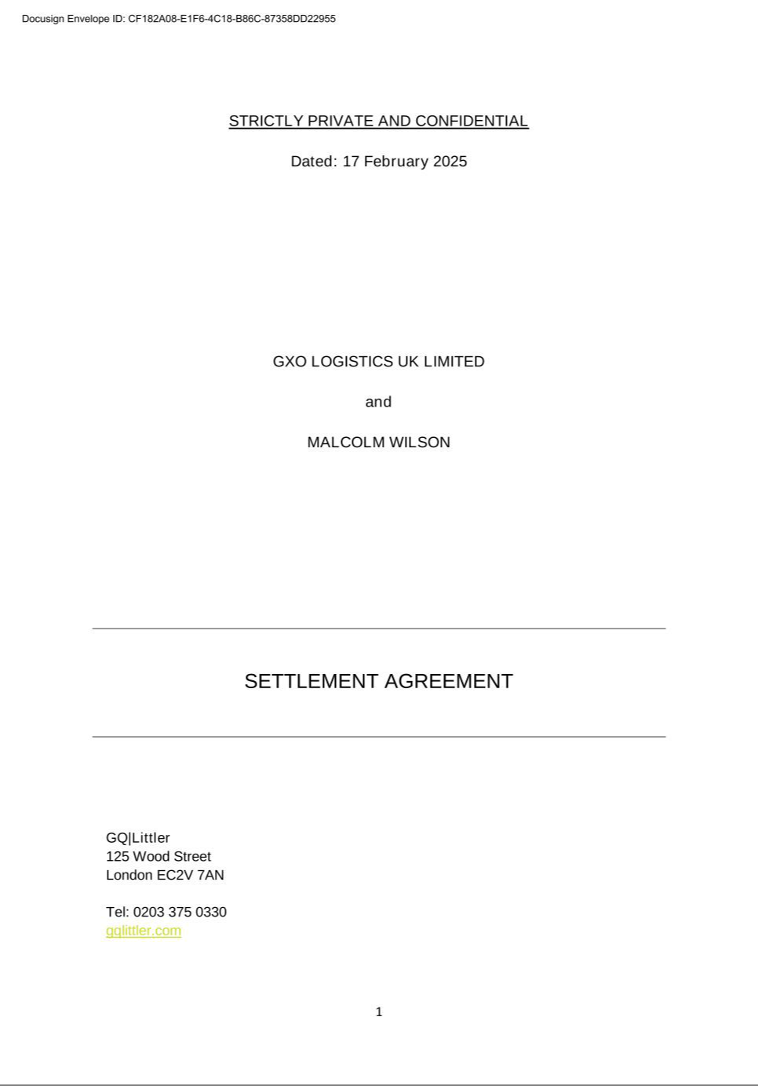

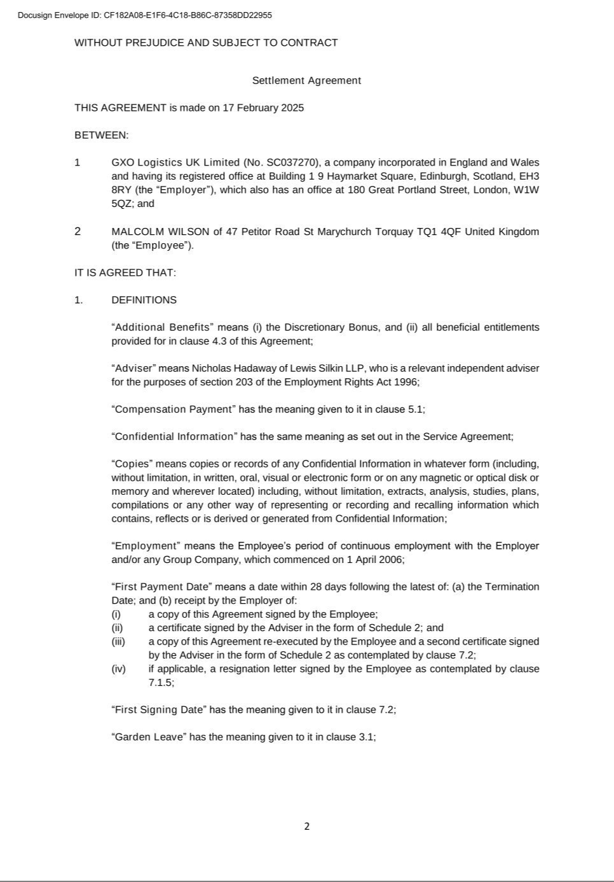

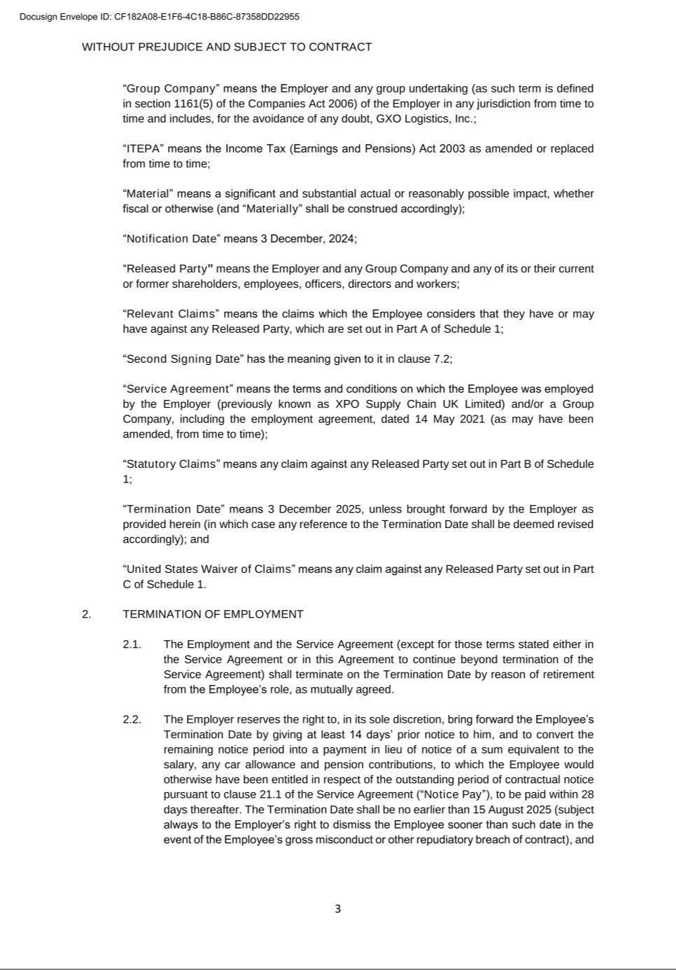

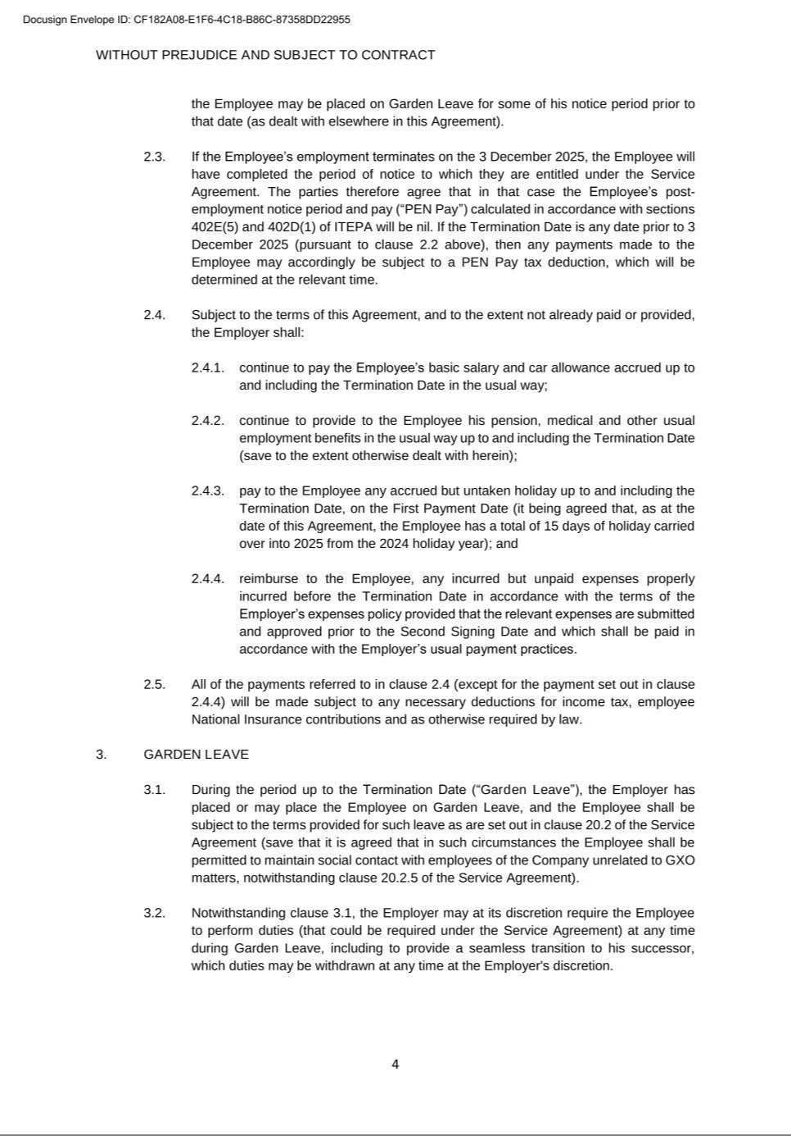

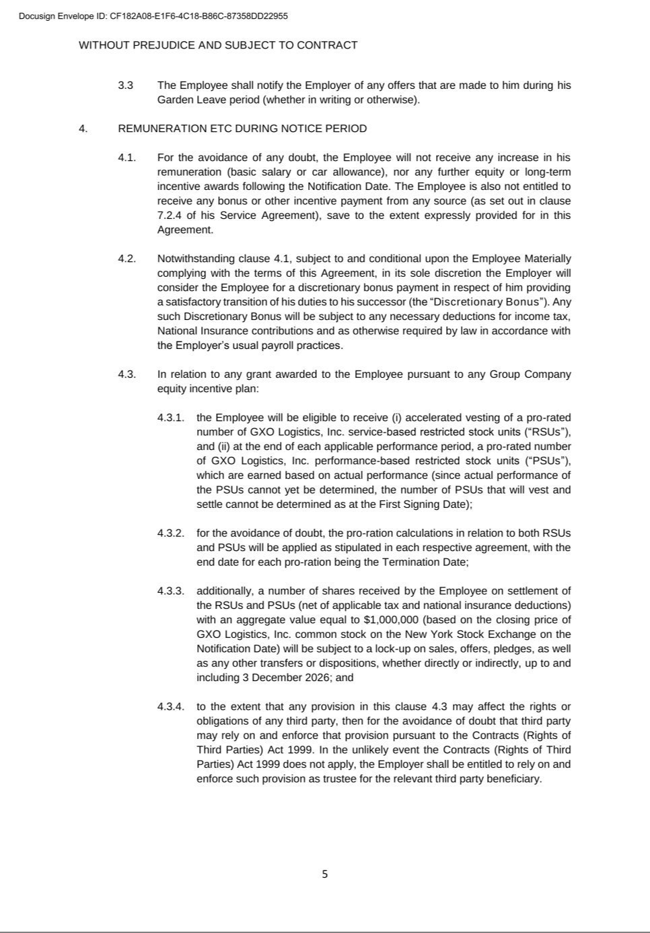

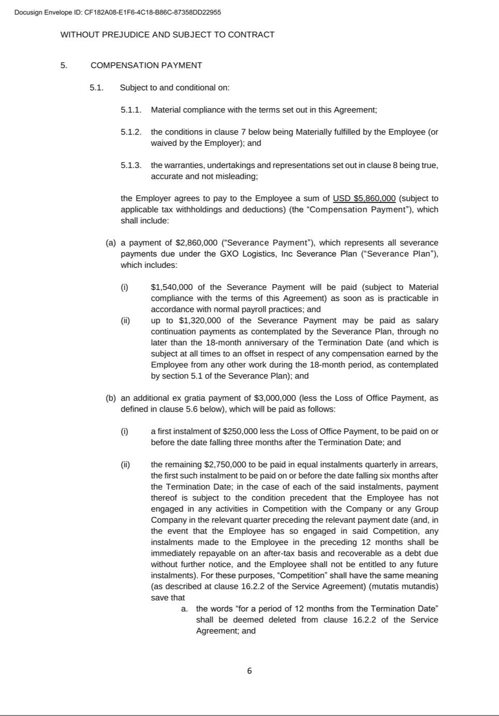

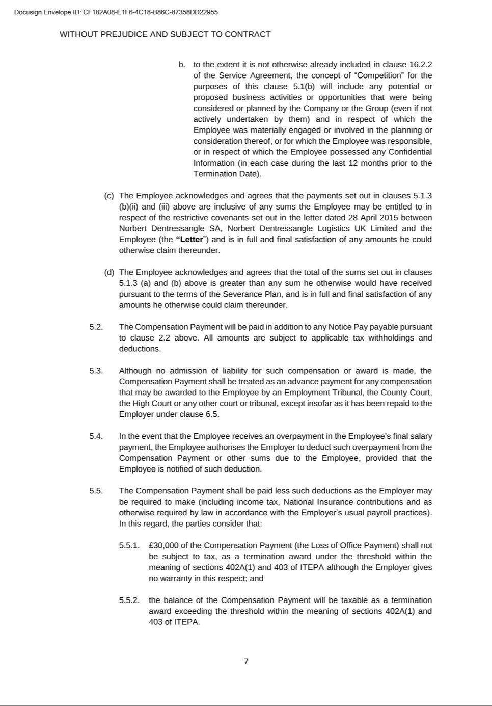

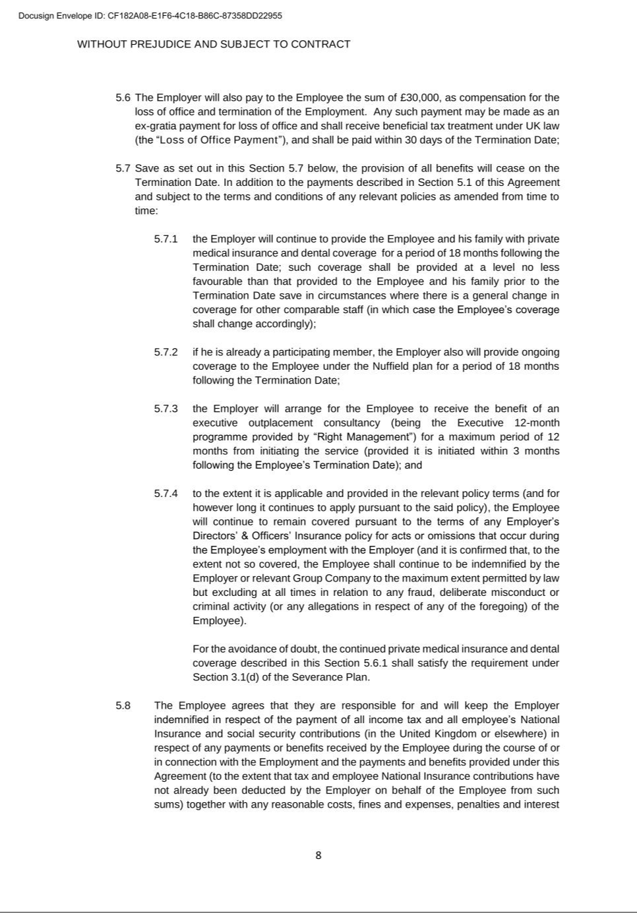

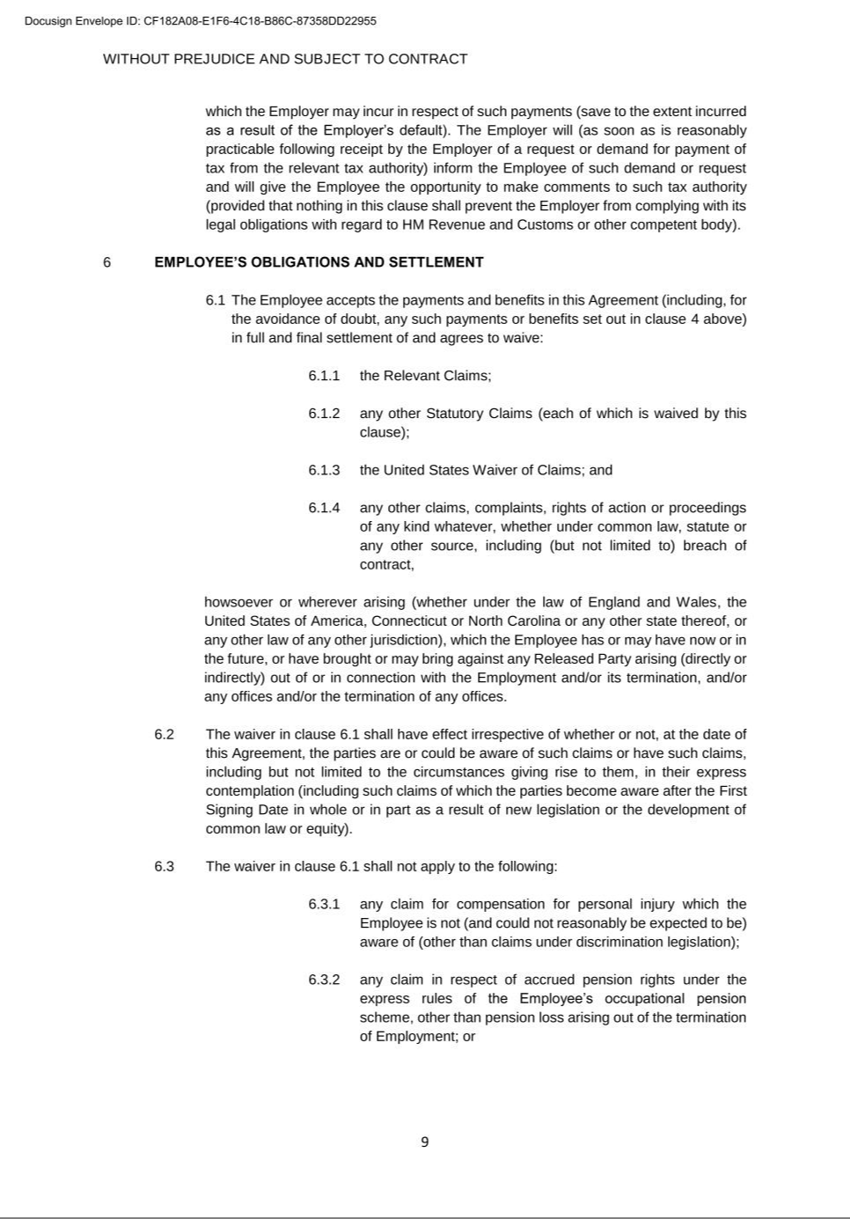

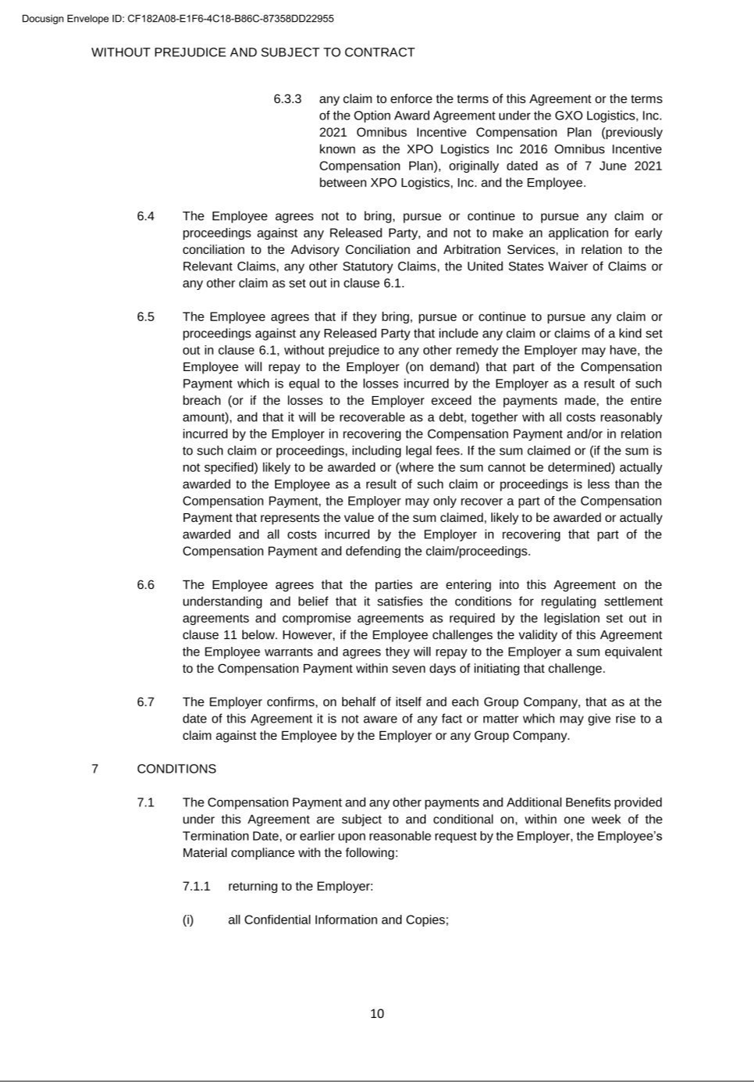

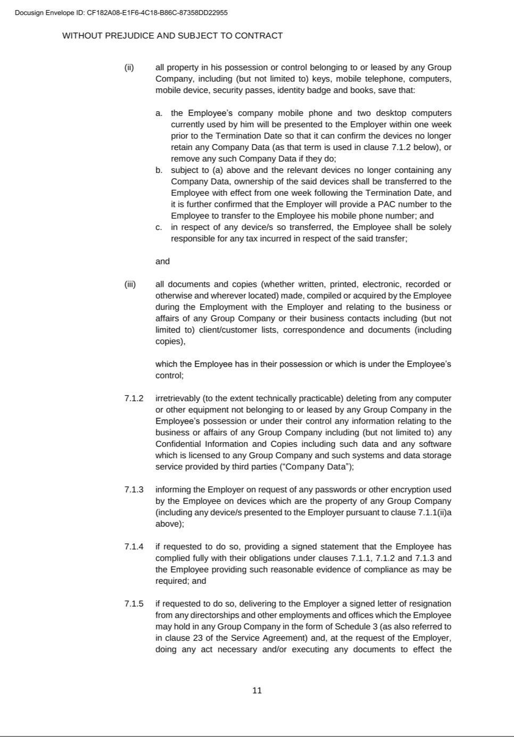

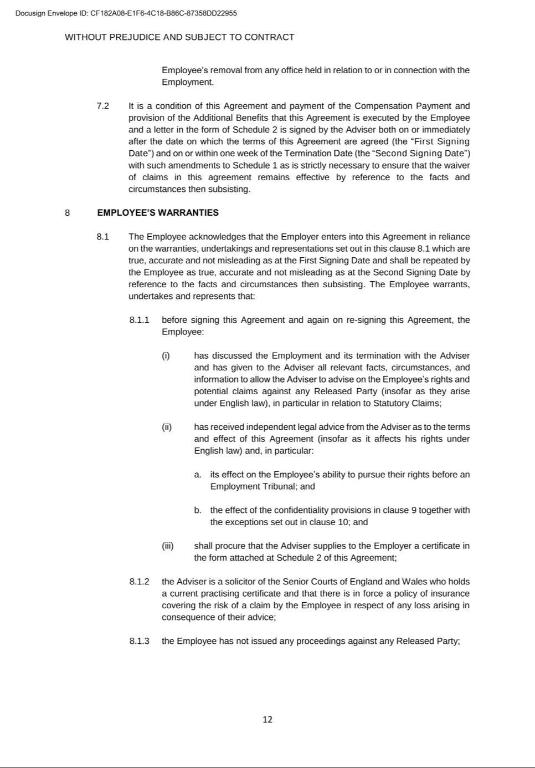

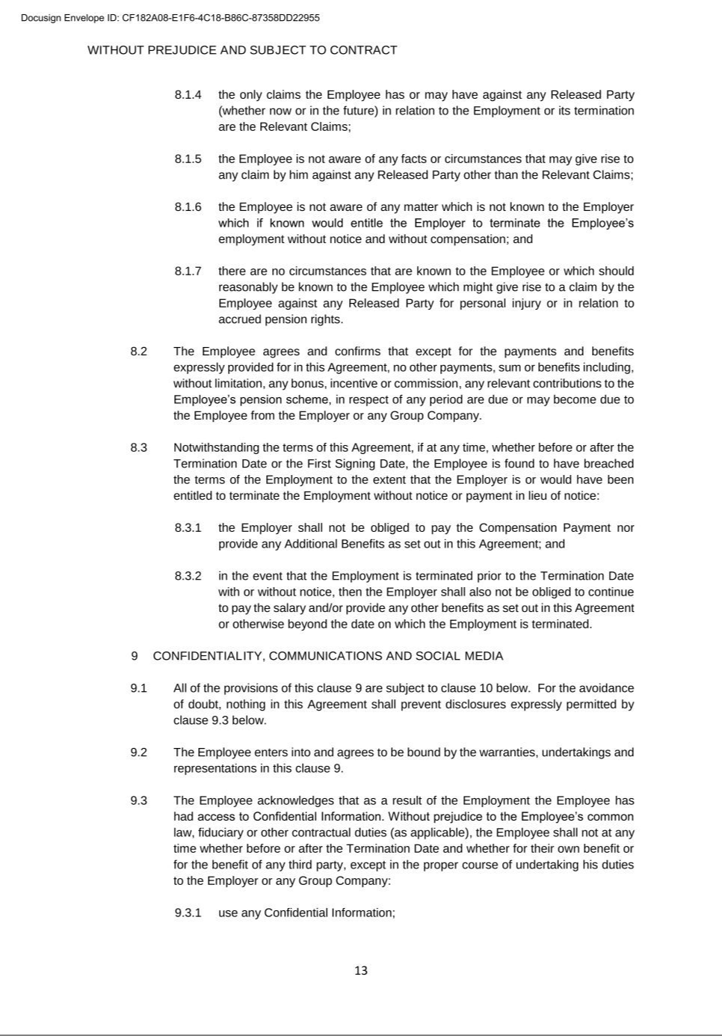

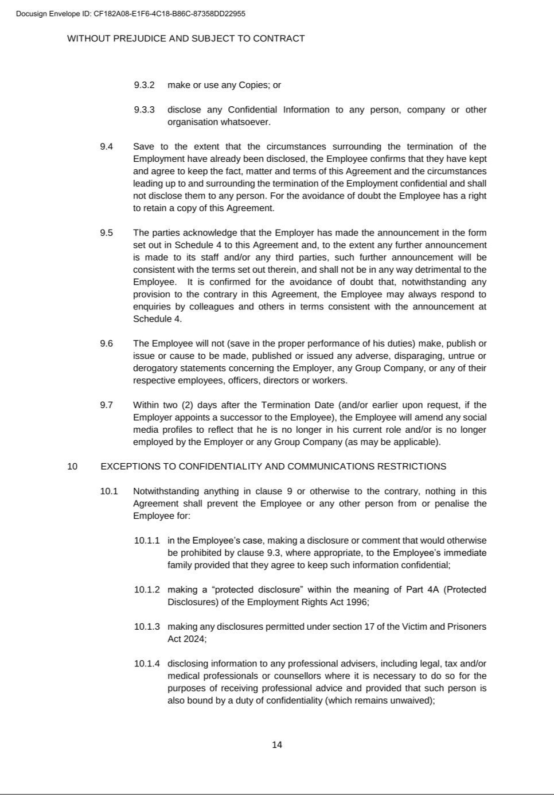

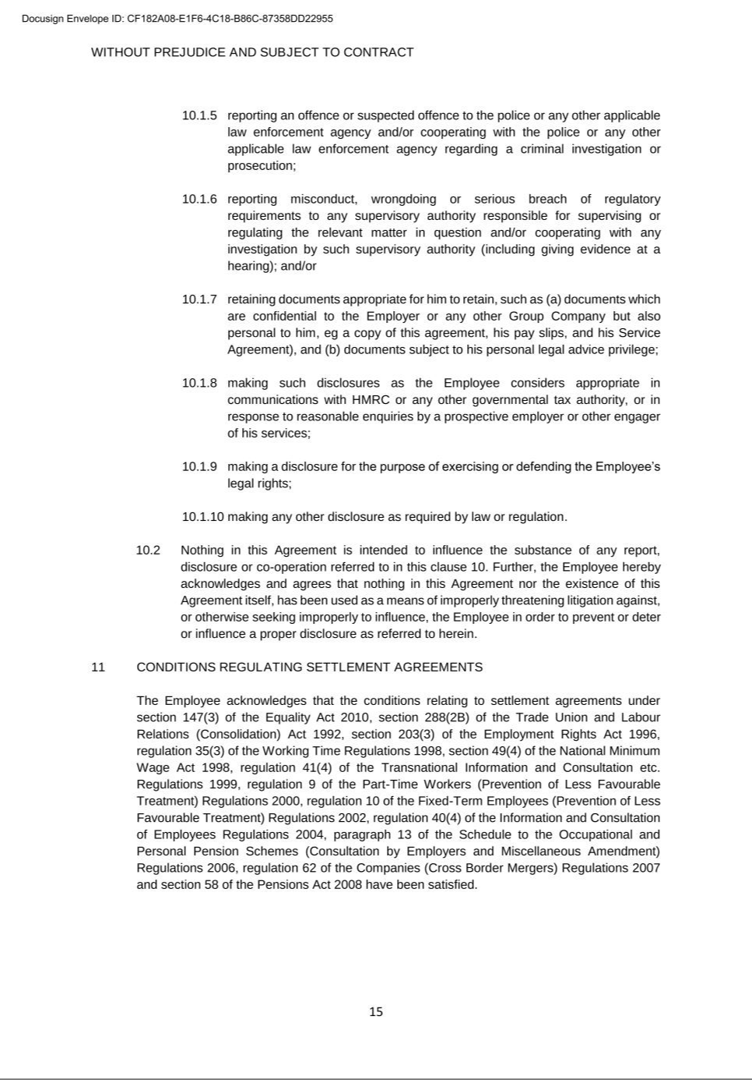

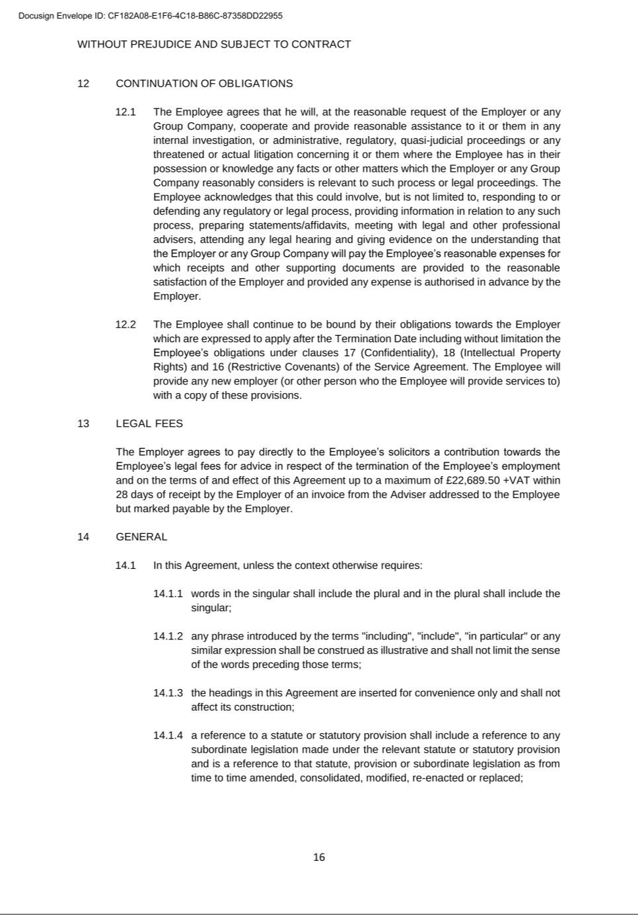

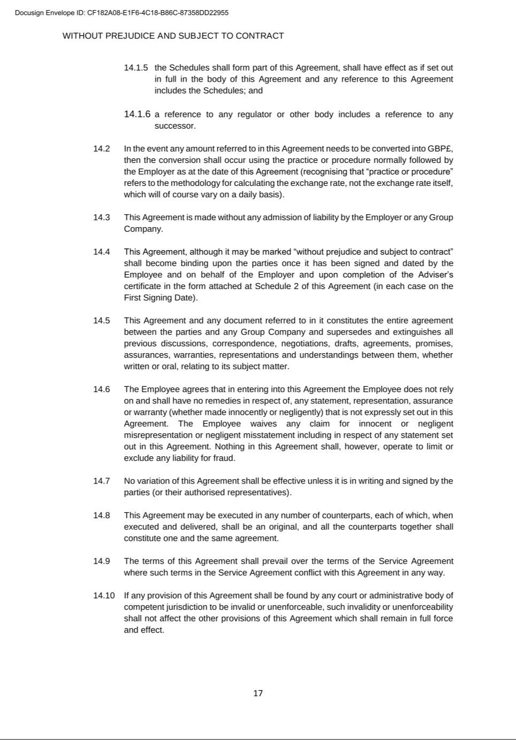



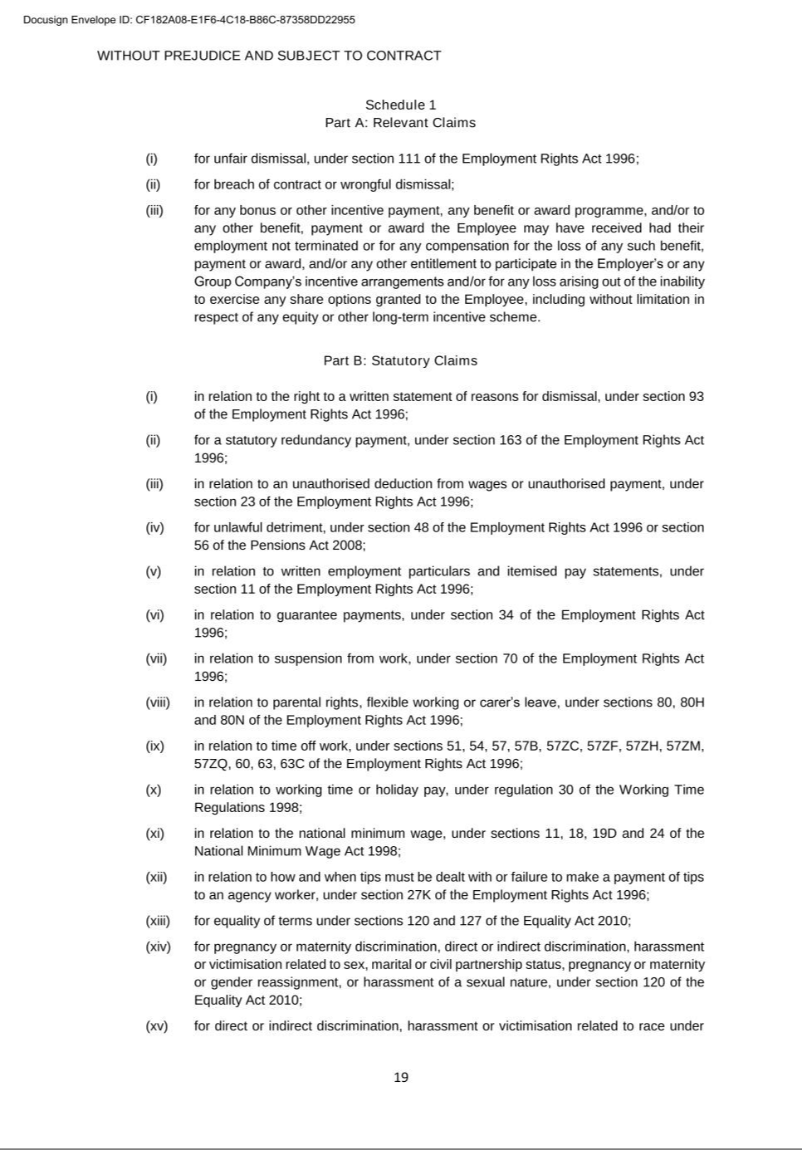

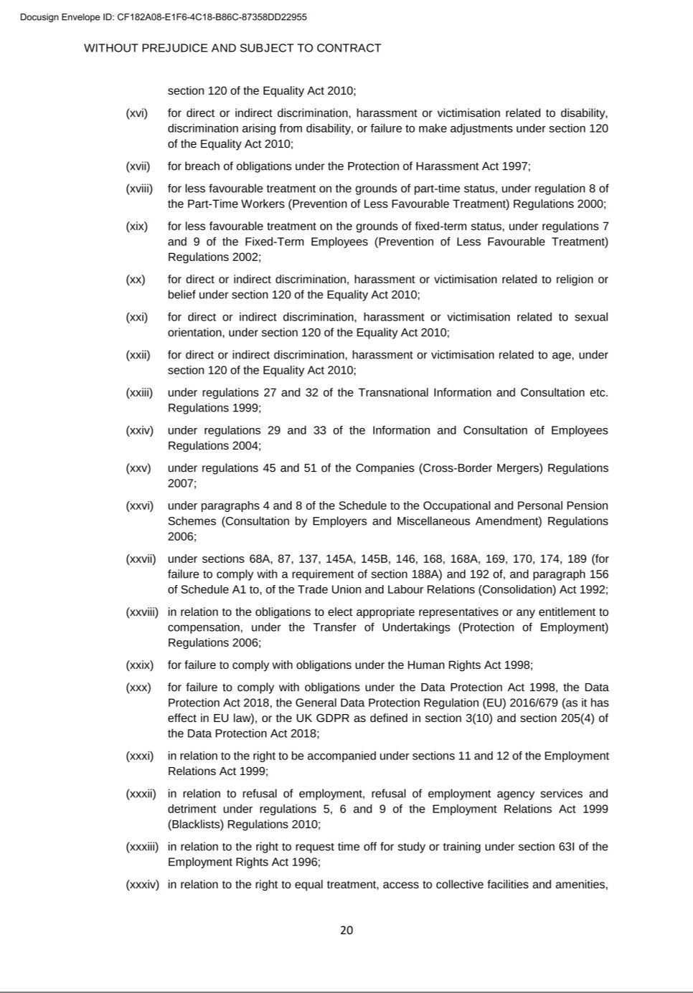

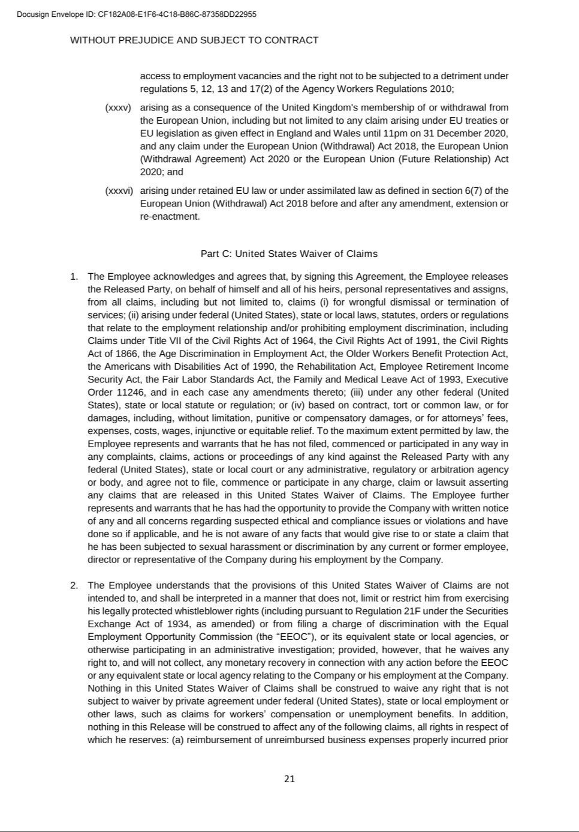

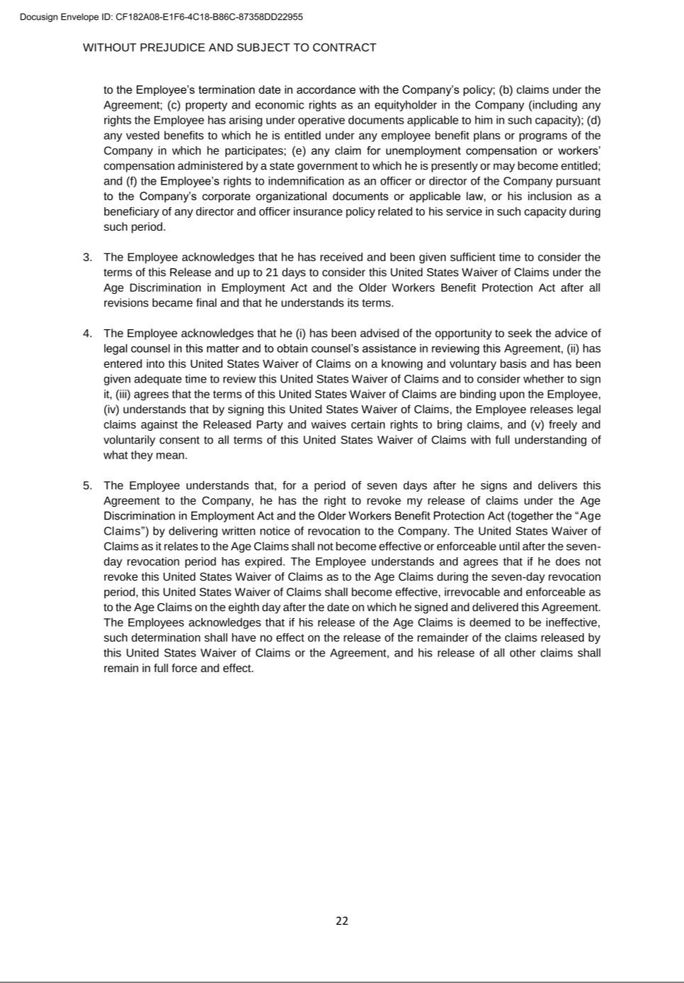

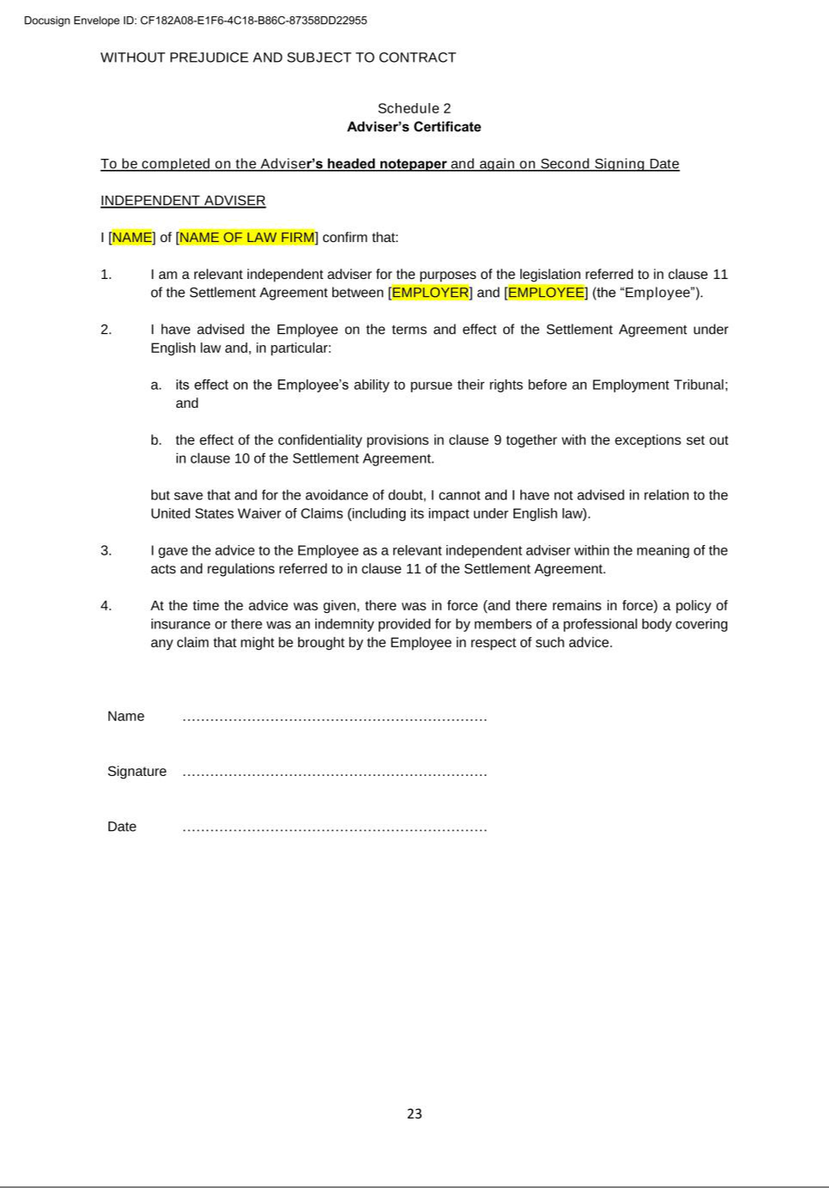

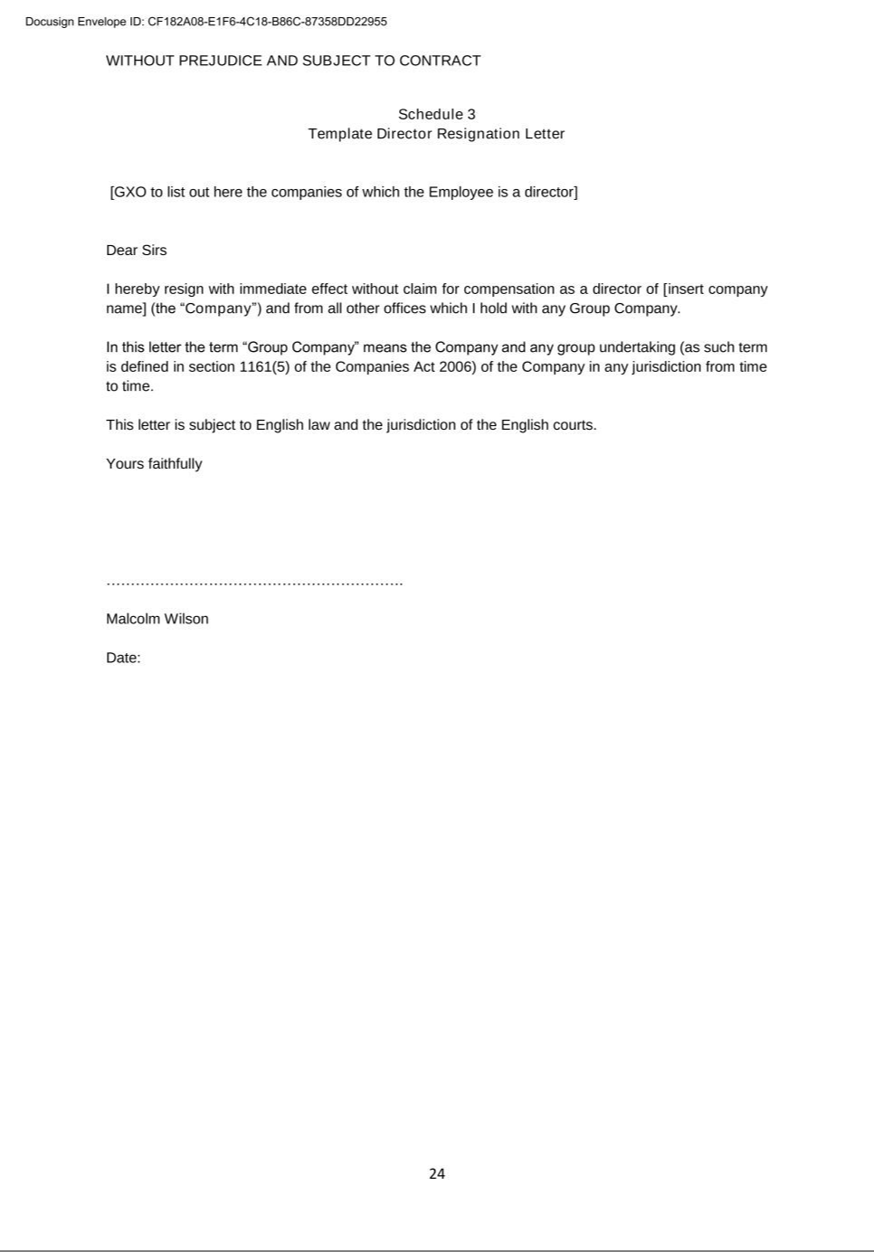

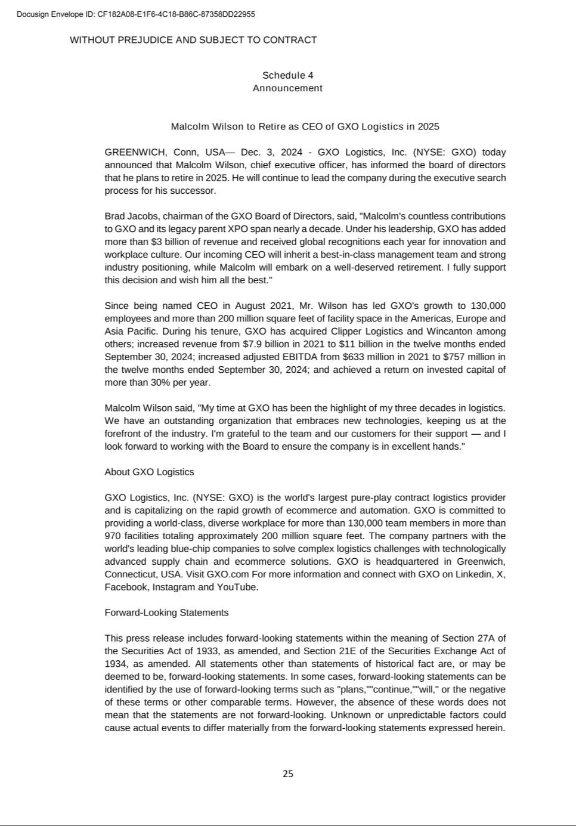

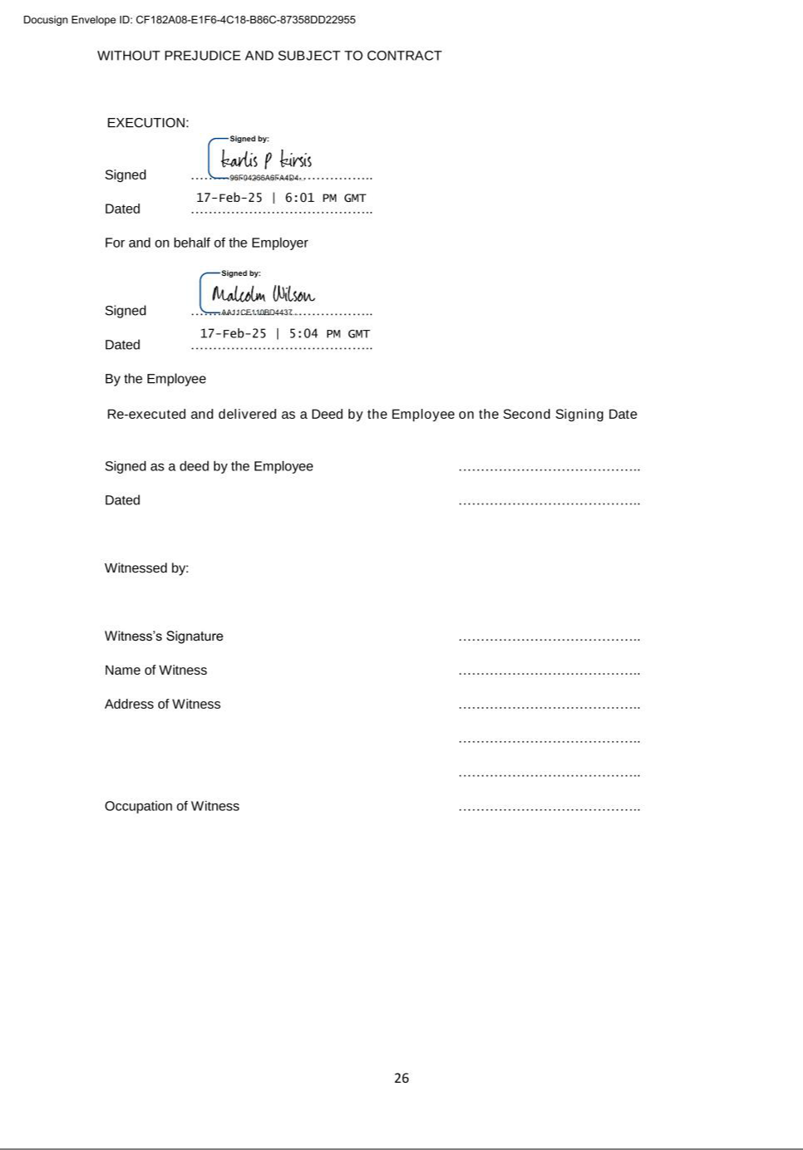

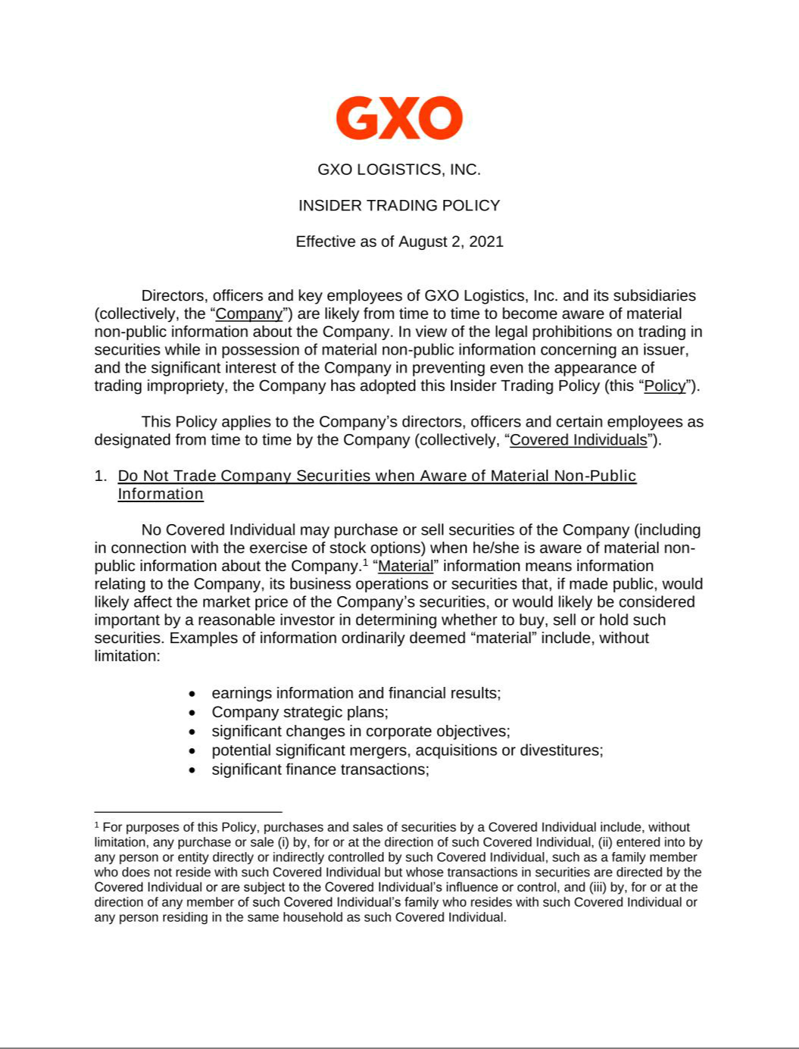

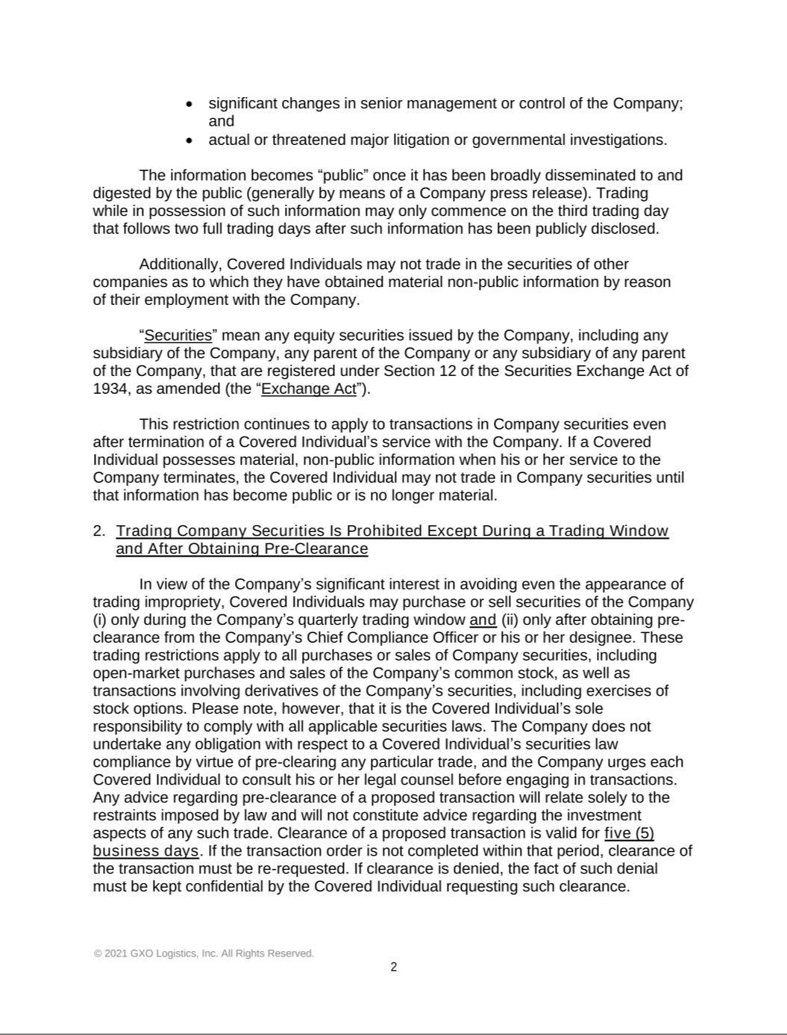

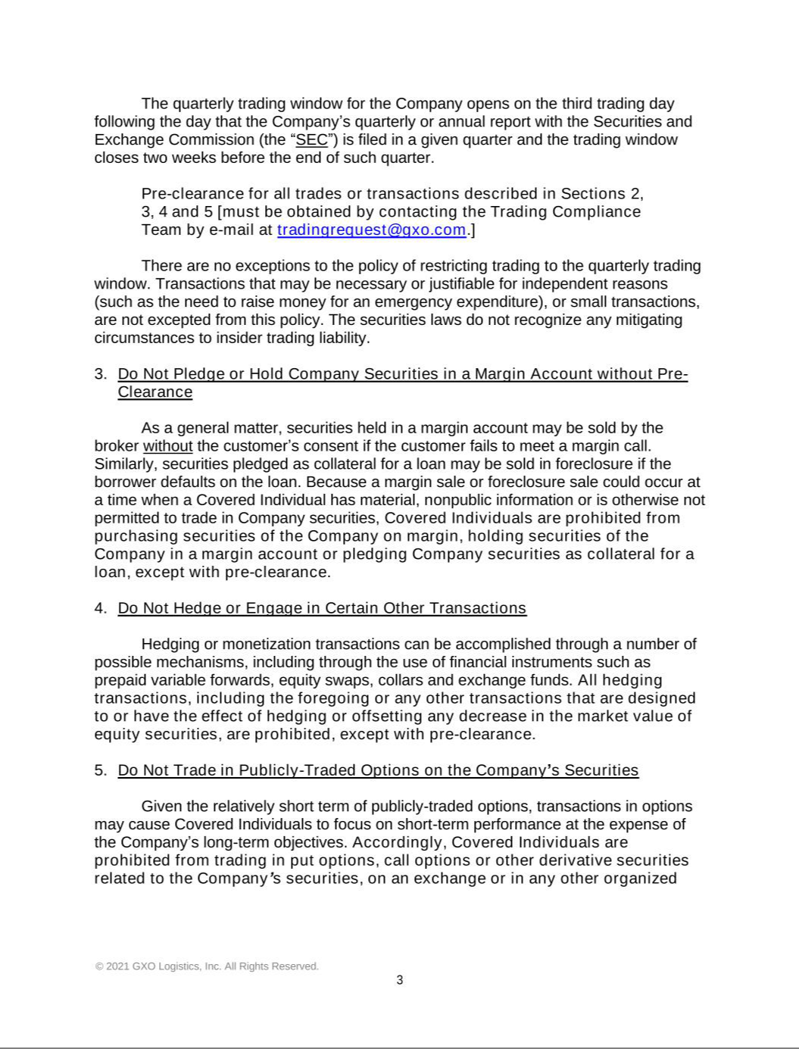

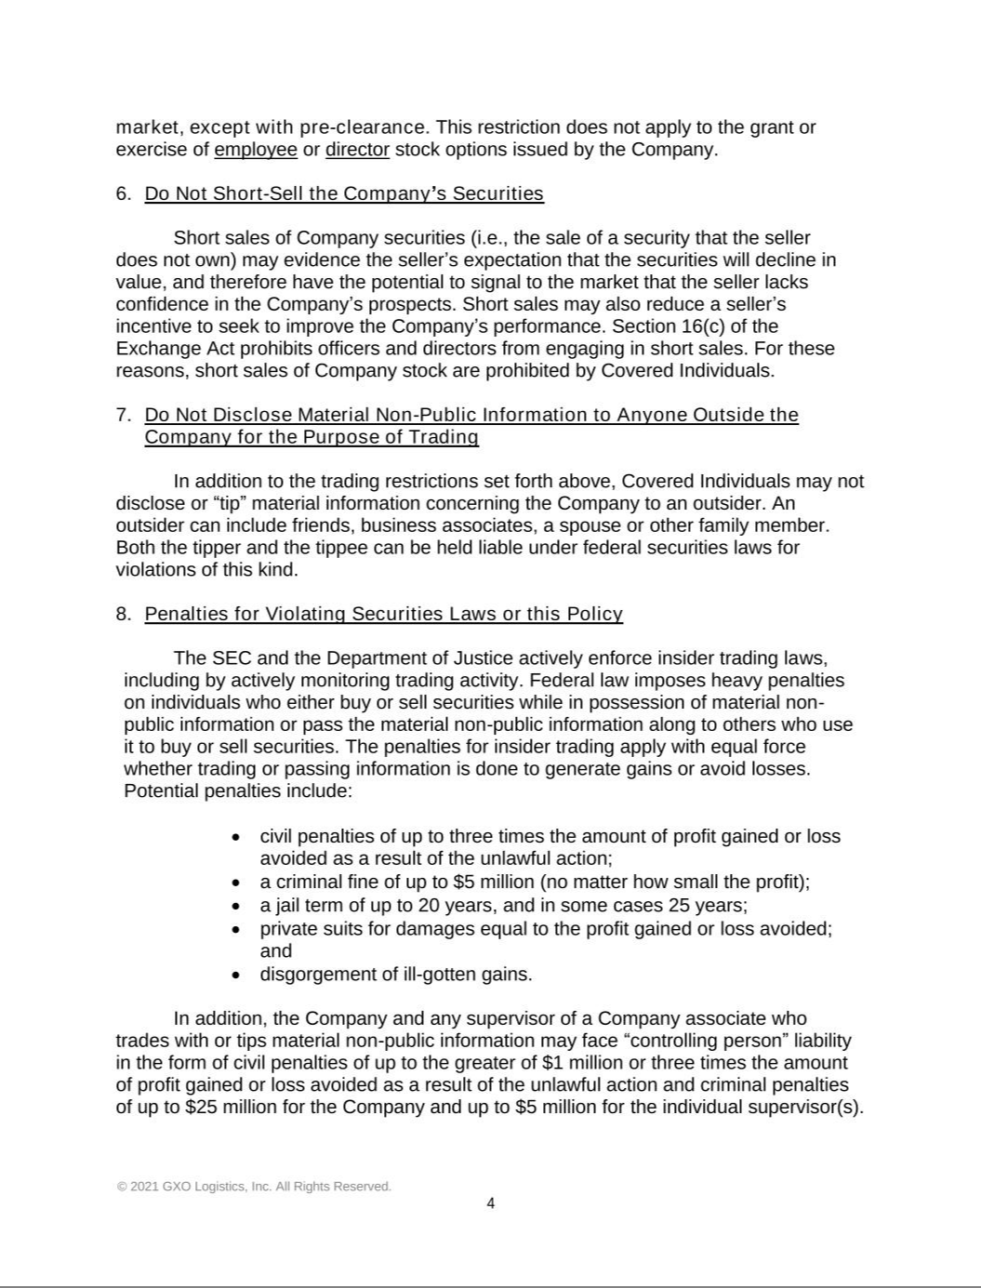

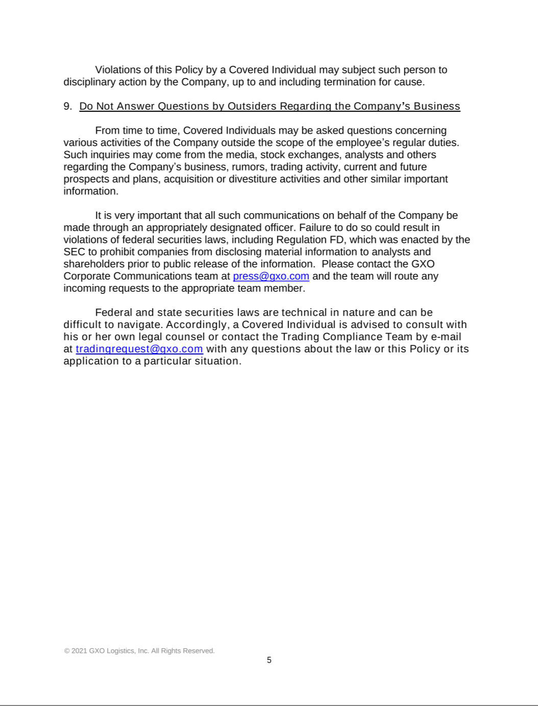

 |  |  |  | Exhibit 21.1
 | Subsidiaries of GXO Logistics, Inc.
Entity |  |  |  | Location of Incorporation
GXO Enterprise Services, LLC |  |  |  | Delaware
GXO Logistics Europe SAS |  |  |  | France
GXO Logistics Netherlands BV |  |  |  | Netherlands
GXO Logistics Netherlands III BV |  |  |  | Netherlands
GXO Logistics Holdings UK Unlimited |  |  |  | United Kingdom
GXO Logistics UK II Limited |  |  |  | United Kingdom
Northern Commercials (Mirfield) Limited |  |  |  | United Kingdom
GXO Logistics UK Limited |  |  |  | Scotland
GXO Logistics Spain SL |  |  |  | Spain
GXO Logistics France SAS |  |  |  | France
GXO Logistics Italy SPA |  |  |  | Italy
GXO Logistics Finance, LLC |  |  |  | Delaware
GXO Logistics Worldwide Holding Company, LLC |  |  |  | Delaware
GXO Logistics Worldwide, LLC |  |  |  | Delaware
GXO Logistics Holding Company |  |  |  | Delaware
GXO Logistics Supply Chain, Inc. |  |  |  | North Carolina
GXO Holdings II, Inc. |  |  |  | Delaware
GXO Holdings III, Inc. |  |  |  | Delaware
GXO Warehouse Company, Inc. |  |  |  | Iowa
Wincanton Holdings Limited |  |  |  | United Kingdom

The names of certain consolidated subsidiaries that do not constitute a significant subsidiary have been omitted. Entities directly owned by subsidiaries of GXO Logistics, Inc. are indented and listed below their immediate parent. Ownership is 100% unless otherwise indicated.

Exhibit 23.1

Consent of Independent Registered Public Accounting Firm

We consent to the incorporation by reference in the registration statements (No. 333-281757) on Form S-3ASR, (No. 333-264901) on Form S-4, and (No. 333-258653) on Form S-8 of our report dated February 18, 2025, with respect to the consolidated financial statements of GXO Logistics, Inc. and subsidiaries and the effectiveness of internal control over financial reporting.

/s/ KPMG LLP

New York, New York

February 18, 2025

Exhibit 31.1

CERTIFICATION

I, Malcolm Wilson, certify that:

- I have reviewed this Annual Report on Form 10-K for the year ended December 31, 2024 of GXO Logistics, Inc.;

- Based on my knowledge, this report does not contain any untrue statement of a material fact or omit to state a material fact necessary to make the statements made, in light of the circumstances under which such statements were made, not misleading with respect to the period covered by this report;

- Based on my knowledge, the financial statements, and other financial information included in this report, fairly present in all material respects the financial condition, results of operations and cash flows of the registrant as of, and for, the periods presented in this report;

- The registrant’s other certifying officer(s) and I are responsible for establishing and maintaining disclosure controls and procedures (as defined in Exchange Act Rules 13a-15(e) and 15d-15(e)) and internal control over financial reporting (as defined in Exchange Act Rules 13a-15(f) and 15d-15(f)) for the registrant and have:

  - Designed such disclosure controls and procedures, or caused such disclosure controls and procedures to be designed under our supervision, to ensure that material information relating to the registrant, including its consolidated subsidiaries, is made known to us by others within those entities, particularly during the period in which this report is being prepared;

  - Designed such internal control over financial reporting, or caused such internal control over financial reporting to be designed under our supervision, to provide reasonable assurance regarding the reliability of financial reporting and the preparation of financial statements for external purposes in accordance with generally accepted accounting principles;

  - Evaluated the effectiveness of the registrant’s disclosure controls and procedures and presented in this report our conclusions about the effectiveness of the disclosure controls and procedures, as of the end of the period covered by this report based on such evaluation; and

  - Disclosed in this report any change in the registrant’s internal control over financial reporting that occurred during the registrant’s most recent fiscal quarter (the registrant’s fourth fiscal quarter in the case of an annual report) that has materially affected, or is reasonably likely to materially affect, the registrant’s internal control over financial reporting; and

- The registrant’s other certifying officer(s) and I have disclosed, based on our most recent evaluation of internal control over financial reporting, to the registrant’s auditors and the audit committee of the registrant’s board of directors (or persons performing the equivalent functions):

  - All significant deficiencies and material weaknesses in the design or operation of internal control over financial reporting which are reasonably likely to adversely affect the registrant’s ability to record, process, summarize and report financial information; and

  - Any fraud, whether or not material, that involves management or other employees who have a significant role in the registrant’s internal control over financial reporting.

/s/ Malcolm Wilson

Malcolm Wilson

Chief Executive Officer

(Principal Executive Officer)

Date: February 18, 2025

Exhibit 31.2

CERTIFICATION

I, Baris Oran, certify that:

- I have reviewed this Annual Report on Form 10-K for the year ended December 31, 2024 of GXO Logistics, Inc.;

- Based on my knowledge, this report does not contain any untrue statement of a material fact or omit to state a material fact necessary to make the statements made, in light of the circumstances under which such statements were made, not misleading with respect to the period covered by this report;

- Based on my knowledge, the financial statements, and other financial information included in this report, fairly present in all material respects the financial condition, results of operations and cash flows of the registrant as of, and for, the periods presented in this report;

- The registrant’s other certifying officer(s) and I are responsible for establishing and maintaining disclosure controls and procedures (as defined in Exchange Act Rules 13a-15(e) and 15d-15(e)) and internal control over financial reporting (as defined in Exchange Act Rules 13a-15(f) and 15d-15(f)) for the registrant and have:

  - Designed such disclosure controls and procedures, or caused such disclosure controls and procedures to be designed under our supervision, to ensure that material information relating to the registrant, including its consolidated subsidiaries, is made known to us by others within those entities, particularly during the period in which this report is being prepared;

  - Designed such internal control over financial reporting, or caused such internal control over financial reporting to be designed under our supervision, to provide reasonable assurance regarding the reliability of financial reporting and the preparation of financial statements for external purposes in accordance with generally accepted accounting principles;

  - Evaluated the effectiveness of the registrant’s disclosure controls and procedures and presented in this report our conclusions about the effectiveness of the disclosure controls and procedures, as of the end of the period covered by this report based on such evaluation; and

  - Disclosed in this report any change in the registrant’s internal control over financial reporting that occurred during the registrant’s most recent fiscal quarter (the registrant’s fourth fiscal quarter in the case of an annual report) that has materially affected, or is reasonably likely to materially affect, the registrant’s internal control over financial reporting; and

- The registrant’s other certifying officer(s) and I have disclosed, based on our most recent evaluation of internal control over financial reporting, to the registrant’s auditors and the audit committee of the registrant’s board of directors (or persons performing the equivalent functions):

  - All significant deficiencies and material weaknesses in the design or operation of internal control over financial reporting which are reasonably likely to adversely affect the registrant’s ability to record, process, summarize and report financial information; and

  - Any fraud, whether or not material, that involves management or other employees who have a significant role in the registrant’s internal control over financial reporting.

/s/ Baris Oran

Baris Oran

Chief Financial Officer

(Principal Financial Officer)

Date: February 18, 2025

Exhibit 32.1

CERTIFICATION OF THE CHIEF EXECUTIVE OFFICER

Pursuant to 18 U.S.C. Section 1350

As adopted pursuant to Section 906 of the Sarbanes-Oxley Act of 2002

Solely for the purposes of complying with 18 U.S.C. Section 1350 as adopted pursuant to Section 906 of the Sarbanes-Oxley Act of 2002, I, the undersigned Chief Executive Officer of GXO Logistics, Inc. (the “Company”), hereby certify, based on my knowledge, that the Annual Report on Form 10-K of the Company for the year ended December 31, 2024 (the “Report”) fully complies with the requirements of Section 13(a) or 15(d) of the Securities Exchange Act of 1934 and that the information contained in the Report fairly presents, in all material respects, the financial condition and results of operations of the Company.

/s/ Malcolm Wilson

Malcolm Wilson

Chief Executive Officer

(Principal Executive Officer)

Date: February 18, 2025

Exhibit 32.2

CERTIFICATION OF THE CHIEF FINANCIAL OFFICER

Pursuant to 18 U.S.C. Section 1350

As adopted pursuant to Section 906 of the Sarbanes-Oxley Act of 2002

Solely for the purposes of complying with 18 U.S.C. Section 1350 as adopted pursuant to Section 906 of the Sarbanes-Oxley Act of 2002, I, the undersigned Chief Financial Officer of GXO Logistics, Inc. (the “Company”), hereby certify, based on my knowledge, that the Annual Report on Form 10-K of the Company for the year ended December 31, 2024 (the “Report”) fully complies with the requirements of Section 13(a) or 15(d) of the Securities Exchange Act of 1934 and that the information contained in the Report fairly presents, in all material respects, the financial condition and results of operations of the Company.

/s/ Baris Oran

Baris Oran

Chief Financial Officer

(Principal Financial Officer)

Date: February 18, 2025

